

Lab?

Pro’s

Con’s

Border Collie?

Pro’s

Con’s

Yorkie?

Pro’s

Con’s

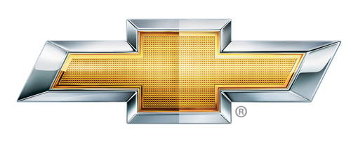

Chevy?

Pro’s

Con’s

Dodge?

Pro’s

Con’s

Ford?

Pro’s

Con’s

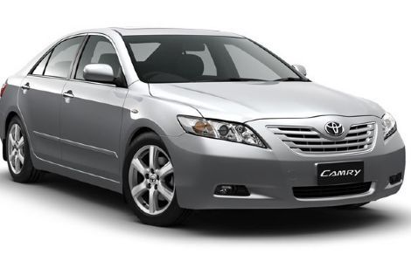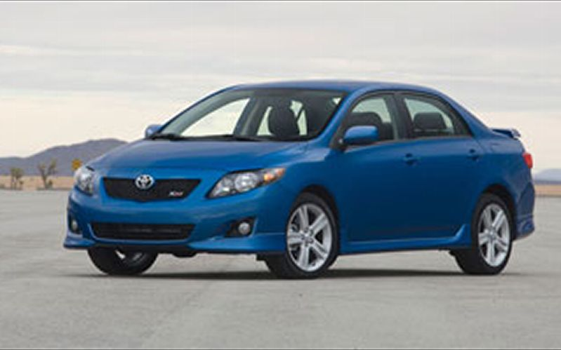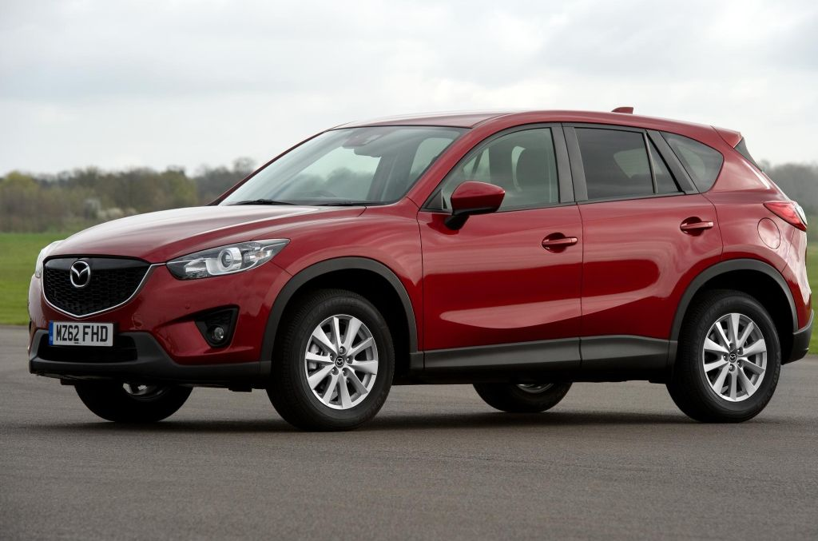

Full Size Car?

Pro’s

Con’s

\*Full size cars are roomier & typically have more luxury features than economy cars, but less gas mileage

Economy Car?

Pro’s

Con’s

\*Economy cars are smaller & typically get better gas mileage

SUV?

Pro’s

Con’s

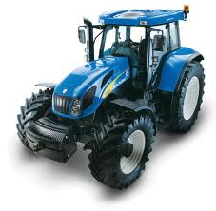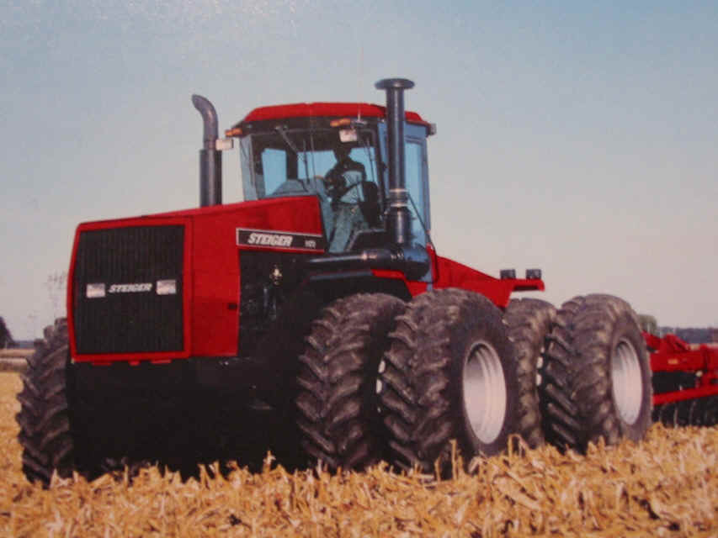

Red?

Pro’s

Con’s

Blue?

Pro’s

Con’s

Green?

Pro’s

Con’s