Name___________________________________ Period_________ Date_________

Animal Diseases & Parasites Notes

- Categorize diseases by their cause

Disease =

Physiological Disease  Examples: Diabetes, hyper/hypothyroidism | Nutritional Disease  Examples: Ricketts, Milk Fever
Morphological Disease  Examples: Cuts, bruises, scratches, broken bones | Pathogenic Disease  Examples: Parvovirus, Rabies
Parasitic Disease  Examples: Heartworm Disease | Congenital Disease  Examples: Hip Dysplasia

- List common diseases found in animals

*See Assignments

- Identify common animal parasites and their symptoms

Parasite:
  - Any organism that lives ___________________ another organism
  - Causes the host harm
  - Parasites will ______________ without a host

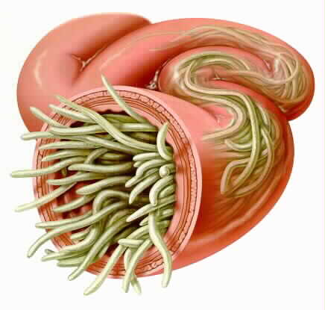
Internal Parasite:
  - Live ___________________ it’s host

    - Looks like spaghetti
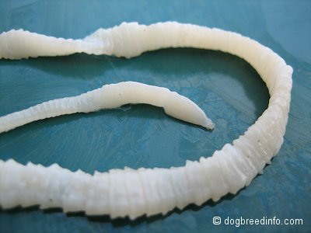
    - Found in intestines

  - Long and flat in intestines
  - Break off in sections which look like rice in the stool
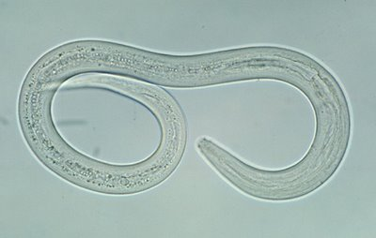

    - Small, hook shape
    - Attaches to walls of intestine

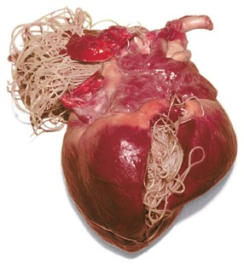

  - Found in circulatory system
  - Eventually blocks heart valves

External Parasite:
  - Lives _________________________it’s host

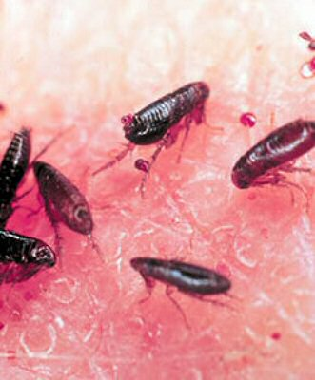

    - Causes extreme Itching
    - Not found in Utah!
(They don’t survive the winters here)
    - Can infect houses, live in couches, etc

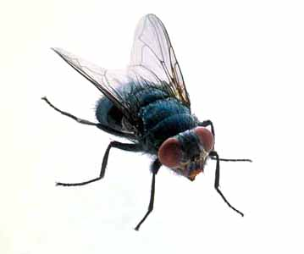

    - Problem in the late summer & early fall
    - Flies are attracted to animals
    - Flies are annoying, but biggest problem is that they transmit disease
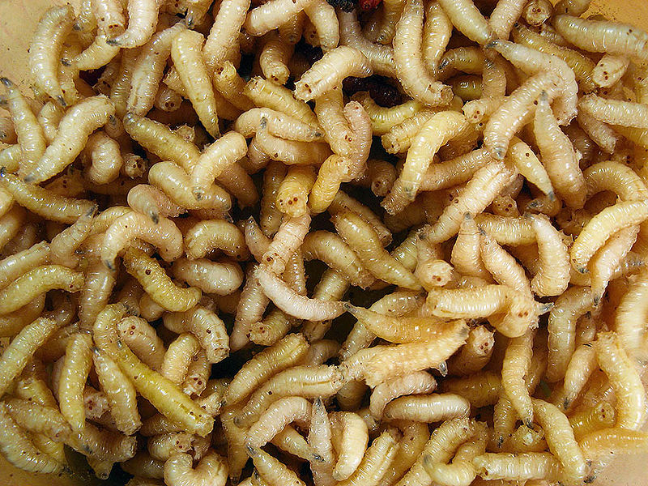

  - Fly larvae (eggs)
  - This parasite begins as external and then becomes internal
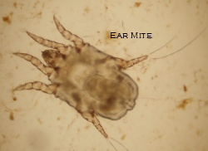

    - Live on surface of skin
    - Attracted to warm, moist places such as the ear
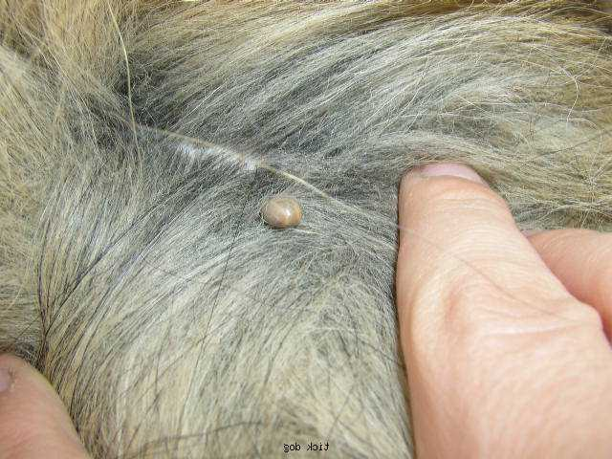

    - Attach themselves to body and suck blood
    - Can transmit Lyme Disease

How are parasites transmitted?
  - Ingesting infected feces
  - From mother to fetus
  - Mosquitos (heartworm)
  - Eating flesh of infected animal
    - Ie: Cat eating mouse

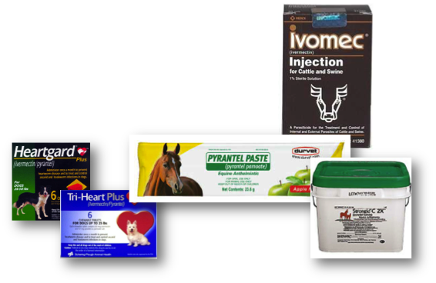
Preventing Parasites:

Internal

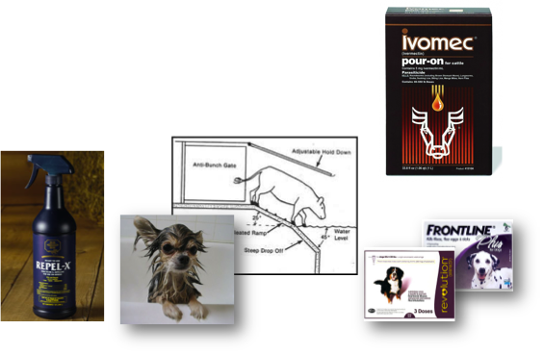

External

- Perform an animal health check

Healthy Animals:
  - Bright __________________________
  - Socialize with other ________________________ and people as usual
  - Shiny ____________________
  - Healthy _________________________
  - ______________________ body functions (urination, defecation, etc)

Sick Animals:
  - Weight ______________________
  - Reduced Performance

  - Diarrhea
  - Dull eyes/drooped _____________________
  - Dull coat
  - High ________________________

- Identify & describe zoonotic diseases

Zoonotic Disease=

-Example: From animal to human

Preventing Zoonotic Disease=
- Wash your hands!
- Keep animals healthy and dewormed regularly

