Name____________________________________________ Period_________ Date__________
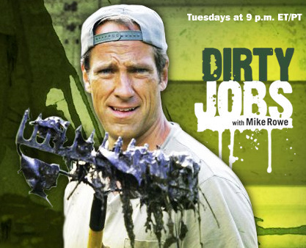
2009 National FFA Convention Key Note Speaker
Mike Rowe from Dirty Jobs

As you watch this recording of Mike Rowe’s speech, answer the following questions about Mike’s suggestions about choosing careers.

- What was Les Swanson’s career(s) prior to being a sewer pump collector?

- Why did he (Les Swanson) choose his job?

- What does Mike Rowe consider himself instead of a “host?” Why?

- Why does Mike consider himself the “most successful failure?”

- What did Mike notice about most everyone that he met who had a “dirty” job?

- What was the original idea Mike Rowe took to the Discovery Channel?

- What is a parapatia?

- What would be a better color to use to describe “going green?” Why?

- What is sustainability in agriculture?

- What is the best protection from getting hurt?

- Who did Mike contact prior to visiting the sheep ranch where they would castrate sheep?

- What did Mike learn AFTER visiting the sheep ranch? Who was right in having the most humane method of castrating the lamb??

Essay: Write a short, 3 paragraph essay reflecting what you learned from Mike Rowe.
Answer the questions below. There should be a minimum of 4 complete sentences in each paragraph.
Describe the most important thing you learned from Mike Rowe.
Describe 1 agricultural job you would enjoy, include 2 SMART goals you should achieve to enter that career.
Define what YOU think is a “Good Job.”

