Name _________________________________________ Period ______ Date ________

Recognizing
Animal Rights vs. Animal Welfare

Directions: Using what you have learned about animal rights and animal welfare, observe the following animal care scenarios and make 3 observations from each perspective. Remember that animal rights advocates want animals to have the same rights as people and animal welfare advocates are concerned about providing for the welfare (food, shelter, and protection) of animals.

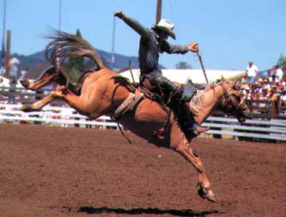
Scenario #1: Rodeo Livestock
Animal Rights

Animal Welfare

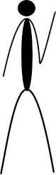

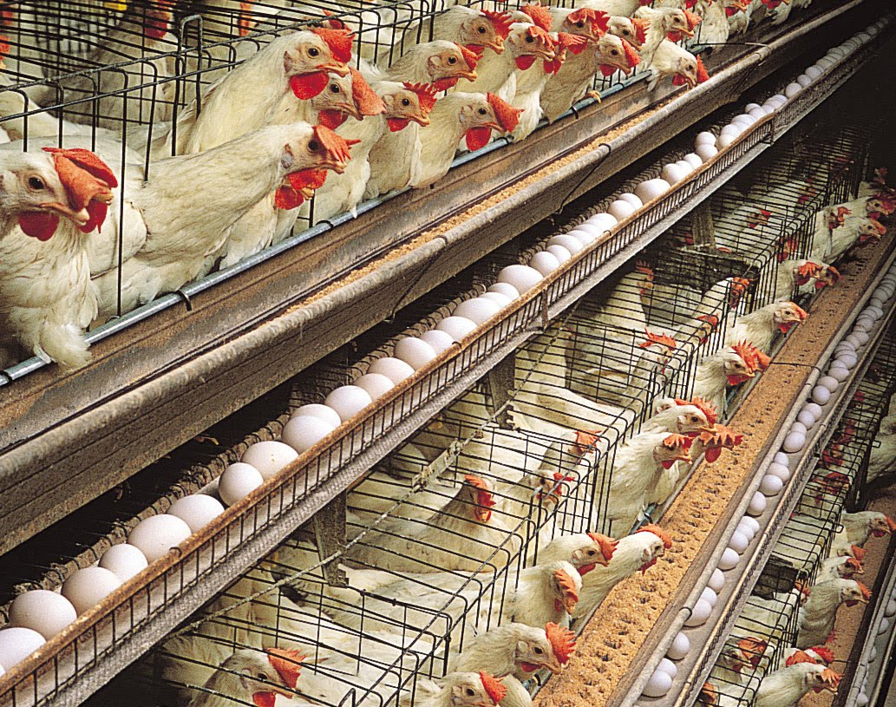
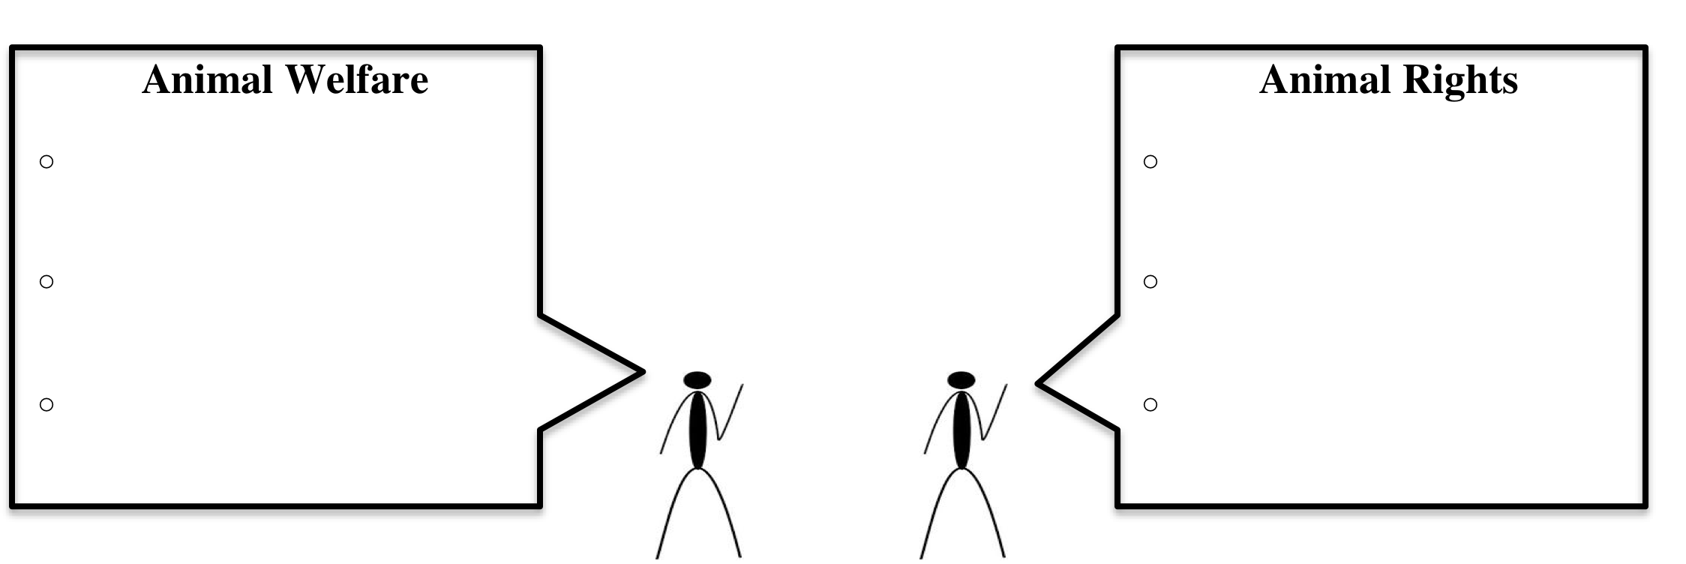
Scenario #2: Large Scale Egg Farms

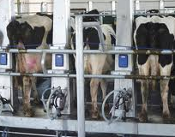
Scenario #3: Dairy Farms

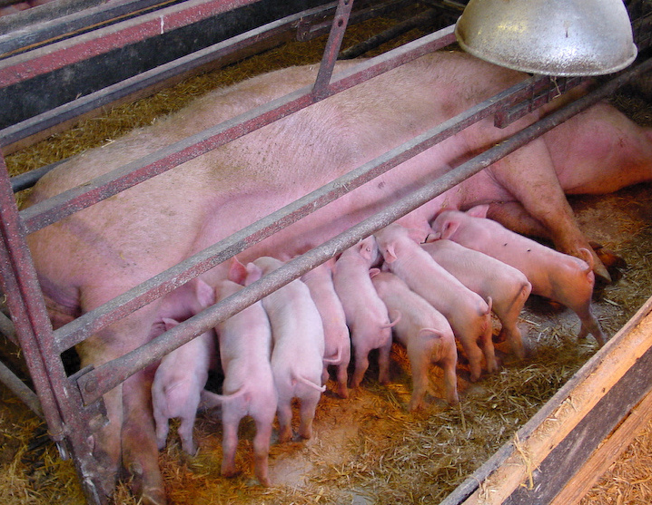
Scenario #4: Hog Farrowing Crates

Scenario #5:
(Choose your own)

