Name____________________________________________ Period_________ Date__________

Animal Science
Career Card

Directions:
- Choose a career that is related to Animal Science
- Research the career
- Make a 2 page “Career Card” summarizing the details of the career. DO NOT write an essay! Follow format of example below

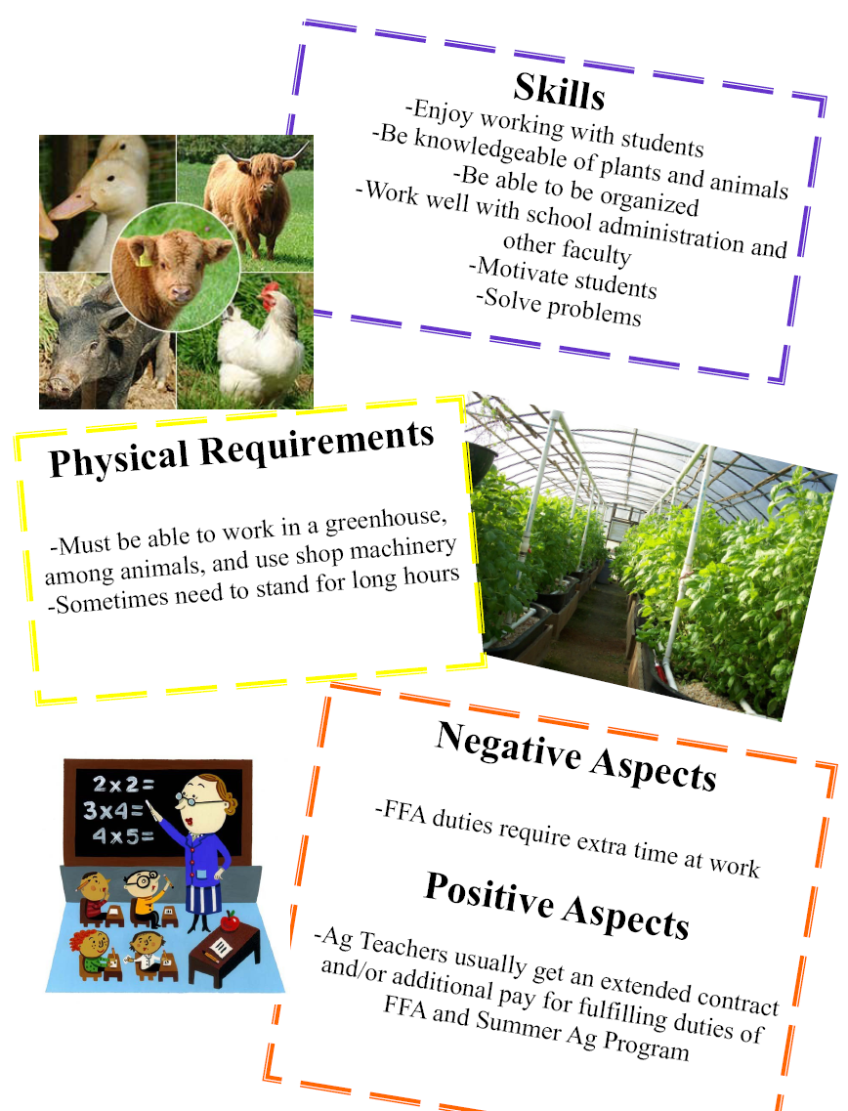
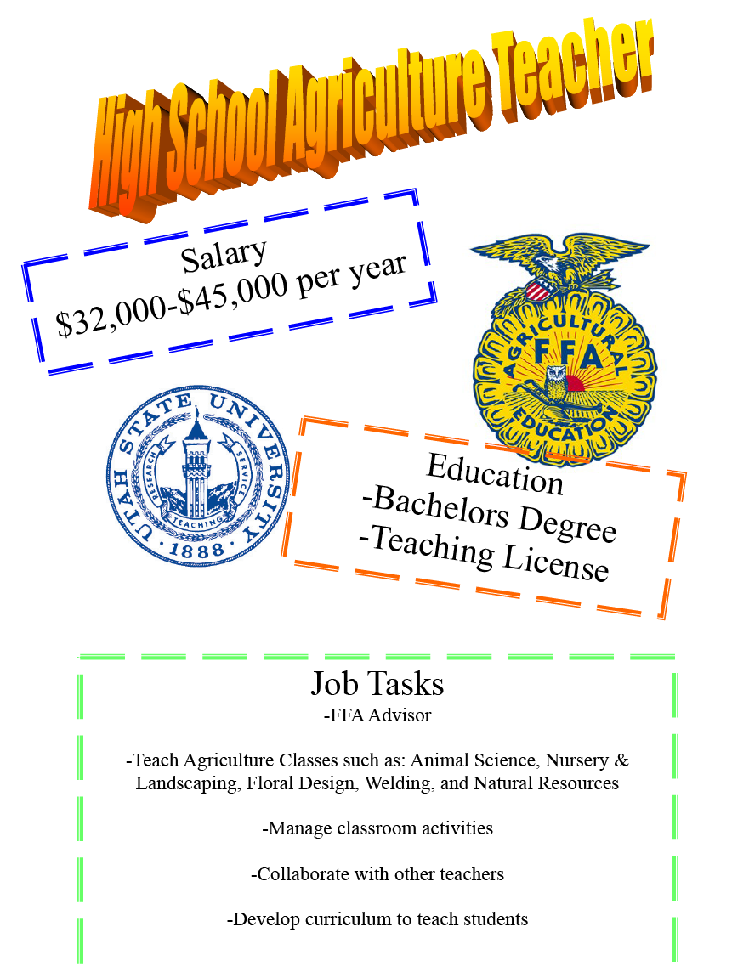

- Include the following information:
  - Average Salary
  - Education & Training Required
  - 5 or more regular job tasks (things you can expect to do on a regular basis)
  - Skills needed to enjoy the job and be successful at it
  - Physical Requirements
  - Negative & Positive Aspects of the job
  - Include 3 or more pictures

