Name_____________ ____________________ Period_______ Date__________

Classified Ad Search

Directions: Find a local source for classified advertisements. Find ads for breeding services OR “For Sale” ads. Ads with a lot of description often list traits and characteristics that are associated with the animal’s genetics, especially if they add value. Answer the questions below for each ad. Completed this worksheet using ads for a minimum of 2 DIFFERENT species. (Cattle, swine, sheep, horses, dogs, goats, or other species as approved by your instructor.)

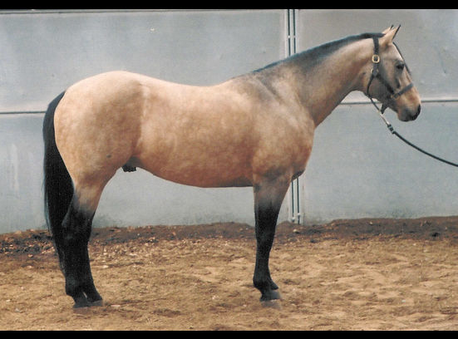

Ad Title: World Class Buckskin Stallion at Stud
Example

Genetic characteristics the animal has which give it added quality or appeal:

Buckskin color, Homozygous for black gene, 16.2 hands tall, Registered Purebred, speed index rating from stallion’s sire, proven in show ring.

Sale Price: $1500 Compared to similar ads is this price: High Low Average (circle one)

Ad Title #1:

Genetic characteristics the animal has which give it added quality or appeal:

Sale Price: Compared to similar ads is this price: High Low Average (circle one)

Ad Title #2:

Genetic characteristics the animal has which give it added quality or appeal:

Sale Price: Compared to similar ads is this price: High Low Average (circle one)

Ad Title #3:

Genetic characteristics the animal has which give it added quality or appeal:

Sale Price: Compared to similar ads is this price: High Low Average (circle one)

Ad Title #4:

Genetic characteristics the animal has which give it added quality or appeal:

Sale Price: Compared to similar ads is this price: High Low Average (circle one)

