Name________________________________ Period_________ Date_____________

Respiratory System Sketch

Directions: Using colored pencils, sketch the respiratory system of a sheep. Include all of the structures.
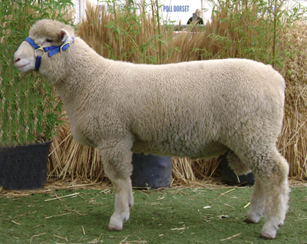

Below: Draw an additional diagram of a set of lungs. Include the trachea, bronchi, bronchioles, alveoli, and diaphragm

Applying what you have learned:

You are “Owen,” the oxygen molecule. Describe and narrate your journey from the outside air as you are inhaled into ‘Melba’ the mountain goat. Describe your journey until you are diffused from the respiratory system into the circulatory system.

