Names_____________________________________________________________ Period_________ Date ____________
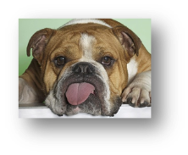
Animal Diseases Group Project
Canine Diseases

- Diseases: Use the internet and/or textbook to research diseases and fill in the following information. Research specified diseases and search for additional diseases until your worksheet is full.

Disease: Parvo Virus  Cause:  Symptoms:  Prevention: | Disease: Bordatella  Cause:  Symptoms:  Prevention:
Disease: Distemper  Cause:  Symptoms:  Prevention: | Disease: Rabies  Cause:  Symptoms:  Prevention:

Disease: Canine Hepatitis  Cause:  Symptoms:  Prevention: | Disease: Corona Virus  Cause:  Symptoms:  Prevention:
Disease: Hip Dysplasia  Cause:  Symptoms:  Prevention: | Disease: Para influenza  Cause:  Symptoms:  Prevention:

Names_____________________________________________________________ Period_________ Date ____________
Animal Diseases Group Project
Feline Diseases

- Diseases: Use the internet and/or textbook to research diseases and fill in the following information. Research specified diseases and search for additional diseases until your worksheet is full.
Disease: Feline Infectious Peritonitis (FIP)  Cause:  Symptoms:  Prevention: | Disease: Feline Immune Deficiency Virus (FIV)  Cause:  Symptoms:  Prevention:
Disease: Feline Leukemia (FELV)  Cause:  Symptoms:  Prevention: | Disease: Rabies  Cause:  Symptoms:  Prevention:

Disease: Feline Infectious Anemia  Cause:  Symptoms:  Prevention: | Disease:  Cause:  Symptoms:  Prevention:
Disease:  Cause:  Symptoms:  Prevention: | Disease:  Cause:  Symptoms:  Prevention:

Names________________________________________________________ Period_________ Date ____________
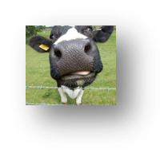

Animal Diseases Group Project
Bovine Diseases

- Diseases: Use the internet and/or textbook to research diseases and fill in the following information. Research specified diseases and search for additional diseases until your worksheet is full.
Disease: Pink Eye  Cause:  Symptoms:  Prevention: | Disease: Camplyobacter  Cause:  Symptoms:  Prevention:
Disease: Leptospirosis  Cause:  Symptoms:  Prevention: | Disease: Bovine Viral Diarrhea (BVD)  Cause:  Symptoms:  Prevention:

Disease: Brucellosis  Cause:  Symptoms:  Prevention: | Disease: Mastitis  Cause:  Symptoms:  Prevention:
Disease: Mad Cow Disease  Cause:  Symptoms:  Prevention: | Disease: Foot & Mouth  Cause:  Symptoms:  Prevention:

Names_____________________________________________________________ Period_________ Date ____________
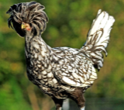
Animal Diseases Group Project
Bird Diseases

- Diseases: Use the internet and/or textbook to research diseases and fill in the following information. Research specified diseases and search for additional diseases until your worksheet is full. This category includes chickens, turkeys, and pet birds such as parakeets, cockatiels, parrots, etc.

Disease: Marek’s Disease Virus (MDV)  Cause:  Symptoms:  Prevention: | Disease: Bird Flu  Cause:  Symptoms:  Prevention:
Disease: Egg Binding  Cause:  Symptoms:  Prevention: | Disease: Parasitic Feather Mites  Cause:  Symptoms:  Prevention:

Disease:  Cause:  Symptoms:  Prevention: | Disease:  Cause:  Symptoms:  Prevention:
Disease:  Cause:  Symptoms:  Prevention: | Disease:  Cause:  Symptoms:  Prevention:

Names_____________________________________________________________ Period_________ Date ____________
Animal Diseases Group Project
Equine Diseases

- Diseases: Use the internet and/or textbook to research diseases and fill in the following information. Research specified diseases and search for additional diseases until your worksheet is full.
Disease: West Nile Virus  Cause:  Symptoms:  Prevention: | Disease: Eastern/Western Influenza  Cause:  Symptoms:  Prevention:
Disease: Rhinotracheitis  Cause:  Symptoms:  Prevention: | Disease: Influenza  Cause:  Symptoms:  Prevention:

Disease: Tetanus  Cause:  Symptoms:  Prevention: | Disease: Strangles  Cause:  Symptoms:  Prevention:
Disease: Equine Infectious Anemia  Cause:  Symptoms:  Prevention: | Disease:  Cause:  Symptoms:  Prevention:

Names_____________________________________________________________ Period_________ Date ____________
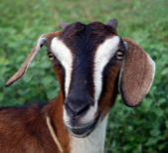
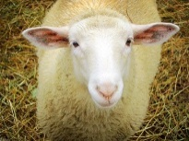
Animal Diseases Group Project
Sheep/Goat Diseases

- Diseases: Use the internet and/or textbook to research diseases and fill in the following information. Research specified diseases and search for additional diseases until your worksheet is full.
Disease: Brucellosis  Cause:  Symptoms:  Prevention: | Disease: Bluetongue  Cause:  Symptoms:  Prevention:
Disease: Chlamydia  Cause:  Symptoms:  Prevention: | Disease: Bloat  Cause:  Symptoms:  Prevention:

Disease: Black Disease  Cause:  Symptoms:  Prevention: | Disease: Nasal Bots  Cause:  Symptoms:  Prevention:
Disease: Scrapies  Cause:  Symptoms:  Prevention: | Disease:  Cause:  Symptoms:  Prevention:

Names_____________________________________________________________ Period_________ Date ____________
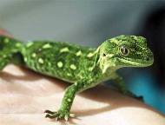
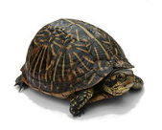
Animal Diseases Group Project
Reptile Diseases

- Diseases: Use the internet and/or textbook to research diseases and fill in the following information. Research specified diseases and search for additional diseases until your worksheet is full. This category includes: lizards, snakes, turtles, frogs, salamanders, & toads.
Disease: Shell Rot (Turtles)  Cause:  Symptoms:  Prevention: | Disease: Egg Binding  Cause:  Symptoms:  Prevention:
Disease: Metabolic Bone Disease (in Reptiles)  Cause:  Symptoms:  Prevention: | Disease: Mouth Rot (Oral inflammation in reptiles)  Cause:  Symptoms:  Prevention:

Disease: Retrovirus (retrovirus)  Cause:  Symptoms:  Prevention: | Disease: Tongue Worm  Cause:  Symptoms:  Prevention:
Disease:  Cause:  Symptoms:  Prevention: | Disease:  Cause:  Symptoms:  Prevention:

Names_____________________________________________________________ Period_________ Date ____________

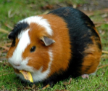
Animal Diseases Group Project
Pocket Pet Diseases

- Diseases: Use the internet and/or textbook to research diseases and fill in the following information. Research specified diseases and search for additional diseases until your worksheet is full. This category includes: Mice, rats, gerbils, hamsters, hedgehogs, chinchillas, & Ferrets.
Disease: Ringworm  Cause:  Symptoms:  Prevention: | Disease: Calcium Deficiency (Guinea Pig)  Cause:  Symptoms:  Prevention:
Disease: Tumors (most common in rats)  Cause:  Symptoms:  Prevention: | Disease: E. Coli (hamsters)  Cause:  Symptoms:  Prevention:

Disease: Mites  Cause:  Symptoms:  Typical Treatments:  Prevention: | Disease:  Cause:  Symptoms:  Typical Treatments:  Prevention:
Disease:  Cause:  Symptoms:  Typical Treatments:  Prevention: | Disease:  Cause:  Symptoms:  Typical Treatments:  Prevention:

Names_____________________________________________________________ Period_________ Date ____________
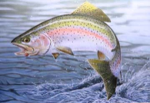
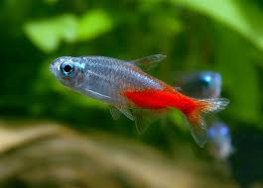
Animal Diseases Group Project
Aquatic Diseases

- Diseases: Use the internet and/or textbook to research diseases and fill in the following information. Research specified diseases and search for additional diseases until your worksheet is full. This category includes: commercial fish (trout, catfish, etc) as well as ornamental fish.
Disease: Whirling Disease  Cause:  Symptoms:  Prevention: | Disease:  Cause:  Symptoms:  Prevention:
Disease:  Cause:  Symptoms:  Prevention: | Disease:  Cause:  Symptoms:  Prevention:

Disease:  Cause:  Symptoms:  Prevention: | Disease:  Cause:  Symptoms:  Prevention:
Disease:  Cause:  Symptoms:  Prevention: | Disease:  Cause:  Symptoms:  Prevention:

Names_____________________________________________________________ Period_________ Date ____________
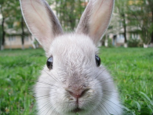
Animal Diseases Group Project
Rabbit Diseases

- Diseases: Use the internet and/or textbook to research diseases and fill in the following information. Research specified diseases and search for additional diseases until your worksheet is full.
Disease: Mites  Cause:  Symptoms:  Prevention: | Disease: Kidney Failure  Cause:  Symptoms:  Prevention:
Disease: Myxoma Virus  Cause:  Symptoms:  Prevention: | Disease: Tooth Rot Abscess  Cause:  Symptoms:  Prevention:

Disease:  Cause:  Symptoms:  Prevention: | Disease:  Cause:  Symptoms:  Prevention:
Disease:  Cause:  Symptoms:  Prevention: | Disease:  Cause:  Symptoms:  Prevention:

