Name________________________________ Period_________ Date_____________

Equine Circulatory System

Directions: Use a red and a blue colored pencil. Color all Veins BLUE, and all Arteries RED. Use PowerPoint slide as a guide. Then answer questions below.

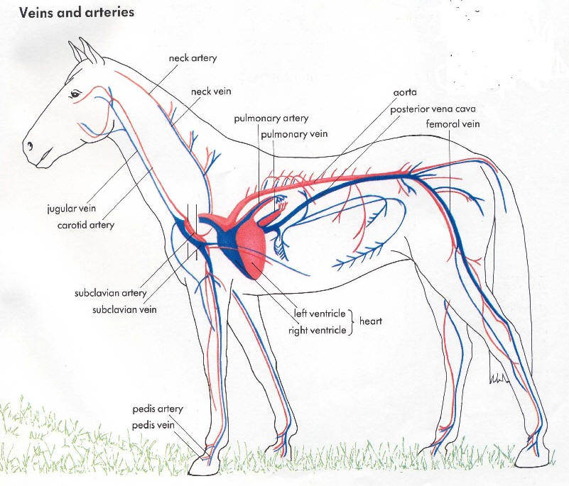
Questions:
- What is known as the “second heart” in a horse? Why?

- Robbie the red blood cell is currently in the left rear hoof of a horse. He’s feeling “blue” and needs to be re oxygenated. Explain his pathway through the ENTIRE circulatory system til he gets back to the hoof again. Use your notes and don’t forget any steps. (Note: the names of the specific veins and arteries are not required)

