Name____________________________________________ Period_________ Date____________

Gesture Drawing Animal Structure

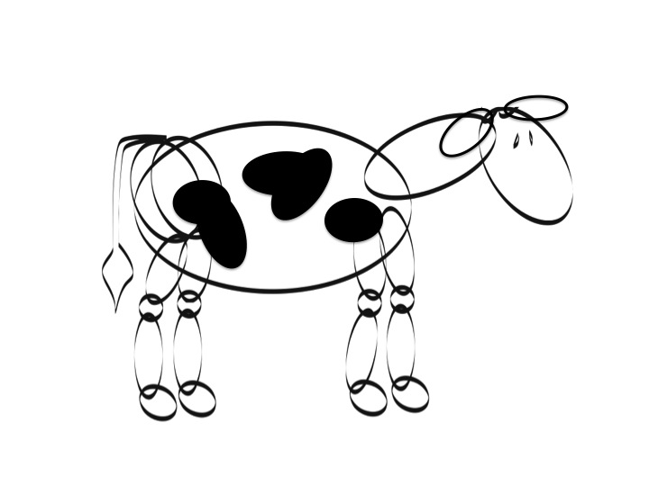
Directions: “Gesture Drawing” is a method of art where you can make drawings with very rapid circles or ovals. It doesn’t include details, just an outline of structure and or poses. No art skills required! Draw the animals below with the specified structural deformity.

Pigeon Toed Horse
(Front Feet)
Splay Footed Lamb
(Front Feet)

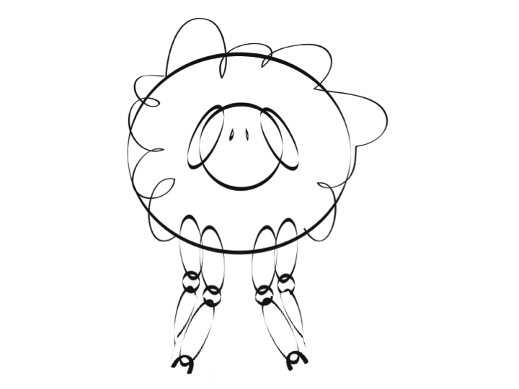

Pig with a Narrow Base
(Front Feet)
Knock Kneed Cow
(Front Feet)

Sickle Hocked Cow
(Rear Legs)
Horse with Correct Structure
(Front Feet)

Horse with Wide Base
(Rear Legs)

Pigeon Toed Pig
(Rear Legs)

Cow Hocked & Splay Footed Lamb
(Rear Legs)

Cow Hocked Cow
(Rear Legs)
Camped Under Horse
(Rear Legs)
Post Legged Pig
(Rear Legs)

