Name____________________________________ Period________ Date_________

**Calculating Rations**

***Directions:*** *Answer the following questions using the feed labels and information listed below.*

**Grow-Power**

IFA GROW-POWER is a pellet feed that is designed to be easily digested for colts, pregnant and lactating mares, breeding stallions and athletic horses.

IFA GROW-POWER contains special yeast cultures to improve digestion.

COLTS: Feed as a supplement for nursing foals at the rate of 1.5 lbs/100lbs. of body weight/day. May be fed to weaned colts at the same rates to supplement good quality hay.

MARES AND STALLIONS: Feed to lactating mares and stallions during the breeding season at the rate of 0.75lbs./100 lbs. of body weight/day or as needed to maintain body condition.

ATHLETIC AND RACE HORSES: Feed at the rate of 1.5 lbs. /100 lbs. of body weight per day for conditioning.

1. How many pounds of “Grow Power” should you feed a colt that weighs 400 lbs?
2. How many pounds of “Grow Power” should you feed a stallion during breeding season that weighs 1100 pounds?
3. How many pounds of “Grow Power” should you feed a race horse that weighs 950 pounds?
4. You are stock contractor feeding your bulls a grain ration designed for performance bulls. You should feed 1% of the bull’s body weight. If the bull weighs 1900 lbs. How many pounds of grain mix should you feed each bull?
5. You are feeding your breeding does a commercial rabbit pellet. 1 doe should consume 5 ounces of pellets per day. How many days will a 50 pound bag last?
6. You are mixing a feed ration for your beef cows. You need to mix a mineral supplement with the feed at a rate of 4 oz per head. You have a herd of 150 cattle. How many pounds of mineral should you feed daily?



**Safe Choice**

1. How many pounds of “Safe Choice” should you feed an 1100 lb mare in the early stages of lactation? Calculate a range according to the scale on the feeding direction.
2. You own a 950 lb performance horse that you are competing in the Reining Cutting Cow Horse Association. The horse is exercised heavily, so you want to feed him the highest, quantity without overfeeding him. How many pounds of “Safe Choice” can you feed daily?

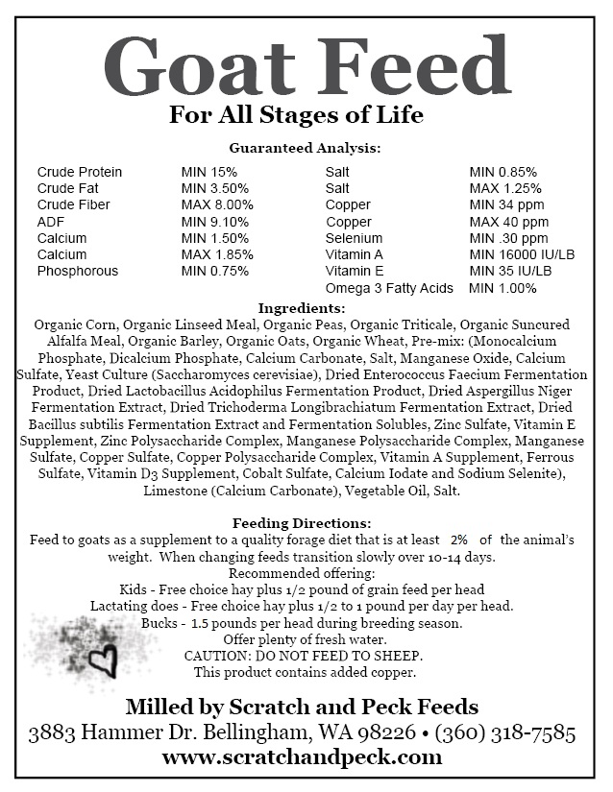

1. Using the feeding directions on the Goat Feed, how many pounds of quality forage should be fed to a 70 lb goat?
2. You have 10 breeding bucks. A 50-pound bag of “Goat Feed” costs $18.70. Calculate 1 month’s feed bill if you feed according to the recommended offering for bucks.