LABORATORY EXERCISE #2--WHAT FACTORS AFFECT RESPIRATION?

Name_________________________________________ Score_____________________________

Selection from Modern Biology, Biology Investigations, Teacher's Edition, by James H. Otto, Albert Towle, W. David Otto, and Myra E. Madnick. Copyright 1977 by Holt, Rinehart and Winston, Inc. Reprinted by permission of the publisher.

Materials needed

Anacharis 2 thermos bottles
8 test tubes 2 gas bottles
2 test tube racks Thermometer
Graduated cylinder Rubber tubing
Brom thymol blue 2 two-hole stoppers to fit thermos bottles
Ammonium hydroxide 2 one-hole stoppers to fit gas bottle
Aquarium water 4 pieces of glass tubing
Fresh apple cider
Dry yeast

Part I: Production of Carbon Dioxide by Anacharis

Plant cells as well as animal cells respire. In this investigation, you will demonstrate that carbon dioxide and energy are produced during respiration.

In this part, you will demonstrate that plants respire by testing for the presence of carbon dioxide.

Brom thymol blue is blue in an alkaline environment, but turns yellow in an acid environment. Carbon dioxide in the presence of water forms a weak acid.

Prepare a solution containing 50 ml of aquarium water and 20 ml of brom thymol solution. Fill 8 test tubes to within 3 cm of the top with this solution. Add a sprig of Anacharis to 4 of the test tubes.

a. Why did you leave 4 test tubes without Anacharis

Place 2 test tubes with the Anacharis and 2 without plants in the dark. Put the other test tubes in bright sunlight. Observe the tubes the next day.

b. Which of the tubes showed a change in color?

c. Why did this happen?

d. What process has taken place?

Part II: Energy Release During Respiration

In this part, you will use the process of fermentation. Fermentation is a type of respiration in which glucose is oxidized and carbon dioxide and ethyl alcohol are formed. You will determine how much energy is released as heat during this process.

Fill a thermos bottle two thirds full with fresh apple cider. Add 2 g of dried yeast. Insert a piece of glass tubing, as shown below, into one of the holes of a two-hole stopper. Then insert a thermometer into the apple cider when the stopper is placed in the thermos bottle. Fill a gas bottle one half full of brom thymol blue. Now put the stopper in the thermos bottle and insert the long end of the glass tubing into the one-hole stopper of the gas bottle, as shown. Identify this thermos bottle as the experimental bottle. As a control, set up a similar apparatus but omit the yeast. Observe the experiment carefully. Record the temperature of both the experimental and control bottles at the beginning and at 24-hour intervals for 3 days.

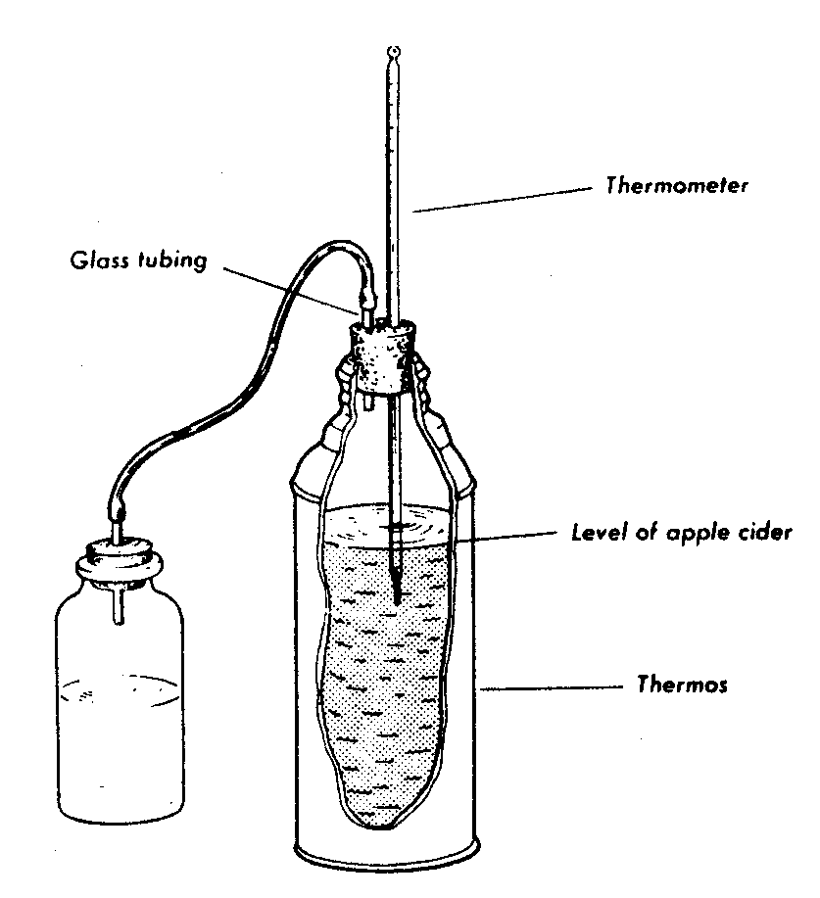

a. Was energy produced in either of the thermos bottles?

b. If so, why did this occur?

c. Describe the contents of both bottles.

d. Did you notice any change in the gas bottle?

e. If so, why was there a change?

f. Was there any product other than carbon dioxide produced during fermentation?
g. What type of respiration is being performed by the yeast cells?

Fill in the table with your data.

 | Temperature
Thermos Bottle | Start | 24 hours | 48 hours | 72 hours
Control
Experimental

Part III: Summary

a. What evidence did you find that respiration occurs in Anacharis?

b. Why must a control be used in the Anacharis-respiration investigation?

c. Why did fermentation take place in one thermos and not in the other

d. How can you prove that a product other than carbon dioxide is produced during fermentation?

Part IV: Investigations On Your Own

- You may be interested in finding out whether germination seeds release carbon dioxide. To do this, soak some seeds (wheat, corn, peas) in 5% formalin solution for about 20 minutes. Wash the seeds in cold water and soak overnight. Fill a gas bottle one third full with the seeds. Fill a

second bottle about one third full with brom thymol blue. Use a U-tube to connect the two gas bottles. Set up a similar apparatus as a control. However, destroy the seeds in the control by soaking them in 10% formalin for an hour. Observe what occurs in the demonstration bottle and in the control. Draw conclusions from your observations.

- Design an original experiment that involves the influence of different foods on yeast respiration rates. Draw conclusions from your observations.

