Name\_\_\_\_\_\_\_\_\_\_\_\_\_\_\_\_\_\_\_\_\_\_\_\_\_\_\_\_\_\_ Period\_\_\_\_\_\_\_ Binder Page #\_\_\_\_\_\_\_\_\_\_\_

**Pinching Notes and Lab Sheet**

Pinching =

Why do we pinch plants?

C:\Documents and Settings\Andrea Clark\Local Settings\Temporary Internet Files\Content.IE5\HXHVIEVO\MCNA00031_0000[1].wmfC:\Documents and Settings\Andrea Clark\Local Settings\Temporary Internet Files\Content.IE5\O4EURBCX\MCNA00016_0000[1].wmf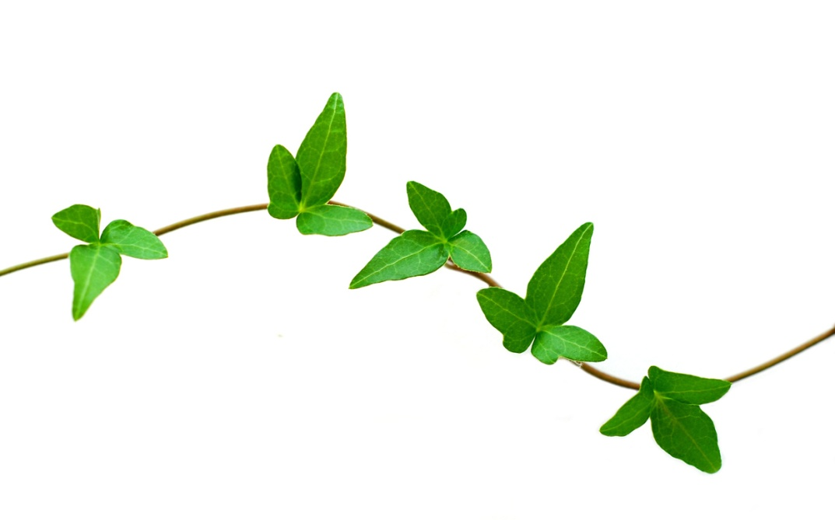Practice:

Now draw what the plant will look like as it continues growing:

How to pinch Poinsettias:

1. Count \_\_\_\_\_\_\_\_\_\_\_\_\_\_\_\_\_ leaves from the bottom and carefully pinch the top of the plant off

-Only count the\_\_\_\_\_\_\_\_\_\_\_\_\_\_\_\_\_\_ and \_\_\_\_\_\_\_\_\_\_\_\_\_\_\_\_\_\_\_\_green leaves