PLANT ANATOMY, GROWTH AND DEVELOPMENT

LABORATORY EXERCISE #4--HOW MONOCOT STEMS DIFFER FROM DICOT STEMS

Name__________________________________________ Score_____________________________

Selection from Modern Biology, Biology Investigations, Teacher's Edition, by James H. Otto, Albert Towle, W. David Otto, and Myra E. Madnick. Copyright 1977 by Holt, Rinehart and Winston, Inc. Reprinted by permission of the publisher.

Materials needed

Cross section of a woody dicot stem, 10-15 years old or older
Prepared slide of: herbaceous monocot stem (Zea mays)
Textbook or charts
Microscope

Part I: Microscopic Examination of a Woody Dicot Stem

Dicot stems can be both herbaceous and woody. Herbaceous dicot stems usually live for only a single growing season. When compared to a year old woody stem, close similarities may be observed in the tissues which compose the stem. In this part, you will examine only a woody dicot stem.

Examine the cross section of a woody stem. You commonly hear the terms bark and wood.ÿ

a. Where is the bark located?

b. Where is the wood in relation to the bark?

c. What tissue occupies the center of the stem?

d. Summarize the tissues that can be observed in a cross section of a woody stem.

Bark and wood are both composed of specialized tissues which can only be observed with a microscope. Without the microscope, it can be seen that bark is divided into the outer bark and inner bark. The outer bark is composed of cork tissue.

e. What are some functions of the cork?

f. What tissue composes the inner bark?

g. What is the function of the phloem?

h. Although you are unable to see it, what layer of cells separates the bark from the wood?

i. What is the function of the vascular cambium?

j. What tissue composes wood?

k. Estimate the amount of wood in proportion to the amount of bark.

l. What evidence is there that the stem has lived for more than a single growing season?

m. What are these rings commonly called?

n. Are all of the rings of equal thickness?

o. Account for your answer.

p. What is the function of the xylem?

In the chart below, summarize your observations of the woody dicot stem. Give the function of the tissue where it applies.

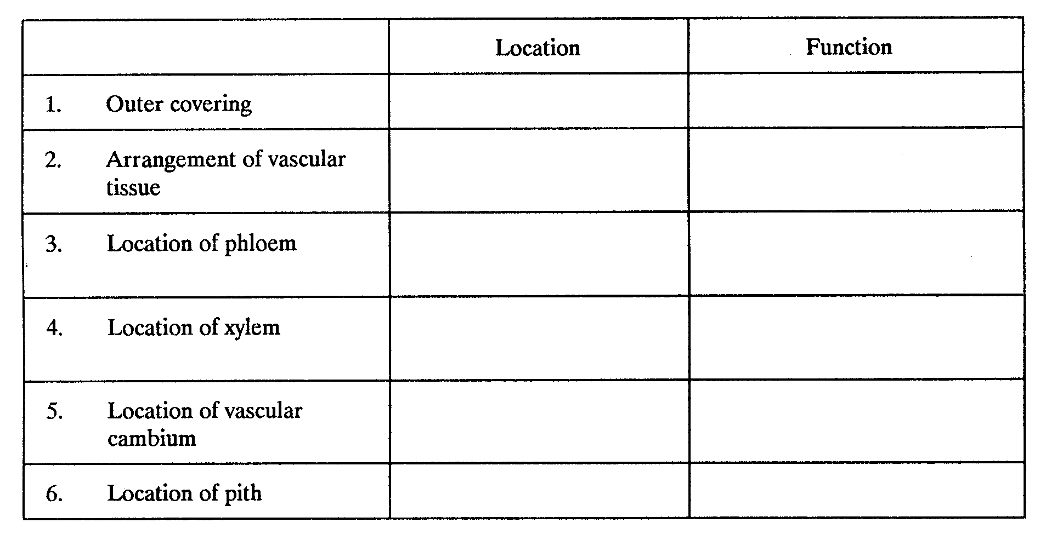
On the figure of the cross section of a woody stem, label: cork tissue, phloem, bark, vascular cambium, xylem tissue, wood, pith, annual ring.

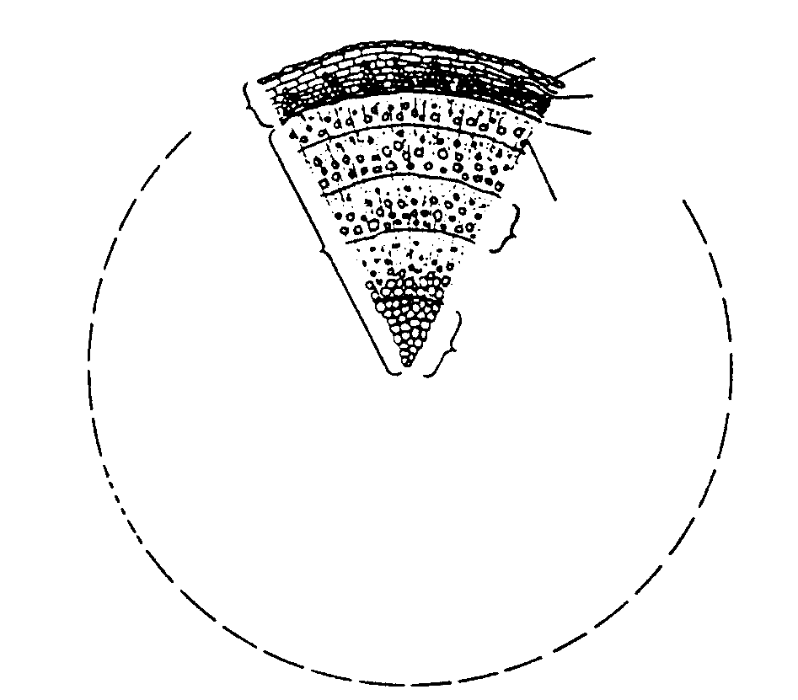
Part II: Examination of a Monocot Stem

Examine the prepared slide of a cross section of the monocot stem with your microscope under low power. The outer layer of cells is the epidermis.

a. Describe the appearance of these cells

Note that just under the epidermis are additional thick-walled cells. These cells, along with those of the epidermis, compose the rind of the mature stem.

b. What tissue occupies most of the stem?

c. Describe the cells which compose this tissue.

Look for the fibrovascular bundles. Count the bundles in an estimated quarter of the stem.

d. How many do you find?

e. Where in the stem are they most numerous?

Of what significance is this observation?

Select a fibrovascular bundle toward the center of the stem. Examine it under high power. Note that the bundle has the appearance of a face with distinct facial regions. Large xylem vessels are found in the position of the "eyes" and "nose" of the face. The phloem occupies the position of the forehead. Locate and distinguish the sieve tubes and companion cells, which compose the phloem.
g. Is a vascular cambium present?

h. What effect does its presence or absence have on a monocot stem?

Locate the thick-walled schlerenchyma fibers surrounding the bundle.

i. What function might they serve?____________________________________________________

The position of the "mouth" is an irregular intercellular space.

j. What can you observe to confirm that it is a space and not a large cell?

k. Suggest how this space might be formed.

On the general view of the corn stem, label: epidermis, rind, pith, fibrovascular bundle. On the figure of the fibrovascular bundle and surrounding tissue, label: xylem vessels, phloem, intercellular space, pith, schlerenchyma fibers.

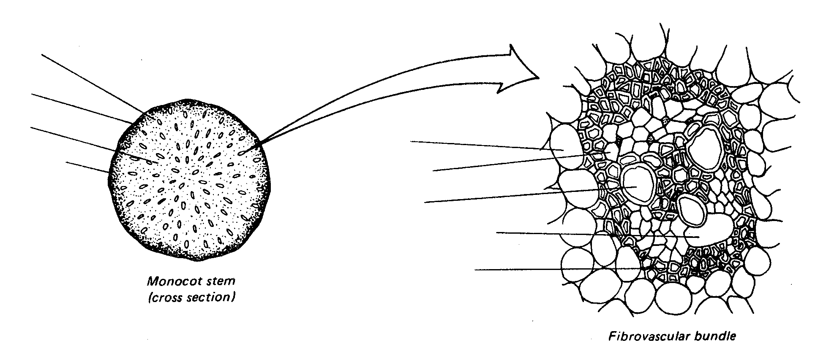

Part III: Summary

In the chart on the following page, summarize the differences and similarities between monocot and dicot stems you have observed and studied.

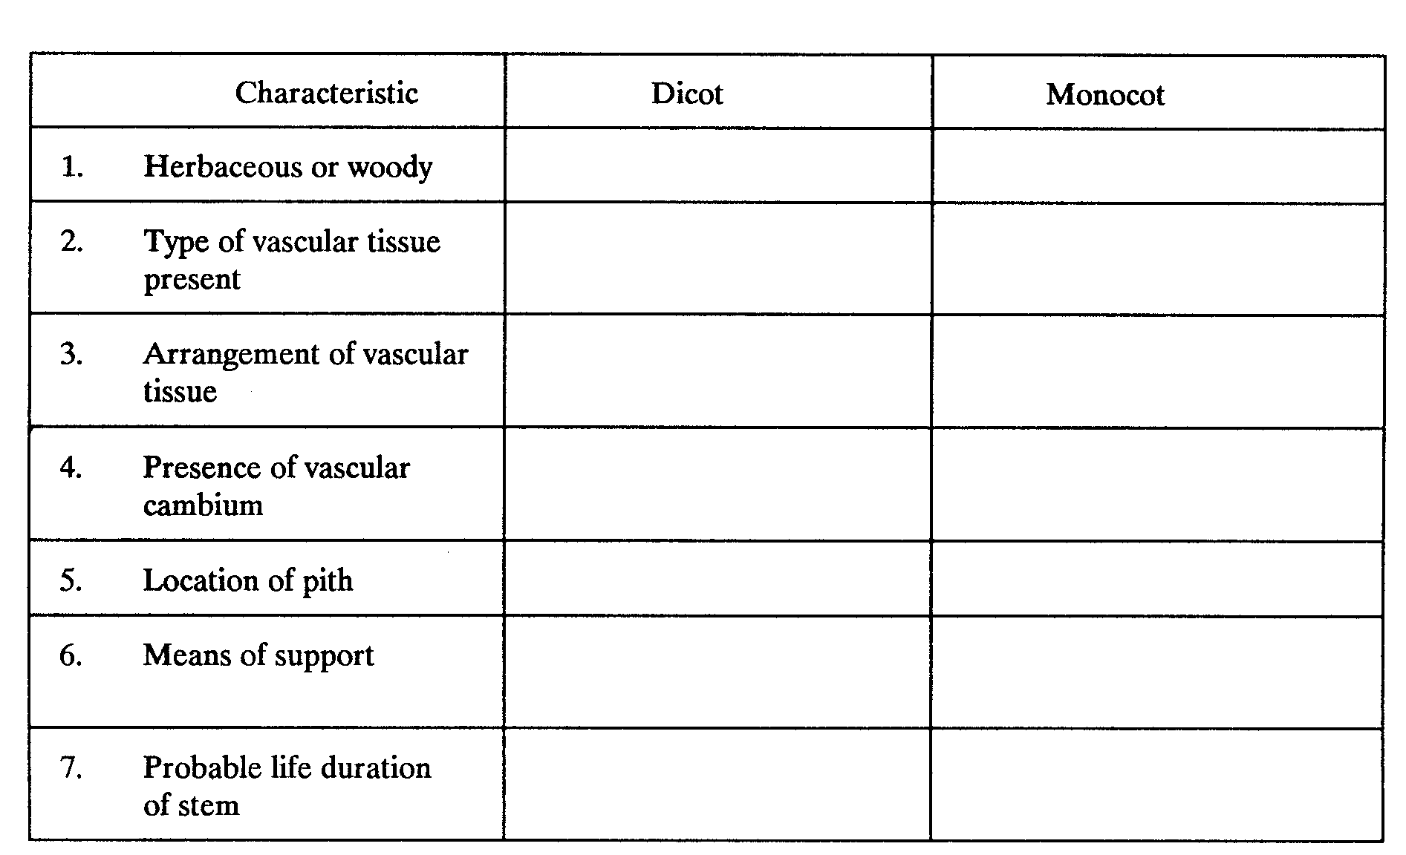

Part IV: Investigations On Your Own

1. Obtain a prepared slide of a 3-year dicot stem (Tilia) and examine it under the microscope. You should observe that the tissues in a woody stem are much more complex than what you observe with the naked eye. Consult a biology or botany textbook for descriptions of the cells which compose the outer and inner bark and the xylem. Make a detailed sketch of a pie-shaped section and label the cells and tissues which you observe.

2. Examine a prepared slide of an herbaceous dicot stem (Helianthus) and locate the tissues studied in the woody dicot stem. Note the similarities and differences. Make a detailed sketch of a pie-shaped section and label the cells and tissues you observe.

3. Make a collection of cross sections of woody stems 3-4 cm in thickness and 5-8 cm in diameter. Identify each with its scientific and family name. The sanding and sealing of the cross sections will help to preserve them for future use.

Answers to Lab 4
Lab #4:

Part I:

a. On the outside of the stem.
b. To the inside of the bark.
c. Pith
d. Bark, wood and pith.
e. Cork resists the passage of water and gases from stem tissues, offers protection against disease and provides insulation.
f. Phloem
g. To conduct food materials up and down the stem.
h. The vascular cambium.
i. The cells of the cambium divide to produce phloem cells and xylem cells.
j. Xylem
k. Answer will vary depending on the age of the stem.
l. The wood is produced in rings. Each ring represents a year's growth.
m. Annual rings.
n. No
o. Environmental factors affect the amount of wood produced each season by the cambium.
p. Conduction and support.

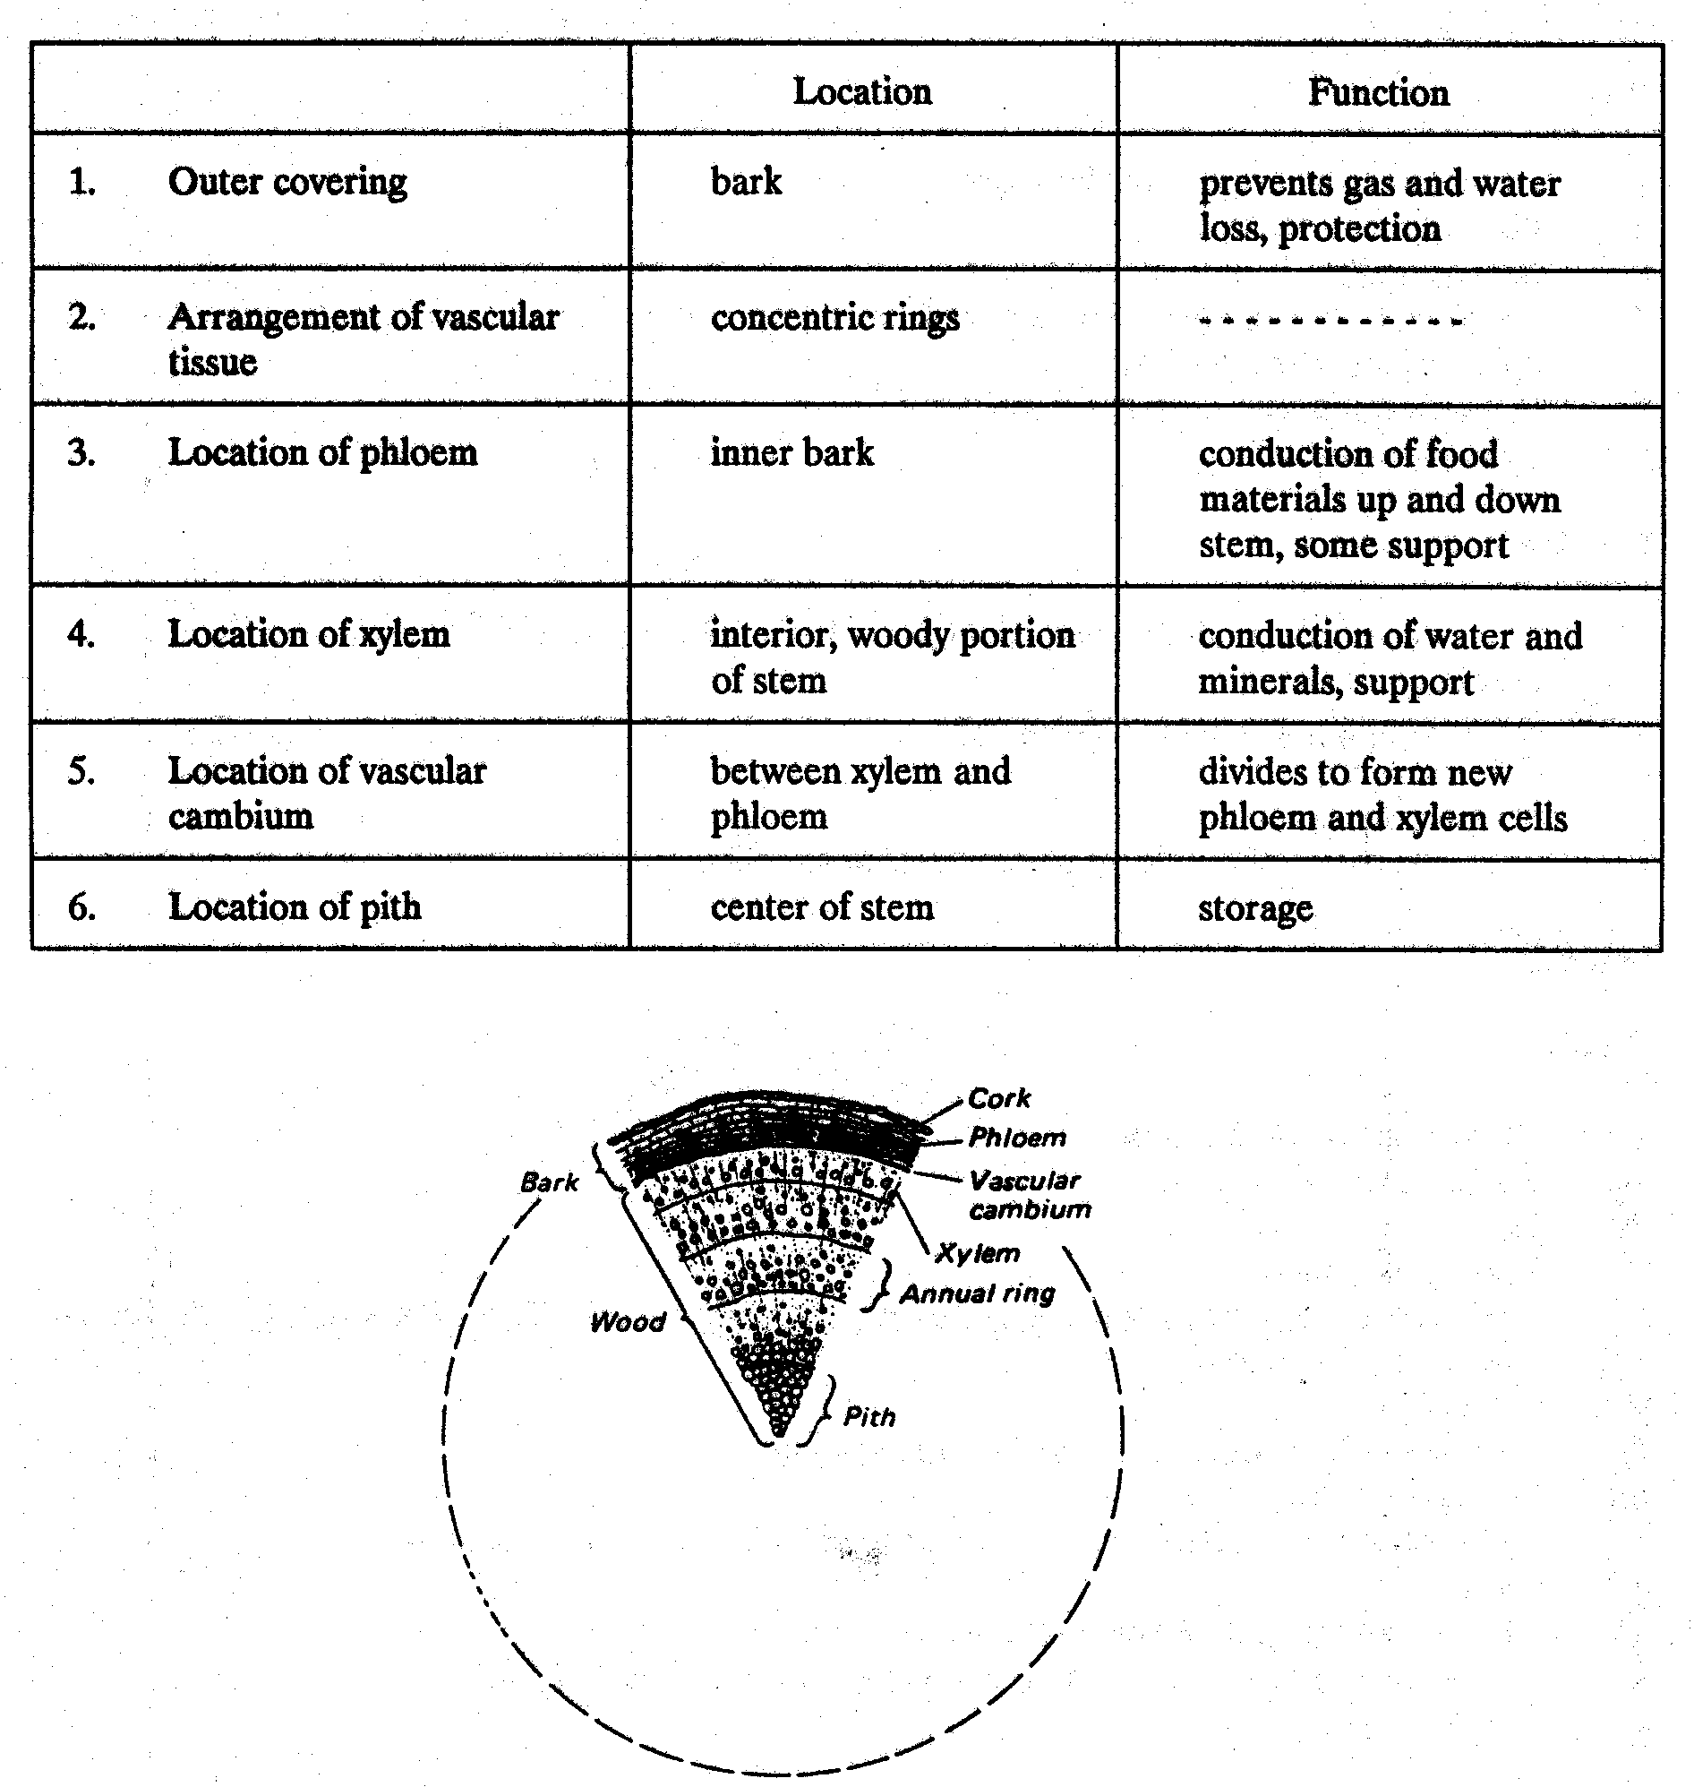

Part II:

a. The cells are thick walled.
b. Pith
c. Thin-walled, large cells.
d. Answers will vary.
e. Toward the outside of the stem.
f. The bundles toward the outside give strength to the stem.
g. No
h. Monocots can grow in diameter only until their cells have reached a maximum size.
i. Support
j. The cells surrounding the space have their own cell walls.
k. As the bundle matures, the cells that were once in contact are pulled apart from each other.

