PLANT ANATOMY, GROWTH AND DEVELOPMENT

LABORATORY EXERCISE #5--EXAMINING ROOTS AND STEMS

Name_______________________________________ Score___________________________

Slesnick, Irwin L., Biology Laboratory Manual, Scott, Foresman and Company, 1985. Reprinted by permission of Scott, Foresman and Company.

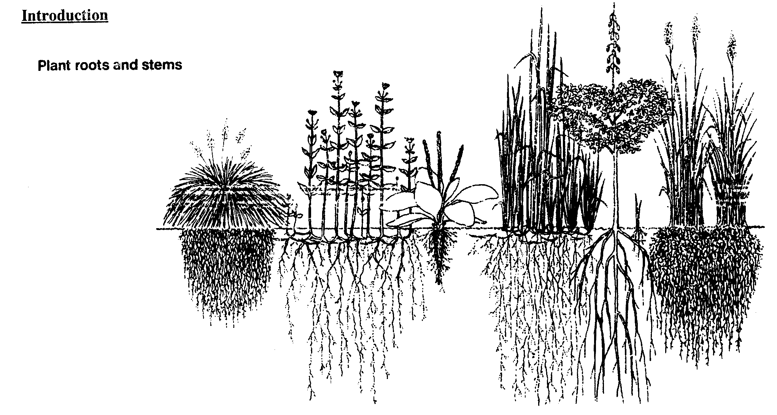
Look at any plant: a tree growing in a field; grass covering a lawn; a rosebush blooming in a garden. You are really seeing only half of the plant. The roots underground make up the other half of the plant. Roots, such as those in the pictures above, perform several important functions for a plant. They anchor the plant in the soil, absorb water necessary for life and growth, and store food and transport it to the rest of the plant.

Locate the stems in the plant pictures above. Plant stems are often among the most conspicuous parts of a plant. Aside from supporting the plant, the stem also transports substances to and from the leaves, stores food, and in some plants, manufactures food. In this laboratory you will examine the tissues that make up roots and stems. By studying root and stem tissues you will learn how the structures in roots and stems contribute to the healthy functioning of the plant.

Materials needed:

Sprouted radish seed Colored pencils
Hand lens or stereoscopic microscope Prepared slides of longitudinal and transverse
Metric ruler cross sections of a root tip, root and
Compound microscope herbaceous monocot and dicot stems
Twig
Scalpel

Part I: Examining Roots

1. Use a hand lens or stereoscopic microscopic to examine the sprout of a radish seed. Notice the region on which root hairs first begin to grow. Locate the longest root hairs. On the cross section in a, draw the root hairs showing where they first appear and where the longest root hairs are located. You may wish to add a scale in mm next to your drawing to indicate the length of the region where root hairs appear.

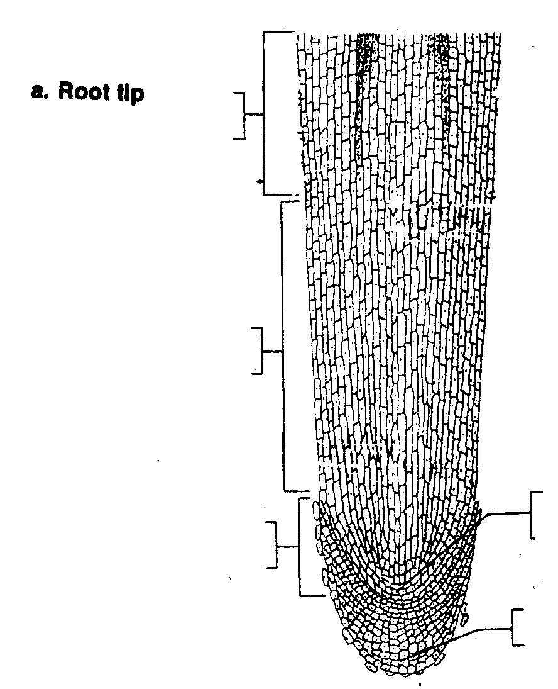

2. Obtain a prepared slide of a longitudinal cross section of a root tip, and examine it under low and high power. Locate root hairs growing off the side of the root tip. Find the three regions of root growth: the region of cell division, the region of elongation and the region of maturation. The root cap is made of larger cells at the very tip of the root. The region of cell division, above the root cap, is made of smaller, dividing cells called the apical meristem. Just above the apical meristem, find the lengthening cells that make up the region of elongation. Above this region, in the region of maturation, cells begin to differentiate into specialized tissues. In this region you will begin to notice root hairs. Identify and label the regions in a, above.

3. Examine a prepared slide of a transverse cross section of the mature region of a root. Find the single layer of epidermal cells that protects the root surface. Locate the parenchyma cells that make up the cortex. These cells may have been stained with iodine, which turns blue in the presence of starch stored in the cortex cells. Notice that cells are very loosely packed to allow water absorbed by root hair to flow to the inner tissues of the roots. The endodermis, surrounding the vascular cylinder, is the next layer in from the cortex. The thick, waxy cell walls of endodermal cells control the passage of dissolved materials into the vascular tissues. Thus, the endodermis prevents the entrance of harmful substances that might be absorbed by the root hairs and dispersed to the rest of the plant. Find the vascular tissues that form a column called the vascular cylinder at the center of the root. Locate the pericycle layer, just inside the endodermis. Root branches form from pericycle tissue. Inside the pericycle, xylem is arranged in the form of a "+." Note the thick walls of the xylem cells. The phloem cells are in circular patches between the arms of the plus-shaped xylem columns. Compare the thickness of the phloem cell walls to that of the xylem cell walls. Label the structures of the root in b on the following page.

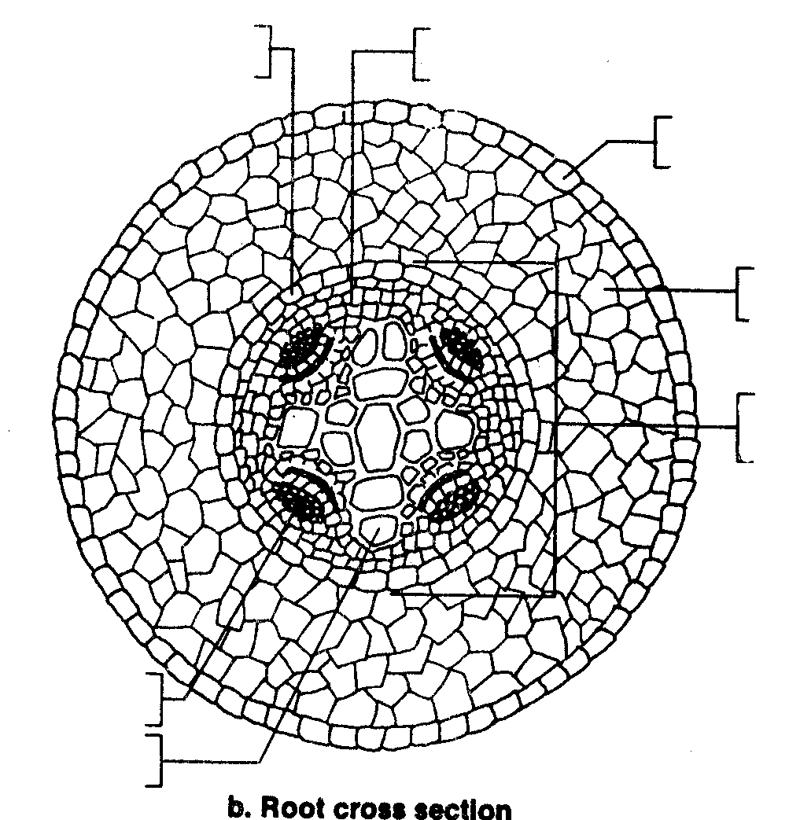

Part II: Examining Stems

1. Obtain a twig from a woody plant. Note that almost all woody plants are dicots. Observe the places where a leaf was attached to the twig. These marks are called leaf scars. Notice the tiny row of dots, arranged in a "v" on the leaf scar. These bundle scars indicate where the xylem and phloem entered the leaf stalk. Find the tiny holes in the surface of the bark. These structures--the lenticels--allow water vapor and other gases to be exchanged through the stem. Examine the terminal bud, at the end of the twig. The length of a growing twig is determined by how fast the terminal bud grows. Examine the bud scales that cover a bud. The scales fall off after they have served their protective function, leaving concentric scars around the twig. Find these budscale scars that mark the end of the twig's yearly growing season. Notice the lateral buds on the side of the twig. Growth of these buds results in new branches, leaves, and flowers. Label the structures shown on diagram c.
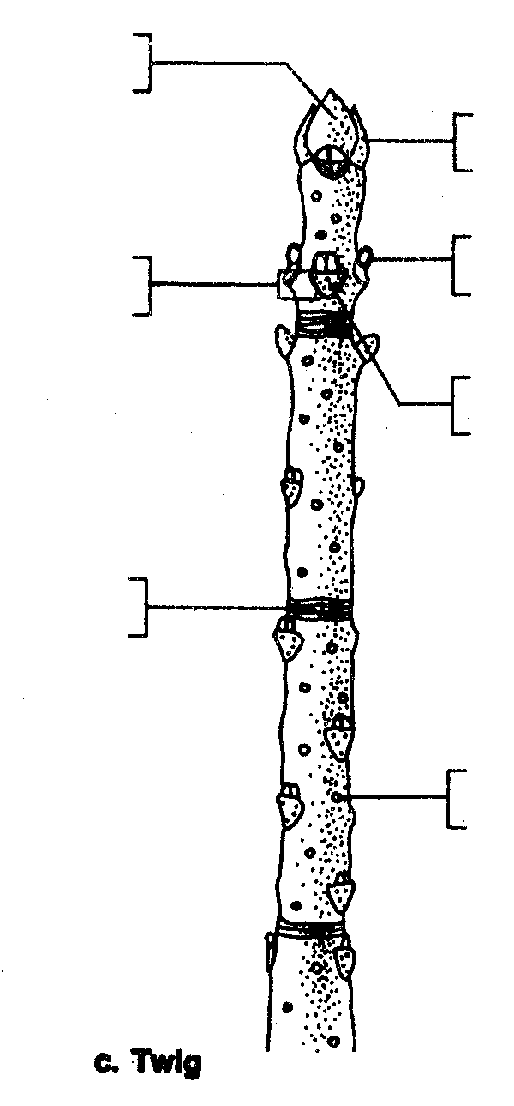
2. Use a scalpel to make a longitudinal cut through the terminal bud. Examine the cut bud with a hand lens. Notice the tiny growing leaves and the green tissue in the lower central portion of the bud. This tissue--the shoot apex--is meristem tissue responsible for the growth in height of the stem.

- Make a transverse cross section of your twig with a scalpel. CAUTION: Use the sharp blade of your cutting instrument carefully to avoid injury. Always cut away from yourself. Use a hand lens to locate the large cells of the light-colored pith at the center of the stem. Rings of xylem make up the wood, the bulk of the stem. Xylem cells that make up spring wood are large and have thin walls. Summer wood is made of smaller, thick-walled xylem cells. The darker-looking summer wood makes a band that contrasts with the lighter spring wood. The contrast in the color of the bands of spring and summer wood can help you determine the age of the twig. Together these bands of different colored xylem cells make up an annual ring. Locate the thin layer of vascular cambium surrounding the outermost xylem cells. The inner layers of cambium become new xylem cells and the outer layers become new phloem cells. Tightly packed phloem cells are arranged in half-moon shapes outside the vascular cambium. Larger parenchyma cells make up the cortex. These cells store starch for the plant. The outermost layers are made of thick, tough, waterproof cells, called cork, that protect the inner tissues. You may notice vascular rays, channels that conduct materials between the different tissues. Label the tissues and structures in d:

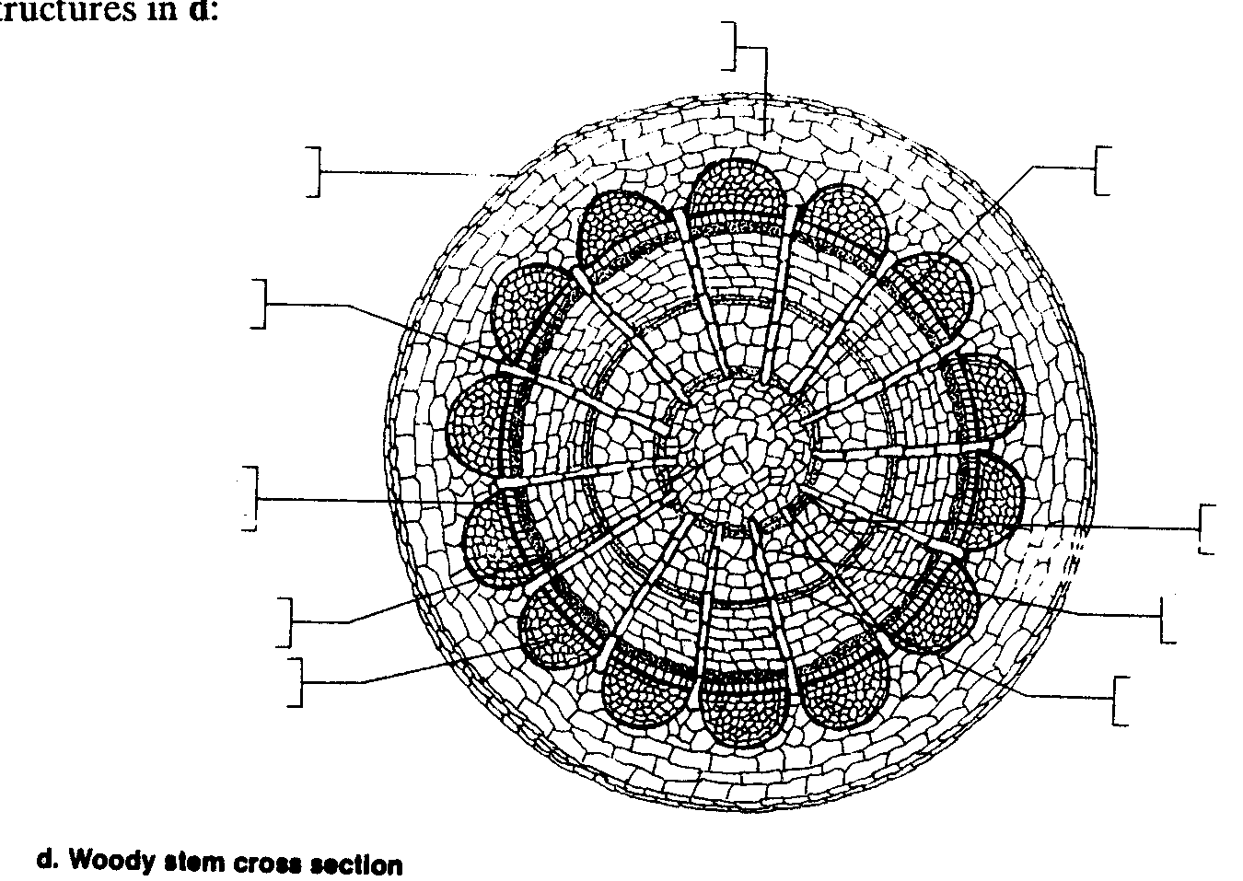

4. Nonwoody--or herbaceous--stems are present in both monocots and dicots. Obtain prepared slides of transverse cross sections of herbaceous monocot and dicot stems. Examine these slides under low power. Locate the epidermis, the outermost layer of the stem tissue. Draw the epidermis on the stem outlines, e and f, on the following page. Notice the vascular bundles contain phloem cells, which may be stained green, and xylem cells, which may be stained red. In dicots, a thin layer of vascular cambium may be located between the xylem and phloem. Compare the arrangement of vascular bundles in the monocot and dicot stems. Sketch the pattern of vascular bundles in the outlines of the monocot and dicot stem. Observe the large food-storing parenchyma cells around the vascular bundles. In the dicot stem these cells make up the cortex to the outside of the vascular bundles; the region of parenchyma cells to the inside of the vascular bundles is called pith. In a monocot stem parenchyma cells are referred to as pith in all regions of the stem. Draw the regions of parenchyma cells, and label the regions in both the monocot and dicot stems. Find the green-colored chloroplasts, and sketch these in your stem drawings.

e. Monocot Stem f. Dicot Stem

Part III: Analysis

1. Complete the table below by checking those tissues that are present in a root, woody dicot stem, herbaceous monocot stem and herbaceous dicot stem. Also, give the function of each tissue.

Table. Structures of roots and stems

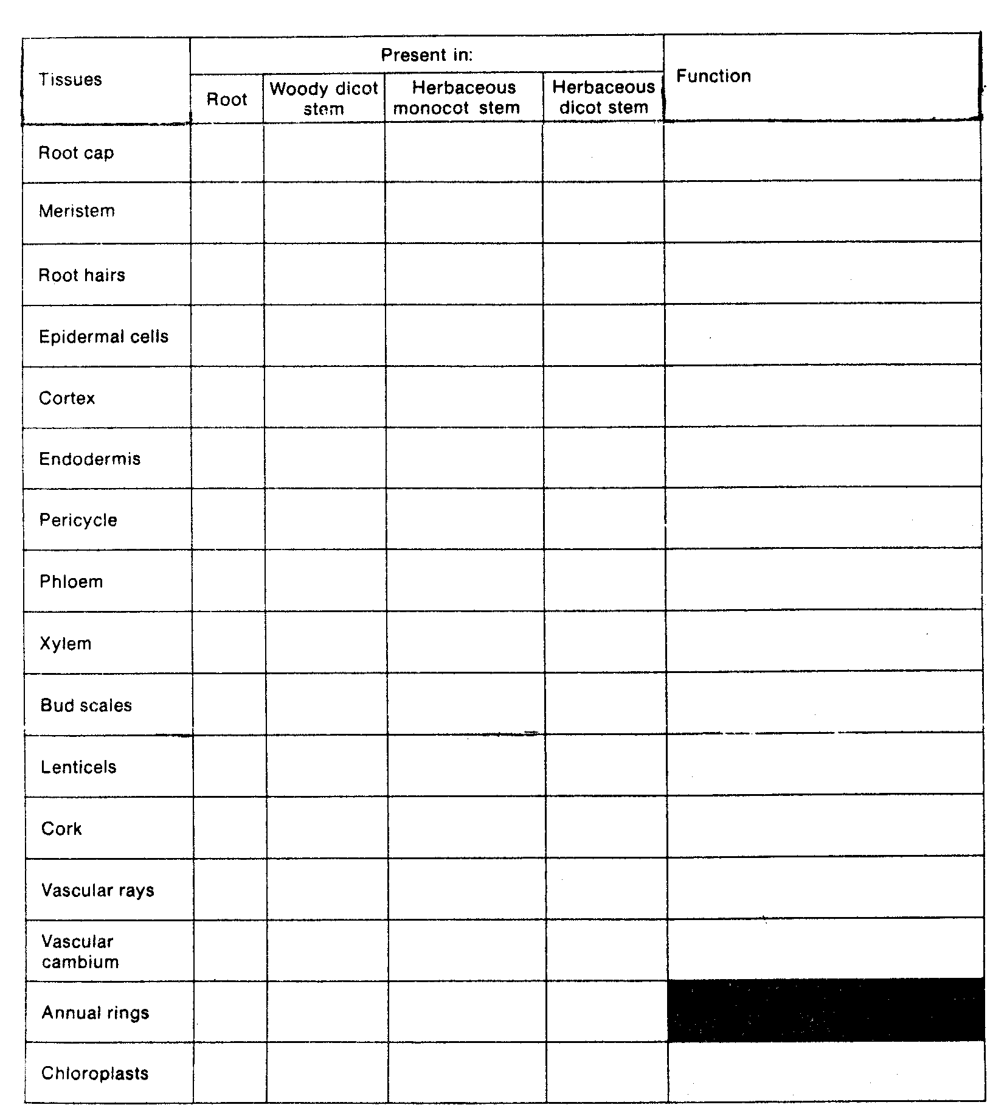
2. Name four tissues common to both roots and stems. What are the main functions that these tissues serve?

3. Name one tissue unique to roots and one tissue unique to stems.

Roots:

Stems:

4. Give a reason why root hairs only appear above a certain point on a root. What does the location of root hairs on the root tell you about the way that the root grows?

5. How does the pattern of growth of woody dicot stems enable you to determine the age of the stem?

6. Describe the major difference between the structure of monocot and dicot stems. How does this difference affect the growth of the stem?

7. Imagine you find a scar on the side of a maple tree 2 m above the ground. If the tree grows 4 m in the next 10 years, at what height would you then find the scar? What does this tell you about the way the tree grows?

Part IV: Going Further

Make your own transverse and longitudinal cross sections of a root, such as a radish sprout or a carrot. Cut very thin slices of the root so that light will be able to pass through the slices when you look at them under a microscope. Stain the root slices with iodine. CAUTION: Avoid getting iodine on your hands. It stains and is poisonous if ingested. Cut away from yourself. Locate the different kinds of cells and tissues that make up the root.

Answers to Lab #5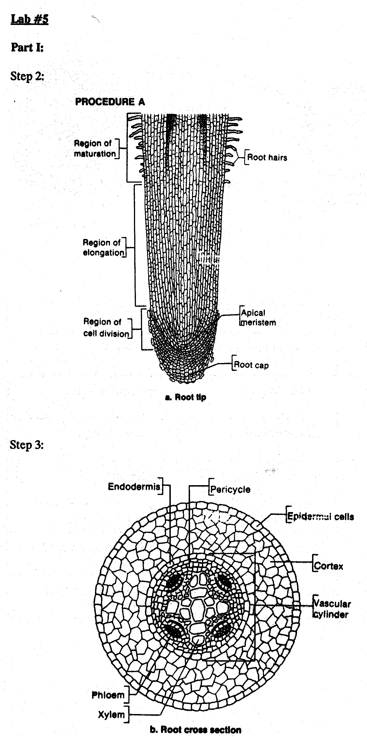
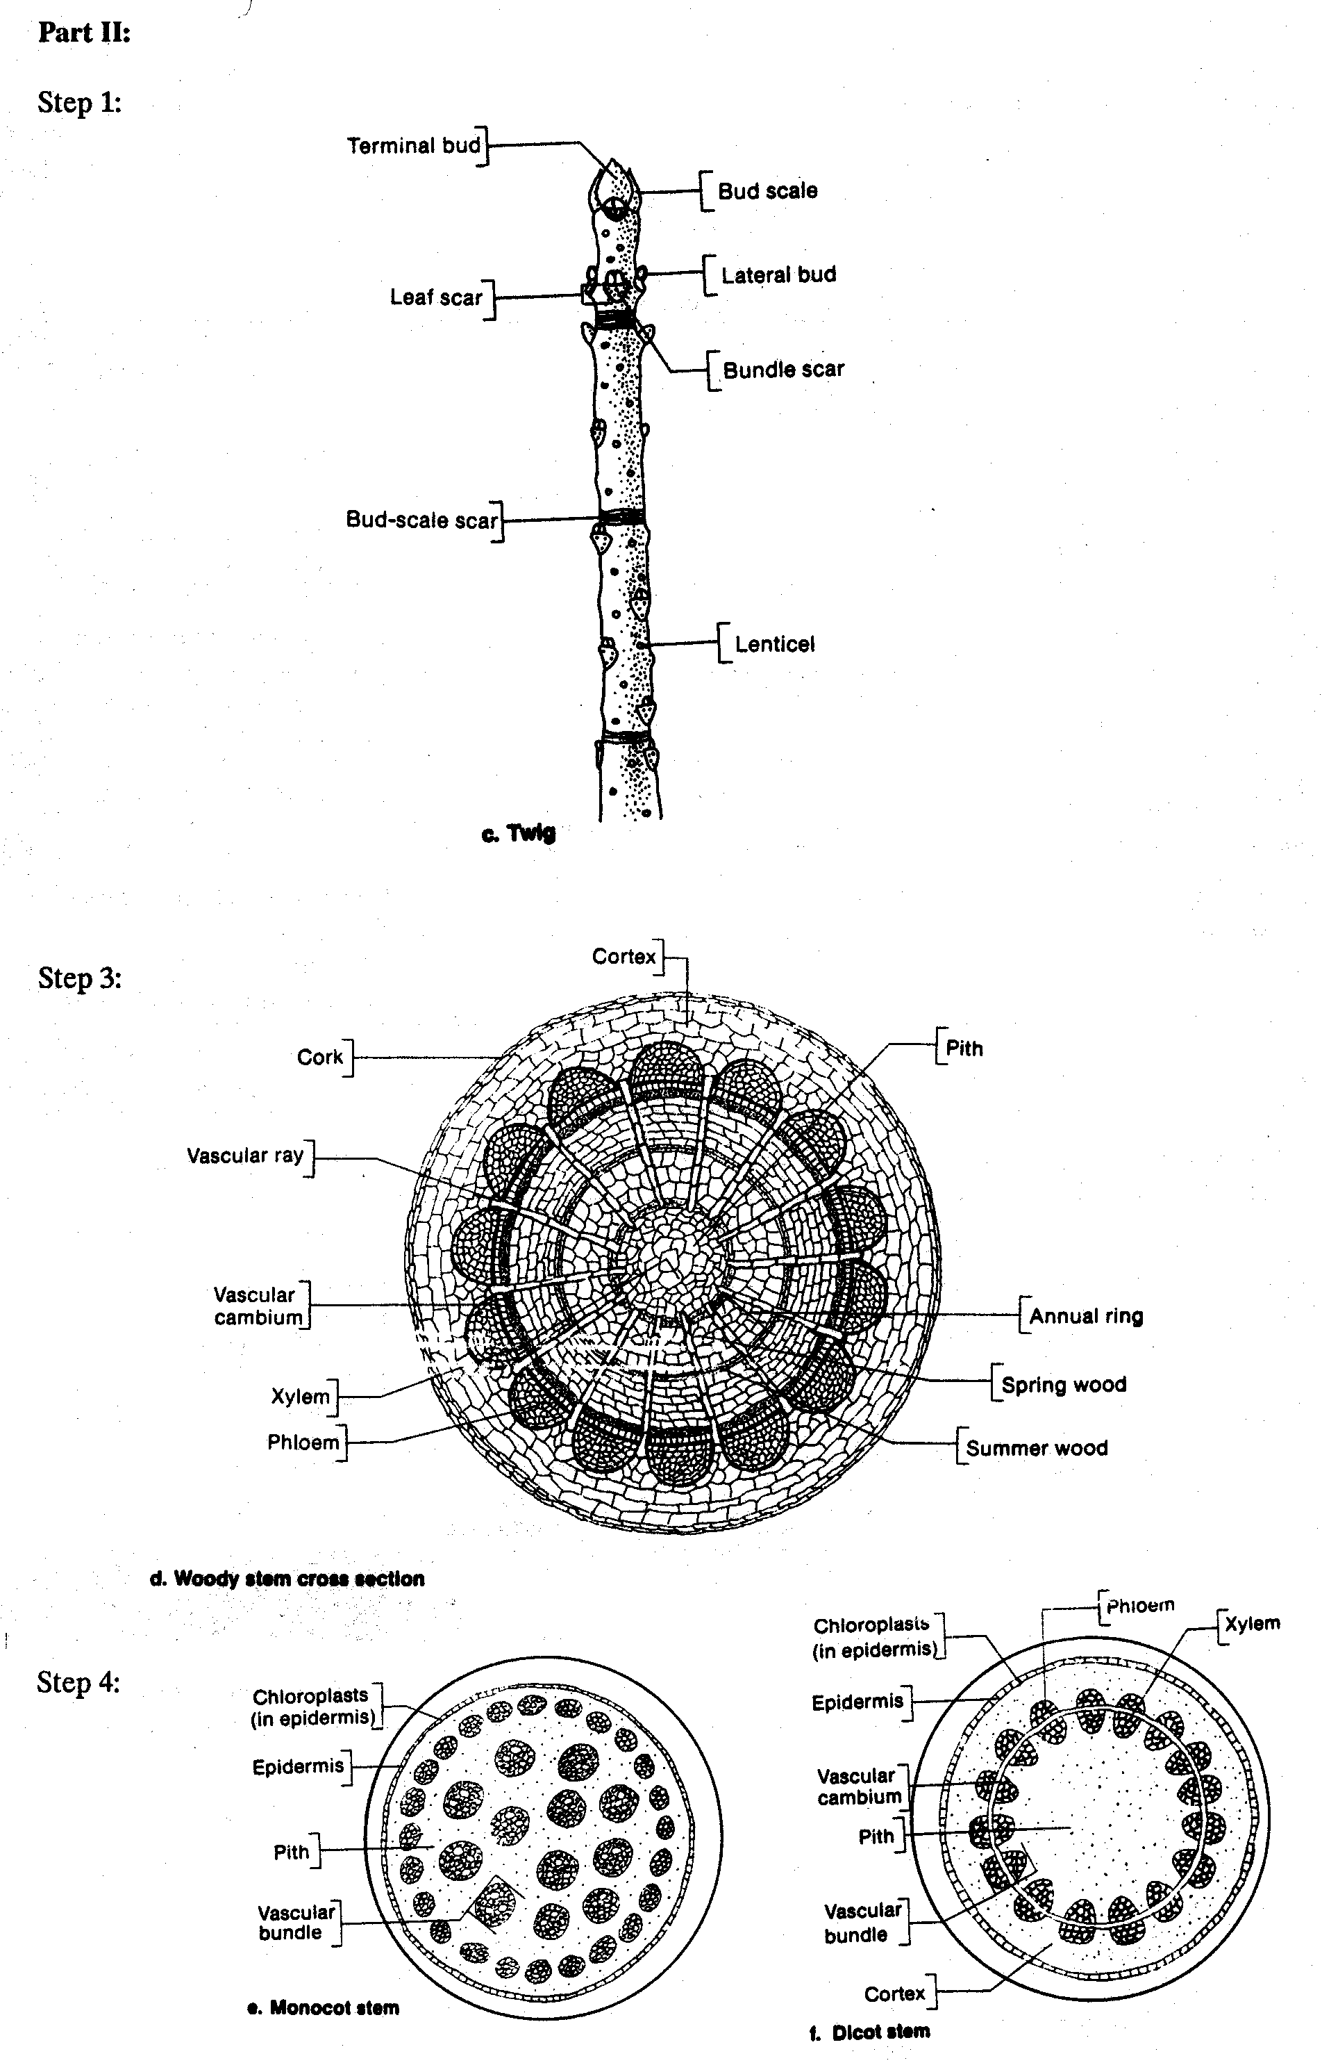
Part III:

Table: Structures of roots and stems

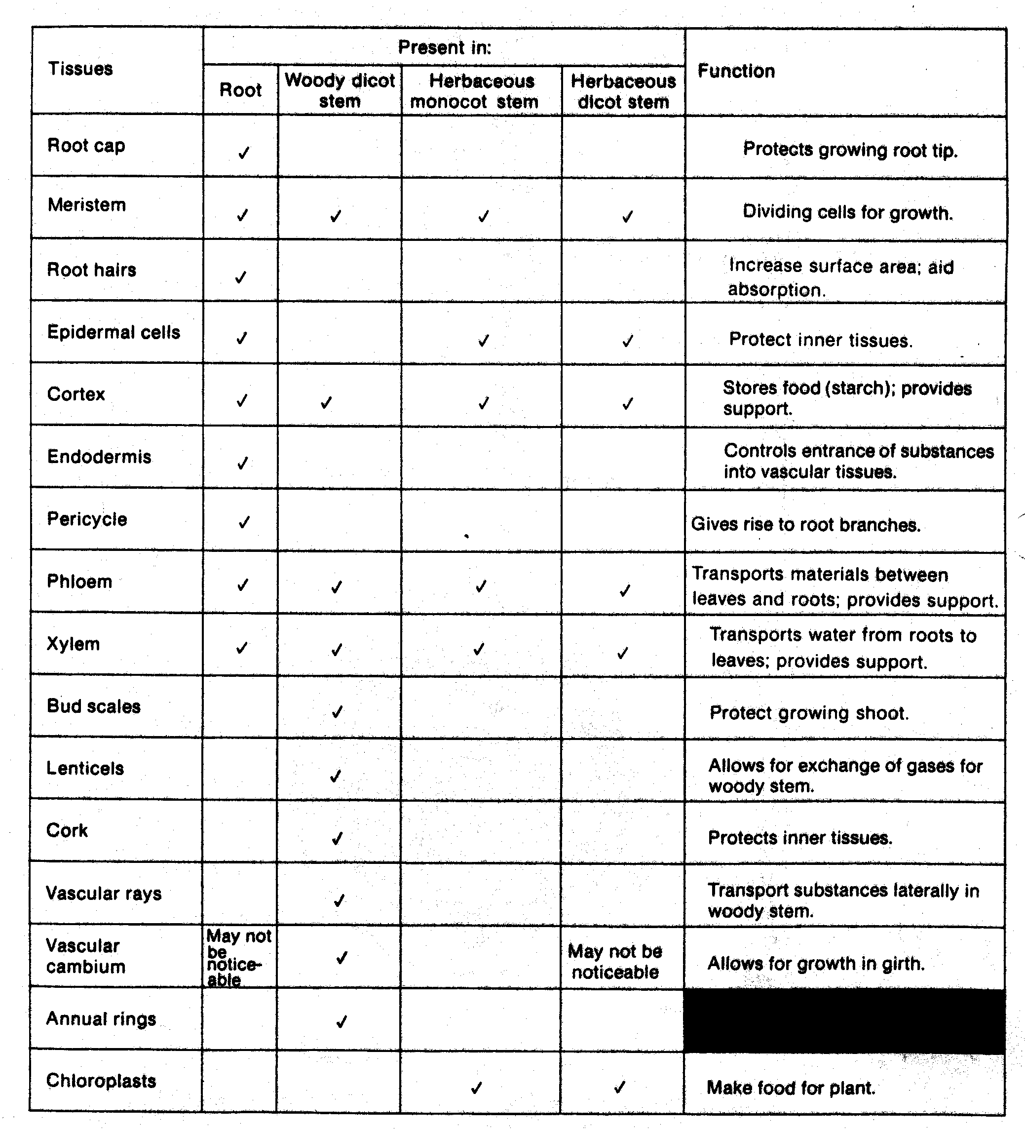
2. Meristem contributes to growth; cortex stores food and provides support; phloem transports materials between leaves and roots and provides support; xylem transports water from roots to leaves and provides support.
3. Students may mention the root cap, endodermis or pericycle as unique root structures. Unique stem structures include bud scales, lenticels, cork or vascular cambium of woody stems or the chloroplasts of herbaceous stems.
4. Root hairs are cells that have differentiated; thus, they only appear in the region of maturation. Their location indicates that growth occurs in the tip.
5. Wood formed in the spring is lighter in color than wood formed in the summer. The bands of different colored wood form a ring each year.
6. Monocot has scattered vascular bundles; dicot has bundles in a ring. Structure and arrangement of bundles in dicots allows more than one season of growth.
7. The scar would remain at 2 m because growth in the stem occurs at the tip.

