PLANT ANATOMY, GROWTH AND DEVELOPMENT

LABORATORY EXERCISE #6--ROOT GROWTH

Name________________________________________ Score_______________________________

Selection from Modern Biology, Biology Investigations, Teacher's Edition, by James H. Otto, Albert Towle, W. David Otto, and Myra E. Madnick. Copyright 1977 by Holt, Rinehart and Winston, Inc. Reprinted by permission of the publisher.

Materials needed:

Radish, bean, pea or corn seeds Dissecting microscope
Petri dishes Prepared slide:
Filter paper Longitudinal section of root tip (Allium)
Hand lens Colored pencils
Microscope
Dissecting needles

Part I: Origin of the Root System

A Week in Advance

To study the origin of roots, it is necessary to begin with a germinating seed from which the first root of a plant emerges. To observe the emergence of the primary root, trim a piece of filter paper to fit snugly in the bottom of a Petri dish. Flood the dish with water and drain off the excess. Lay 3 or 4 radish seeds at equal distances from each other on the filter paper and set aside until the roots have developed to a length of at least 2 cm. Repeat the procedure with other available seeds to note any differences in the primary root development.

When the roots have developed, remove the cover from the dish and examine the seedlings with a hand lens. Locate the primary root.

a. Describe its structure.

b. Where are the secondary roots developing?

________________________________________________. The fuzzy outgrowths are root hairs.

c. Locate and describe their growth.

d. What function do root hairs perform?

e. Describe the relationship of the base of the shoot and the base of the root.

On the figure, label: primary root, secondary root, root hair, seed coat, shoot.

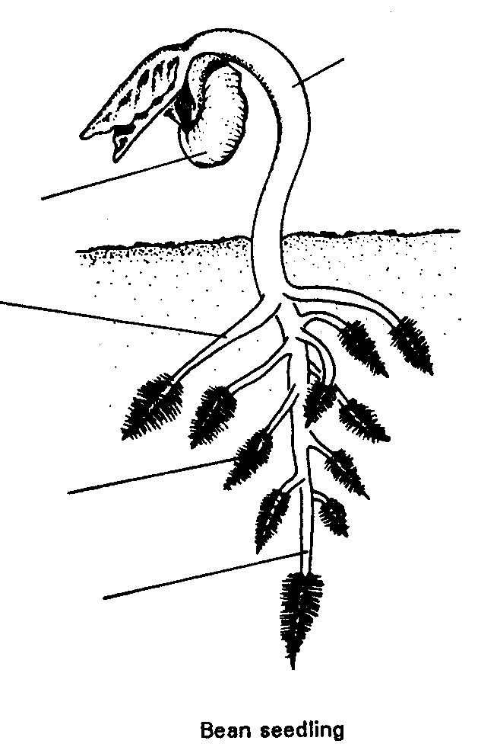

Part II: How is Growth Accomplished in Root Tip?

Remove a germinated seed from the Petri dish prepared in Part I. Cut a section of the portion of the root bearing root hairs and place this in a drop of water on a slide. Examine under a dissecting microscope and carefully, with dissecting needles, remove a portion of the tissue bearing the root hairs. In order to see the detail of the cells, add a drop of iodine to the preparation and examine it under low power. Observe the root hairs.

a. Are the root hairs composed of cells?

b. Explain your answer.

c. From what cells do the root hairs project?

d. Suggest how the root hairs absorb water.

Examine a prepared slide of a longitudinal section of the young root tip under low power. Use a biology or botany textbook or charts to locate the various regions of the root tip. Move the slide and examine all areas.

e. Are root hairs present?

f. If not, explain their absence.

Locate the root cap at the tip.

g. What function does it serve?

Cells on the surface of the root cap are worn off as it pushes through the soil.

h. Why doesn't the root tip cap disappear entirely in time?

i. Where are the smallest cells of the root tip located?

Examine these cells closely.

j. What important activity is carried on in this region?

k. Why is this activity important to the root?

Move the slide from the tip toward the older regions.

l. What noticeable changes occur in the size of the cells?

m. What term applies to this region of the root?

n. Why is the activity of this region important to the root?

o. Why are the regions of the root not clearly defined?

From what region do the root hairs originate?

This is the region from which root hairs develop.

In the outline, locate with brackets the root cap, meristematic region, elongation region, maturation region. Accurately draw several rows of cells in each region.

Part III: Summary

a. On the basis of your observations of the root tip above, explain how the roots grow longer.

Test what you have learned by matching the function of the tissue in the left column with the tissue in the right column. Place the number of the tissue in the space before the function.

_____b. produces new root cells 1. maturation region

_____c. function in the absorption of water 2. epidermis

_____d. protects the growing root tip 3. root hairs

_____e. activity in this region serves 4. elongation region
to push a root tip through the soil
5. root cap
_____f. region producing root hairs
6. meristematic region
Part IV: Investigations On Your Own

1. The secondary growth of a root may be studied through the examination of a carrot or similar root. Consult a biology or botany textbook to determine what becomes of the primary tissues as the root increases in diameter. Make drawings of the longitudinal and cross sections and label the tissues you observe.

2. Make a collection of root modifications as they are found on different plants. (for example: adventitious roots of corn, English Ivy, tap roots of Dandelion, and turnip, etc.) Give the name of the plant and tell how the modification serves the plan

Answers to Lab #6

Lab #6

Part I:

a. It appears white and is long and tapering. Delicate strands project from the upper portion.
b. From the upper regions of the root
c. The root hairs are located a short distance from the tip of the root and appear as many numerous hairs.
d. They absorb water and increase the absorptive surface of the root.
e. The developing root supplies the developing shoot with necessary water and minerals.

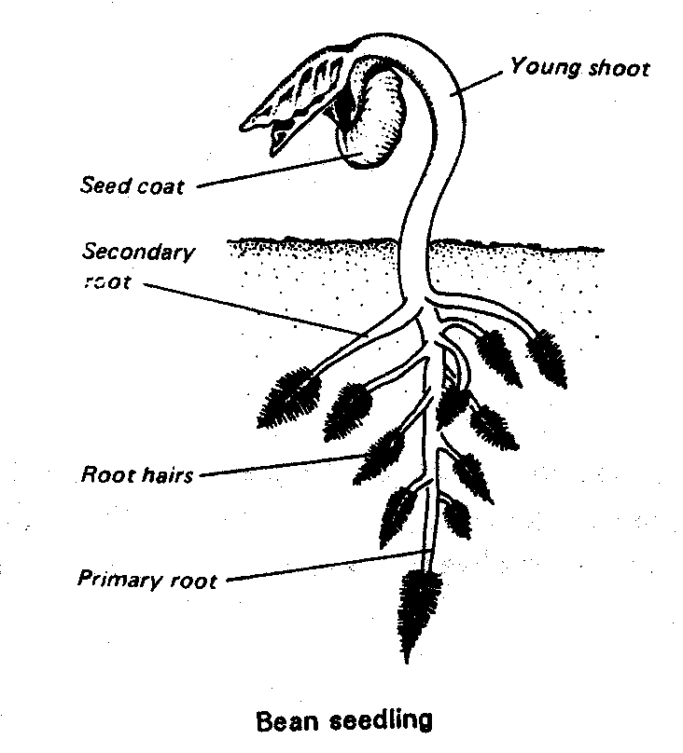
Part II:

a. No
b. They appear cellular, but are actually long projections from a single epidermal cell.
c. Epidermal cells
d. Water is absorbed by osmosis.
e. Probably not
f. Being delicate structures, they were probably lost in the process of making the slide preparation.
g. It protects the meristematic region where new root cells are being produced.
h. New cells are formed from the meristematic region to replace the cells that are worn off.
i. Meristematic region
j. Production of new root cells by mitosis.
k. Without new cells, the root could not grow.
l. They lengthen.
m. Elongation region
n. As the cells elongate, the root grows and is pushed through the soil.
o. Cells are produced at different rates by the meristematic region and, therefore, elongate and mature at different rates.
p. Maturation region

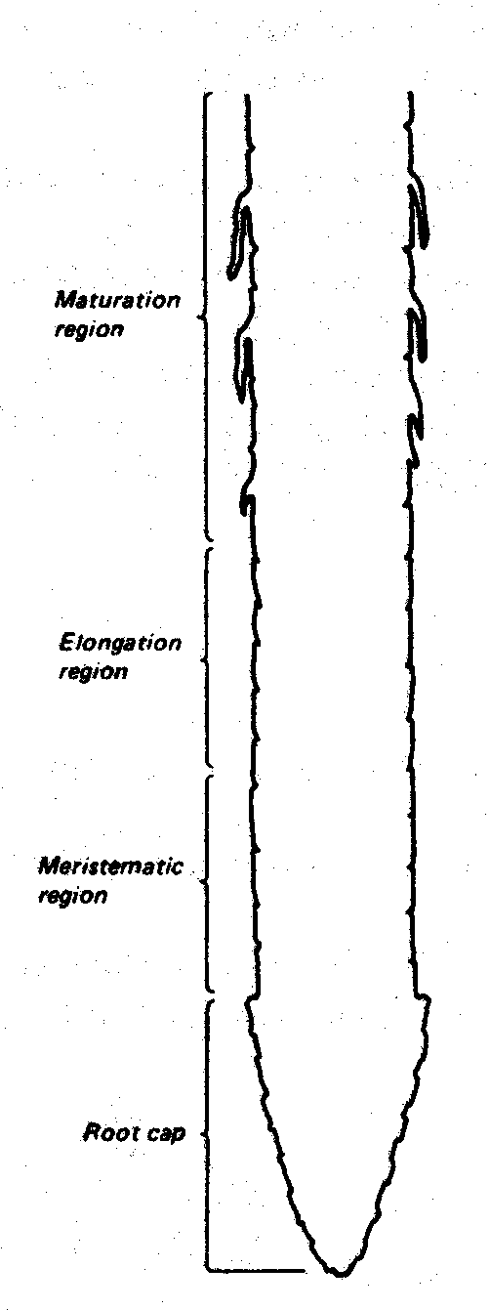

Part III:

a. New cells produced by the meristematic region become pushed back to where they elongate. The process of elongation serves to push the root tip through the soil whereupon growth in length is achieved. Following elongation, the cells mature into tissues dependent on their location in the root tip.
b. 1
c. 3
d. 5
e. 4
f. 2

