Name___________________________________ Period_________ Date_________

Careers in Animal Science Notes

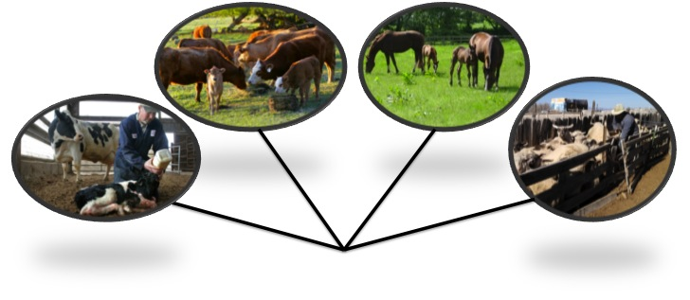
- Identify career clusters within the animal science industry
Production

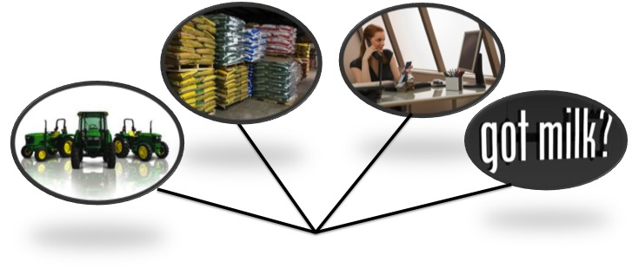
Sales & Marketing

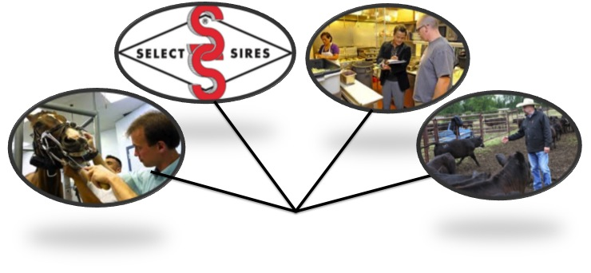
Services

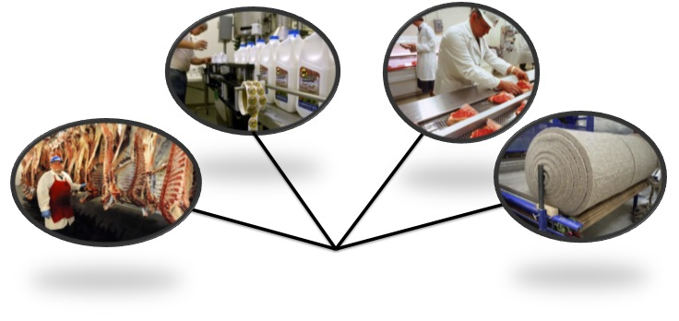
Processing

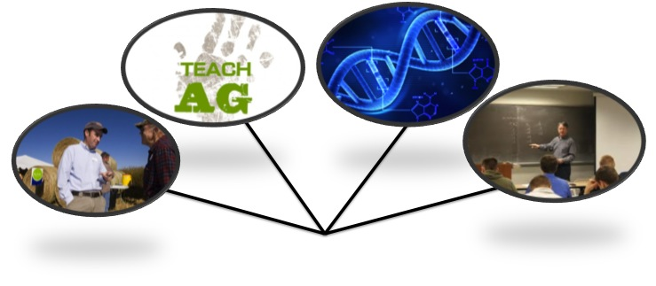
Education & Research

      - Formally in school
      - Through extension programs

- Recognize trends in the animal industry and how they affect the job market

- Trend /trend/ (noun)
A general direction in which something is _________________ or _____________________.

Are there trends in agriculture?

- Increased consumer demand for _________________________________________
- Increased consumer demand for labels indicating how food was _____________________________
  - Free range, cage free
  - Grass fed
- Animal production follows the trends of human food consumption
  - Lower fat

How do trends affect animal production?
- Farmers & ranchers produce what consumers __________________

How do trends affect job market?
  - Trends either ___________________ or ___________________ job markets

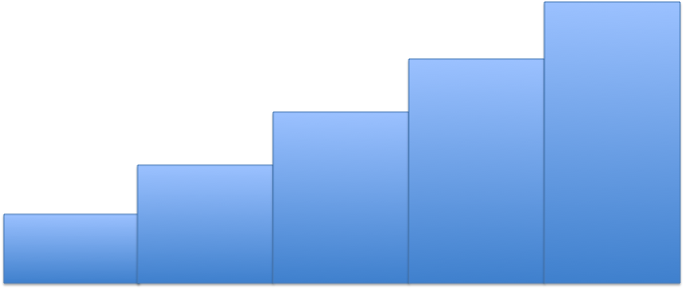
- Develop a career plan
  - Plan for your education
  - Prepare financially

- Get experience early
  - Internships
  - Entry level jobs in related fields
  - Career Development Events

