Name__________________________________________ Period________ Date__________

Animal Science

**FFA Around the Clock Notes**

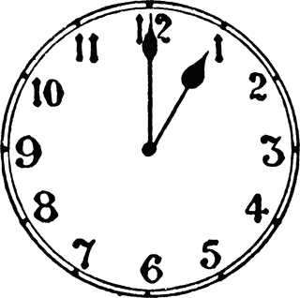

1st Day of FFA

2 Dudes

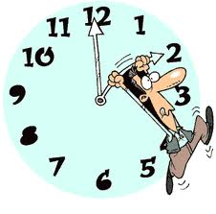



3 Circles

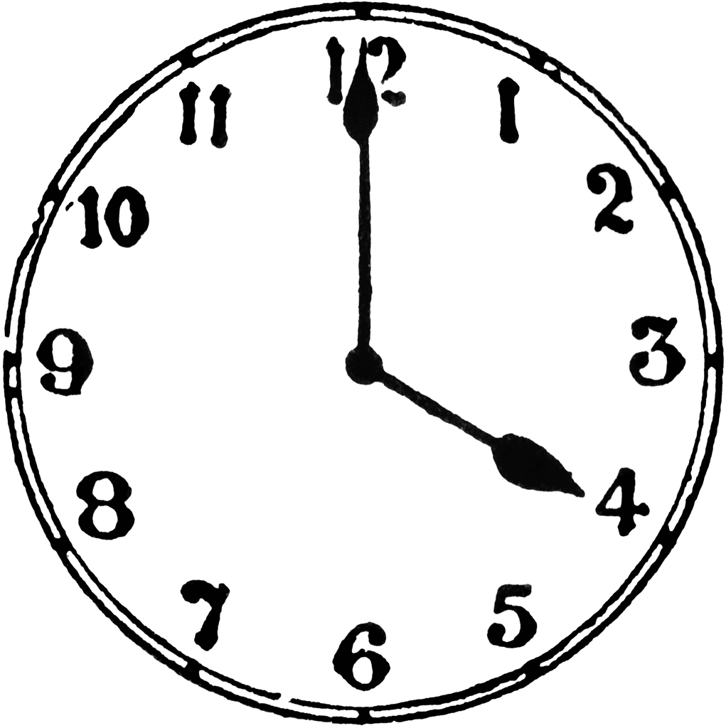

4 Lines of the

FFA Motto

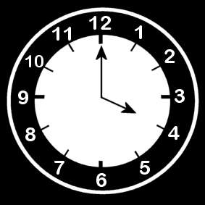



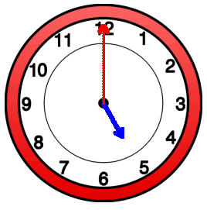

5 Degrees

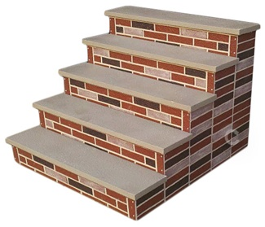



6 parts of the

FFA Emblem

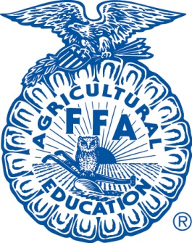



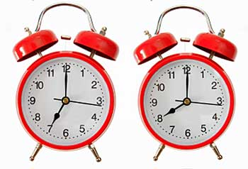

7 Offices



FFA is Gr-8



Awards are fine

FFA Timeline

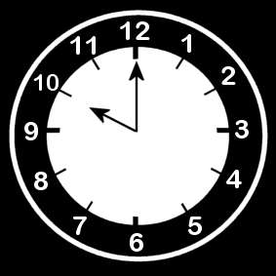

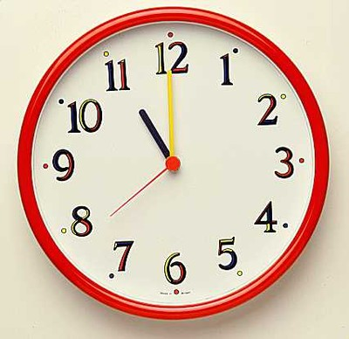

Code of Ethics

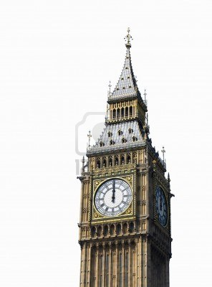

Official Dress

