Name___________________________________ Period_________ Date_________

Animal Health & Housing Notes

- Relate concepts of animal welfare and animal rights to the well being of animals

  - Advocates that animals have the same rights and freedoms as humans. They should not be used for human benefit

  - Advocates high standards of welfare for animals. They should be fed, housed and cared for to meet their needs.

- Identify equipment used to maintain animal health
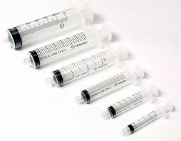  *Size measured by cc’s (cubic centimeters) | 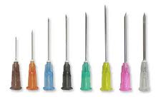  *Size measured by gauge (diameter) & length of needle | 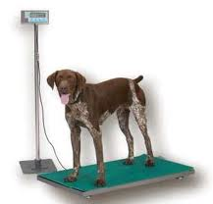  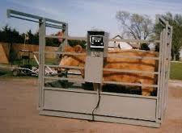
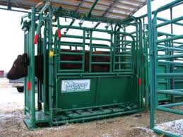  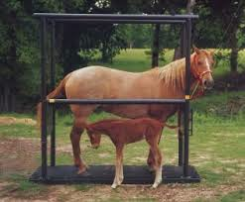 | 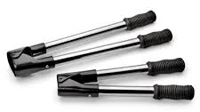
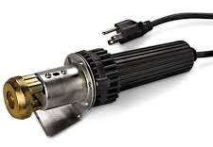 | 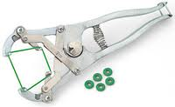 | 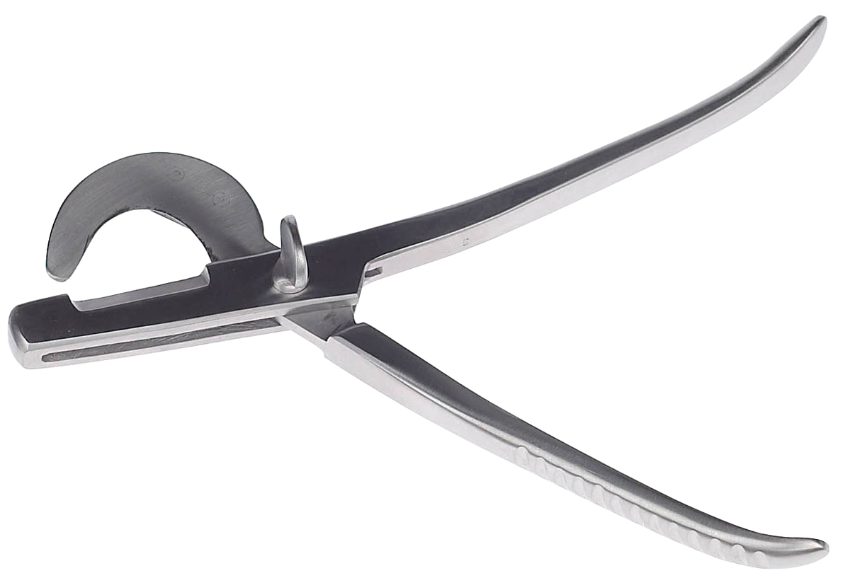
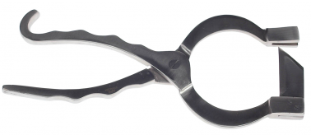 | 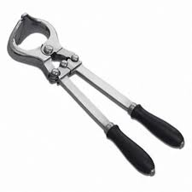 | 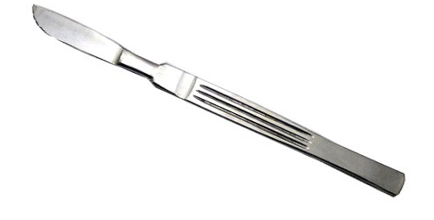
 | 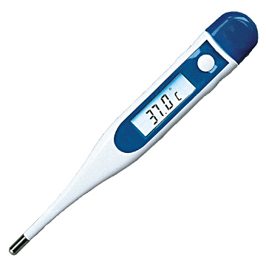

- List measures used to prevent disease and parasites in livestock

1-

- Prevent disease
- Protects your animals & other’s

2-

- Dusts, sprays & baths for external parasites
- Injections, pill, and pastes for internal parasites

3-

- Prevents animals from harming themselves, other animals, or people
4-

- Increases meat quality (in livestock)
- Decreases aggressive behavior in all animals
- Decreases likelihood of reproductive diseases and cancer

5-

- Excessive manure and wet living spaces harbor viruses and bacteria
- Proper Bedding in wet and/or cold climates decreases likelihood of disease transmission
- Prevent overcrowding

- Identify animal housing needs

  - Enclosed or partially enclosed buildings need ventilation
  - Outdoor housing provides natural ventilation

  - Some animals need a shelter and straw or shavings
  - However, in good weather, outdoor pastures and dry corrals are adequate

  - On a large scale farm, liquid manure is stored in a lagoon and solid waste can be stored in a pile until it is spread as fertilizer on fields

  - On a large scale farm, liquid manure is stored in a lagoon and solid waste can be stored in a pile until it is spread as fertilizer on fields

  - Shelters could be completely enclosed or partially covered depending on animal needs, climate, and available resources
  - Even in the winter, animals can stay warm with a dry place to bed down. Ruminants create heat as they digest feed.
  - The shade and wind break of a tree may be all animals need

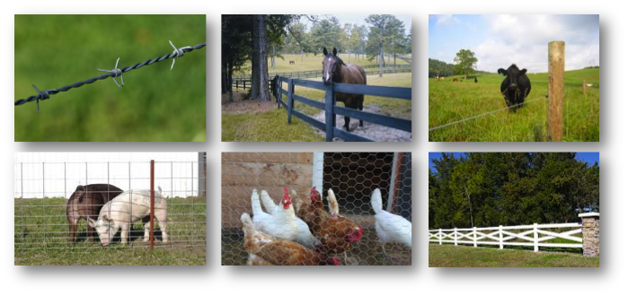

- Design an animal health & housing plan to promote efficiency of production

