Name___________________________________ Period_________ Date_________

Meats Notes

  - Identify the differences between beef, pork, and lamb cuts;
Beef:

Pork:

Lamb:

  - Diagram and identify the wholesale cuts of beef, pork, and lamb;
  - List retail meat cuts and identify the wholesale cut that it came from;
*Hint: Write the wholesale cut on the diagram where it appears on the PowerPoint so you can write the retail cuts on the line afterward.

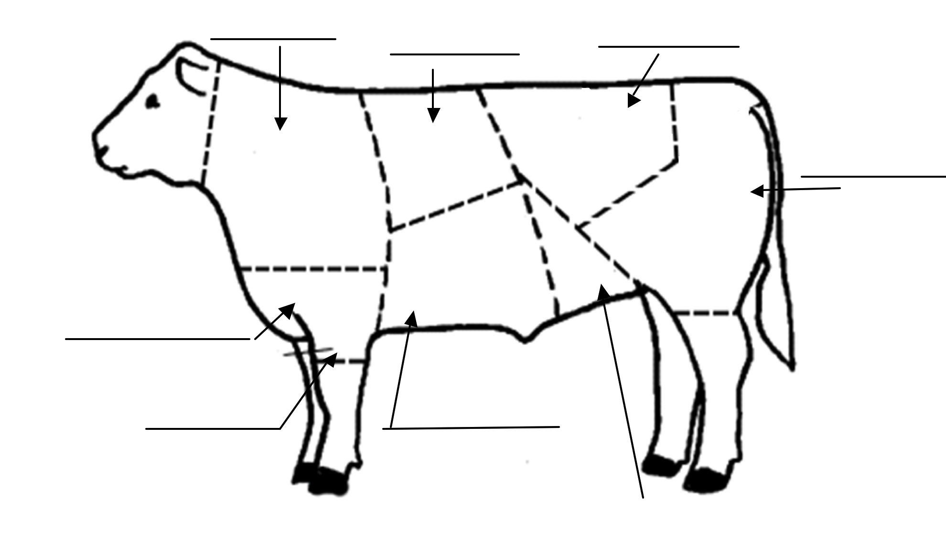

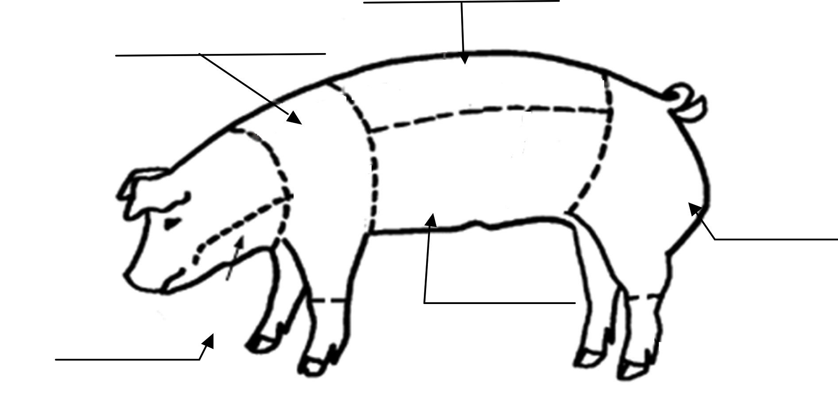

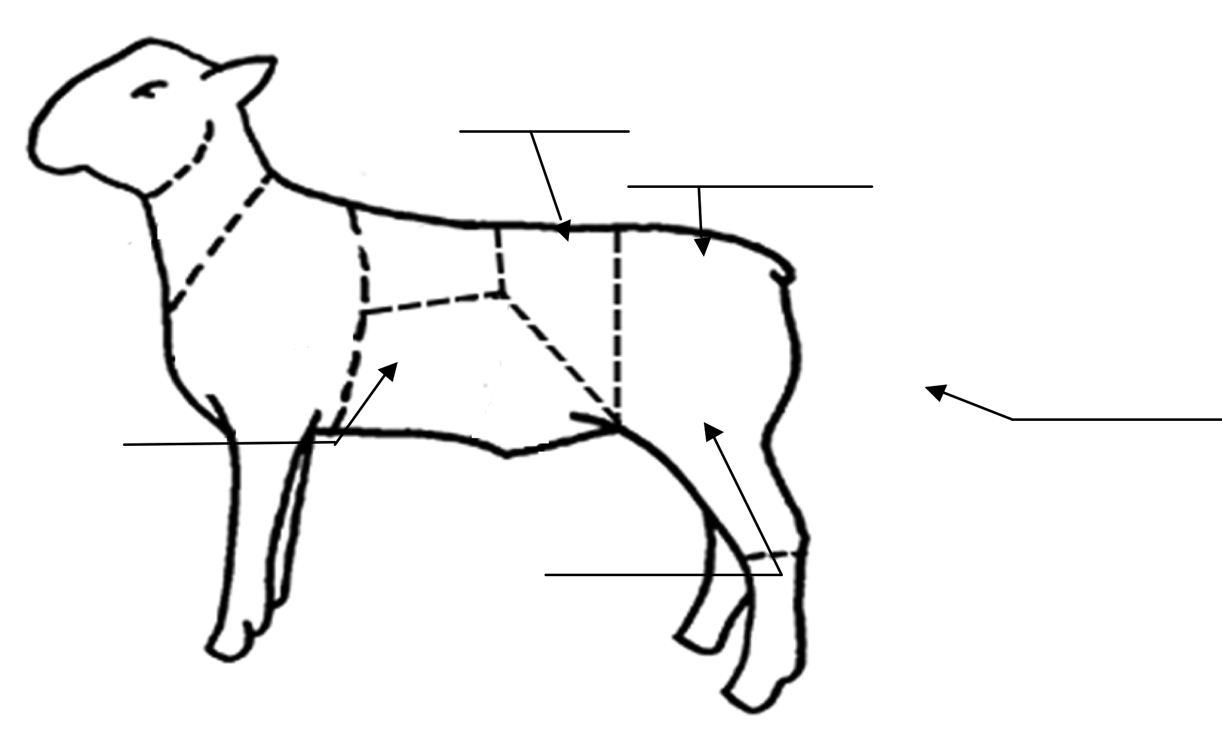

  - Explain the yield and quality grades of meat;

Quality Grade:

1-

2-

How age is determined:

- ______________________ carcasses have cartilage “buttons”
  - Shiny, white cartilage

- ______________________ carcasses have bones that are completely ossified

Three quality grades of meat are:

1-

2-

3-

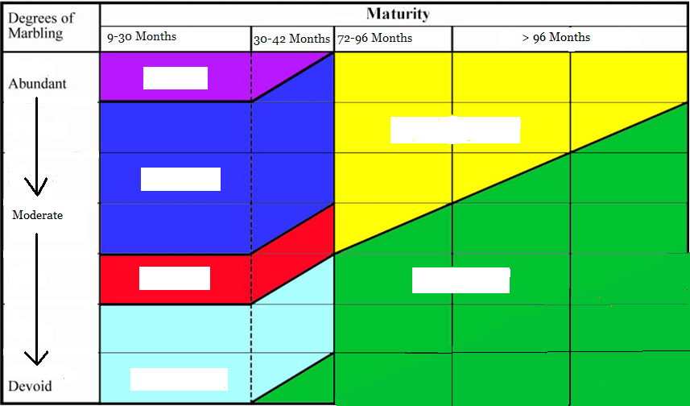

Yield Grade
- measure of the __________________, closely trimmed retail cut
- also known as “_______________________”
- a scale of 1 to 5 is used to judge Yield
- 1 is the __________________, 5 is the _____________________.

  - List signs and causes of meat spoilage; and
Meat is considered “spoiled” when it is unfit for human consumption.
The major causes of spoiling are:

Signs of Spoilage:

  - Judge a class of meat cuts.
Observe and Rank According to:
1.
- Highest amount of lean meat

- Least amount of exterior fat
- Highest content of intramuscular fat or “Marbling”

Place a class of Beef T-Bones:

_________ - _________ - _________ - _________

Place a class of Pork Loin Chops:

_________ - _________ - _________ - _________

