Name_____________________________________________ Period________ Date____________

Plant Propagation Notes

- List & describe common methods of sexual plant propagation

Plant Propagation

- Sexual Plant Propagation
  - Reproduction of plants by ______________ or ______________ by the uniting of 2 gametes.

  - Offspring plants are genetically ___________________ than parent plants

- Sexual Reproduction in Plants
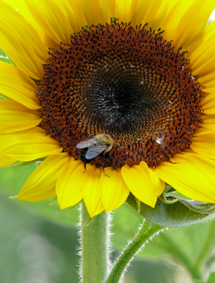
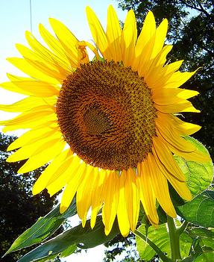
  - Flower produces __________________

  - Seeds are pollinated (fertilized) by _____________________________

  - Seed is harvested and planted to produce a ________________ plant.
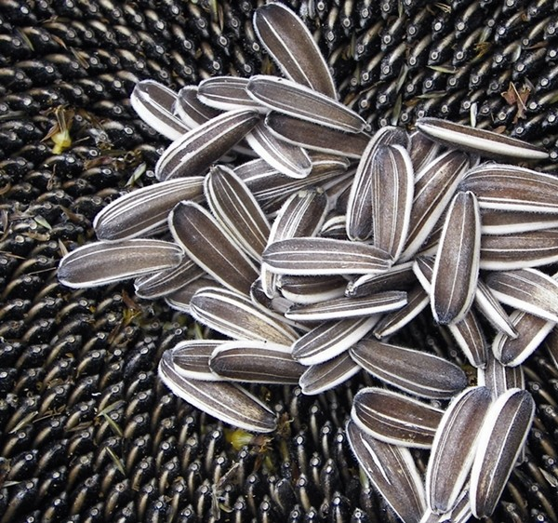
  - Offspring plant has ½ of it’s genes from 1 plant and ½ from another

  - Offspring plant is genetically ________________ than both parent plants.

- Methods of sexual plant propagation
1- Seed
    - Seeds are harvested from ___________________and planted

    - Most common method of plant reproduction

Where do seeds come from?
- Seeds develop in the ___________________of a flower & are harvested

- Seeds are kept to grow another season

How are seeds harvested?

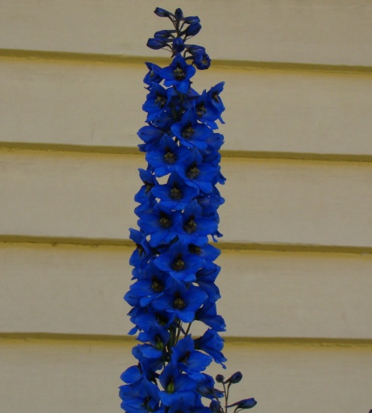
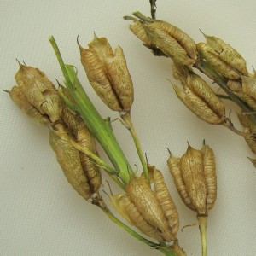
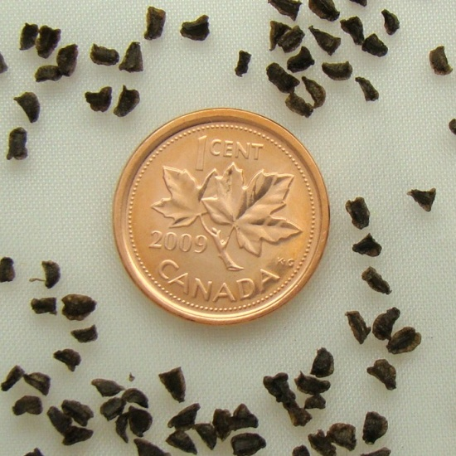

- 2. 3.

3
4
2
1
Parts of a Seed

- Seed Coat: Hard surface that protects interior of plant

- Embryo: The new plant that develops as result of fertilization

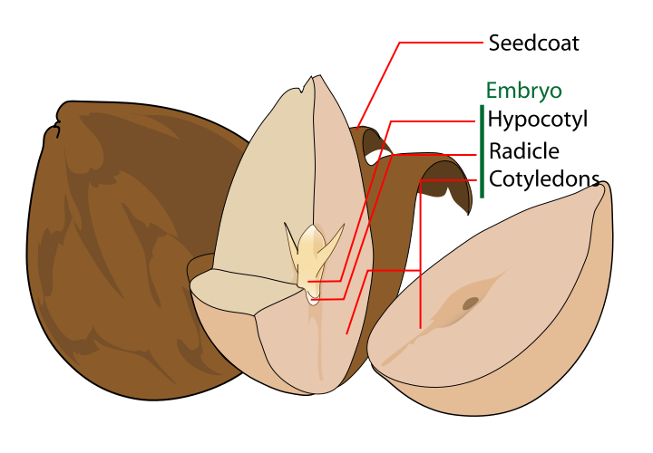

Types of Commercial Seed

- Raw
- Pelleted: Coated to make seed bigger and easier to handle

Name the Seed:
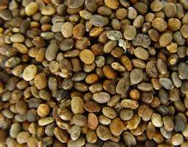
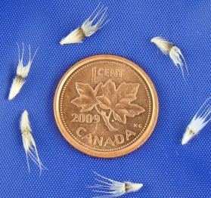
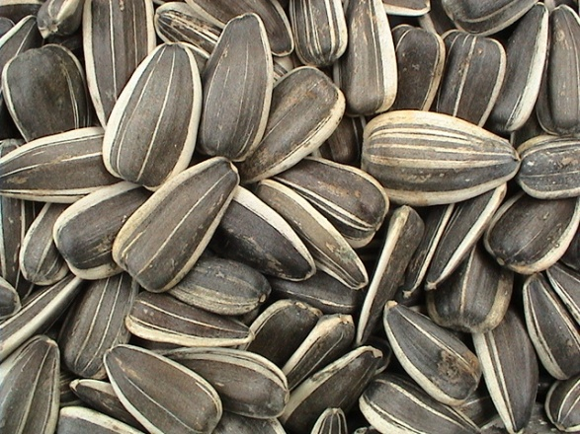

Hybrid Seed

- “Hybrid” can apply to any cross-pollinated plant
- Plants grown from seed that is a result of special breeding
- Considered genetically ________________________
- Seedlings have “_______________________”
- Result of controlled crossing of a dedicated “female line” and a dedicated “male line”
  - Both lines are genetically pure and will have the best traits from both parents.
- Seed saved from hybrid plants does not produce quality plants.
2- Spores

  - Primarily with ferns
    - Ferns do not have ________________
    - Usually found on back of fern
    - They drop to ground and grow into a new plant

- Describe the process and environmental conditions of seed germination

Germination:

- Development of a seed from a resting stage to a stage of growth.
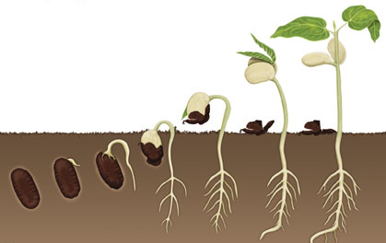

Environmental Requirements:

- Diagram the process of plant fertilization

Plant Fertilization:
  - The meeting of the _________ gamete with the ________ gamete
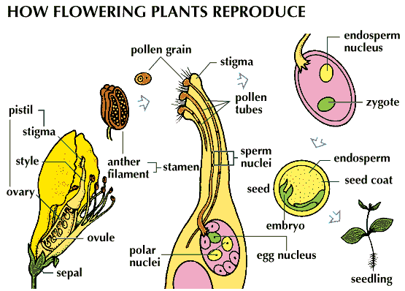
  - Takes places in ___________ of flower

- 2. 3.

- Explain the importance of seed viability and vigor.

The most viable seed is:
  - Collected from strong, healthy _________________ plants
  - _____________________ properly prior to seed harvest
  - Kept at moisture/temperature level to keep seed in _________________

- Explain pollination, cross-pollination, and self-pollination of flowering plants.
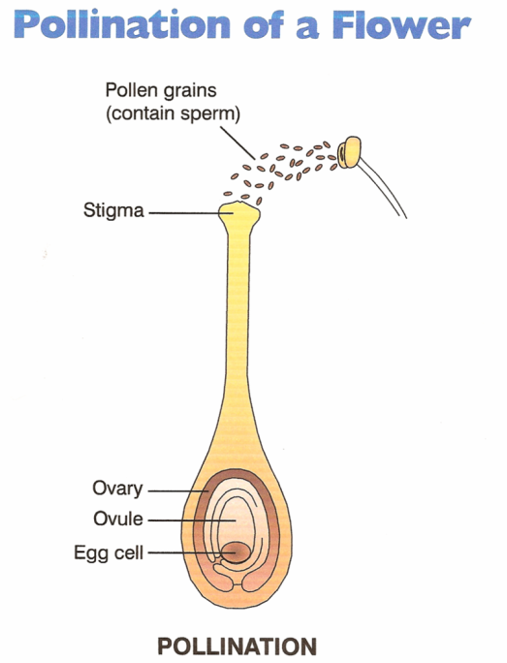
Pollination:
Transfer of pollen from an anther to a stigma of a flower of the same species

Self Pollination:
  - Pollen from a plant pollinates a flower on the SAME plant

Cross Pollination:
  - Pollen from a plant pollinates a flower on a DIFFERENT plant

Methods of Pollination:
  - Insects
    - Bees
    - Butterflies
    - Moths
  - Wind

- List & describe methods of asexual plant reproduction

Asexual Reproduction:
  - Reproduction of plant ______________ the use of reproductive organs (flower pistil & stamen)
  - Also called “_________________” propagation
  - Use of _______________, _______________, or ______________ to grow a new plant
  - Produces genetically __________________ plants (clones)

Benefits:
  - Can be quicker
  - Assures characteristics to be passed to offspring
  - Less expensive

Drawbacks:
  - Can’t be used with all plants
  - No genetic diversity

1-Separation/Division:
  - Separating or dividing one plant into several smaller plants
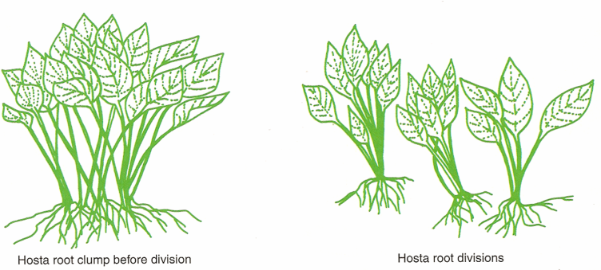

2-Layering:
  - Reproduce a new plant while offspring plant is still connected to parent.
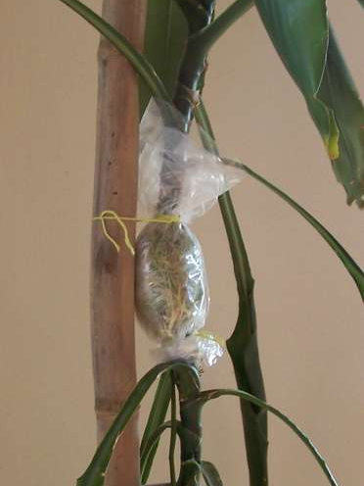
    - Advantage: No water stress
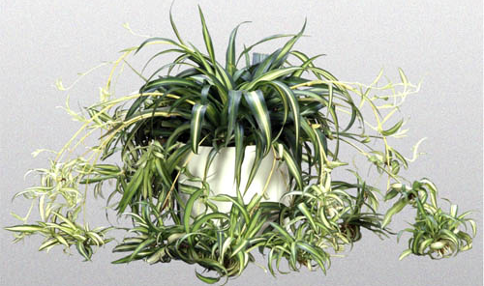

3-Tissue Culture:
  - Also called “Micropropagation”
  - Propagation of plants from nearly microscopic parent plants
  - Benefit= Mass production of a cultivar from an extremely limited amount of parent stock

4-Cuttings:
  - Using a section of stem and/or leaf to produce a new plant

- Describe optimal conditions for asexual propagation.

Environment:
  - Moisture/humidity
  - Good draining soil
Plants:
  - Healthy & strong
  - Correct plant varieties
    - Some plants don’t propagate well asexually

- Demonstrate techniques used to propagate plants by cuttings, division, separation, and layering.

-See Lab Sheets for step by step instructions
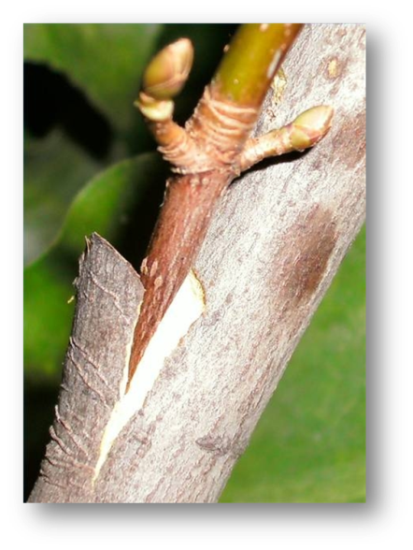
- Describe grafting techniques.

Grafting:
  - Connecting 2 pieces of living plant material together to form a single plant

  - Scion= New plant material

  - Rootstock= old plant material

Benefits of Grafting:

  - Increase the strength and disease resistance of roots
    - Peach trees have stronger roots that are more resistant to root rot than almond tree roots

  - Several Varieties grown on one tree/bush
    - Apple trees with 2-3 varieties of apple
    - Rose bushes with multiple colors of roses

Types of Grafts:
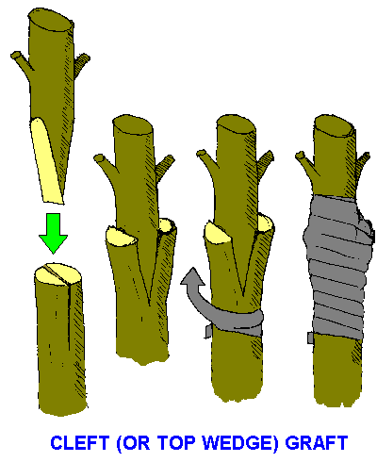
  - Wedge Graft

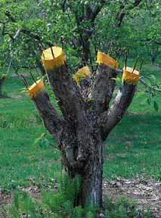
  - Saw Kerf Graft

  - Whip & Tongue Graft
