Name__________________________________ Period_______ Date____________

Introduction to
Livestock Judging & Selection Notes

- Explain the importance of animal selection in the success of a production enterprise

When do you evaluate the quality of an animal?

1-
  - Determine if it will perform to the level you need
  - Be sure it is healthy & structurally sound
  - Confirm that the sale price matches the value

2-
  - Overpriced animals don’t usually sell
  - Underpriced animals lose potential profit

3-
  - Choose the best breeding animals to keep as replacements in your herd

4-
  - Pick the animal with the most show potential

5-
  - Learn skills in comparing animals quickly and ranking from top to bottom

- MOST judging characteristics are related directly to efficiently producing agricultural products
- In the show industry, a few characteristics are just for show
- Pigs:
- Dairy Cattle:
- Sheep:
- Beef Cattle:
- Horses:

- Discuss the importance of conformation in animal selection and how it is evaluated through the muscular and skeletal systems

- “______________________” in the animal industry is used to describe an animal without injury or structural fault.

- ______________________: provides structure and support to the body with:
  - Bones
  - Tendons (Connects bone to bone)

- ______________________: provides ability for body to move
  - Moves Bones
  - Ligaments (Connect muscle to bone)

- Structural Incorrectness can cause “_______________________”
  - Lameness or limping
  - Inability for animal to move freely (Stiff or post legged)

- Muscular AND Skeletal System work together
  - If 1 fails, the other will too

- Label external parts of agricultural animals

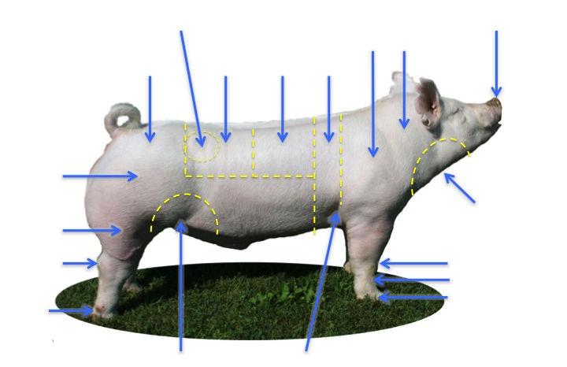

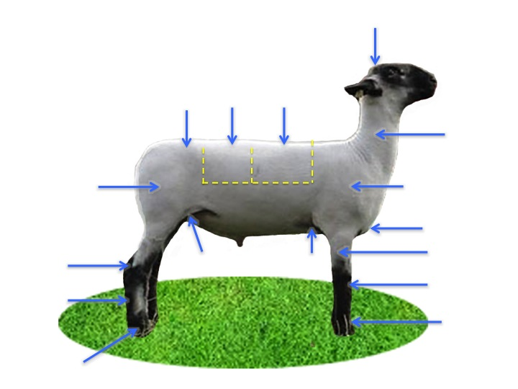

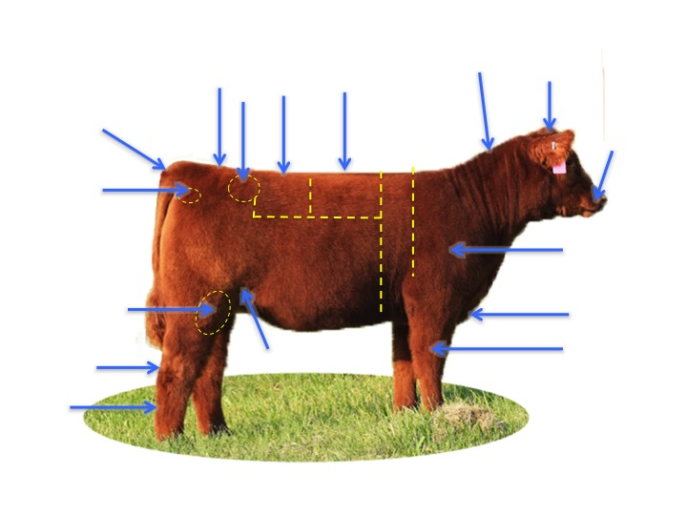

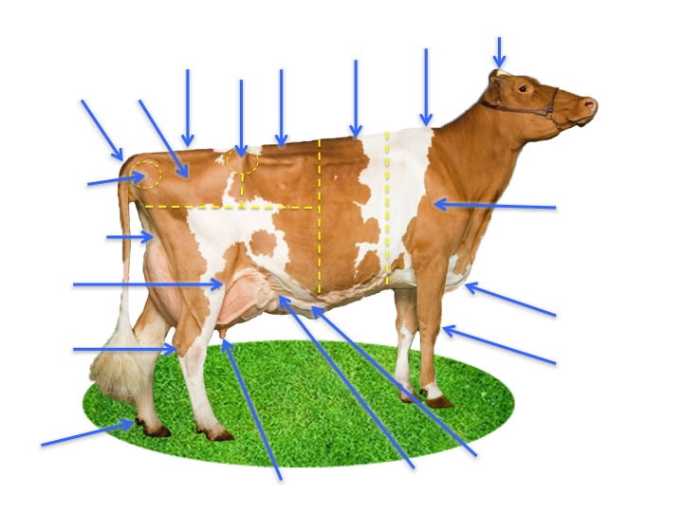

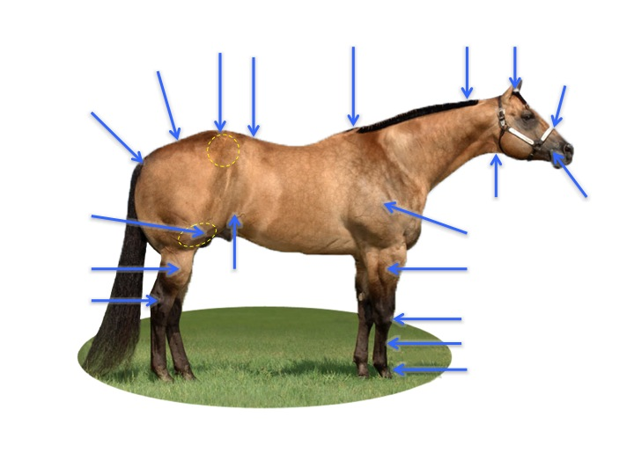

- Describe the judging process and fill out a judging card correctly

Steps:
- Identify ideal characteristics
- Compare each animal to the ideal
- Rank from best to worst
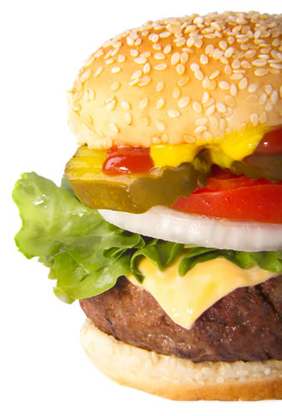
Example:
An ideal hamburger has:

Compare the following hamburgers to the ideal hamburger and rank them from top to bottom:
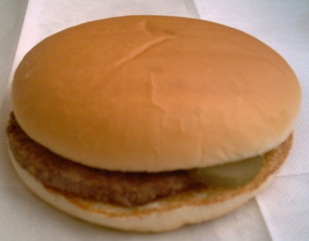
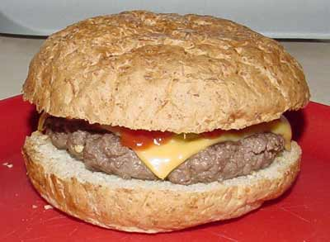
#1 #2

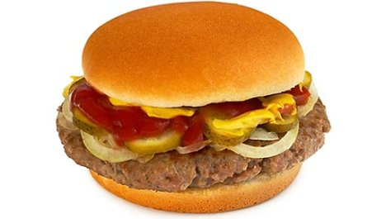
#3 #4

\

Now Rank: _____________ - _____________ - _____________ - _____________
1st 2nd 3rd 4th

How to fill out a score card:

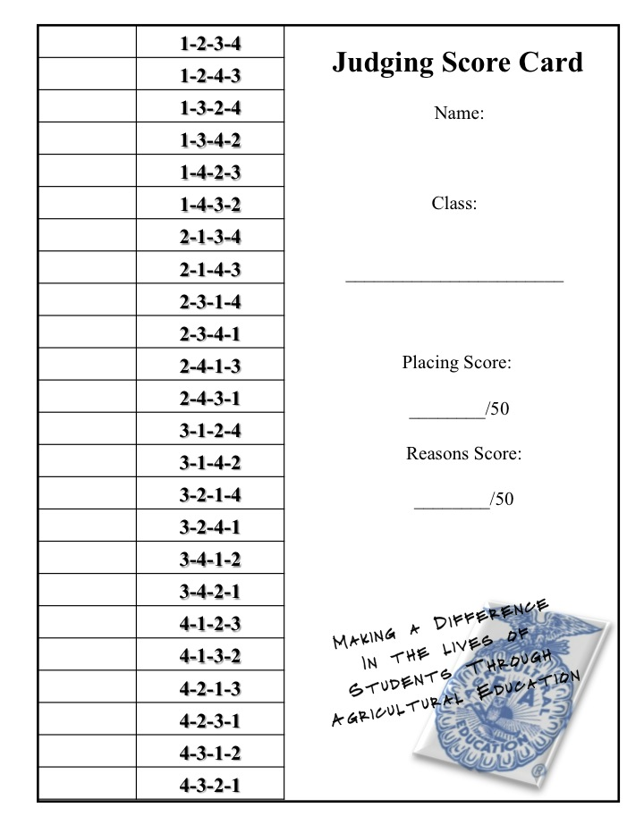

- Judge classes of livestock

- _______________________ = Animals being judged for immediate slaughter
- _______________________ = Animals that still have time to grow and finish
- _______________________ = Male or Female Animals evaluated for their breeding quality

Market Hogs:

Market Steers:

Market Lambs:
Horses:

Dairy Cattle:

- Present oral reasons

- An explanation of why you ranked the class as you did
- Provide backup for your judgment
- 2 min or less

“#____ wins this class because…” | another good thing about 1st place | “I realize #_____...” (2nd place)  (something good about 2nd that was better than 1st)
Good thing about 2nd place | Another Good thing about 2rd place | “I recognize #_____...” (3rd place)  (something about 3rd place that was better than 2nd)
Good thing about 3rd place | Good thing about 3rd place | “Granted #_____...” (last place)  (something about last place that was better than 3rd)
 |  | “#_____placed last because…”

