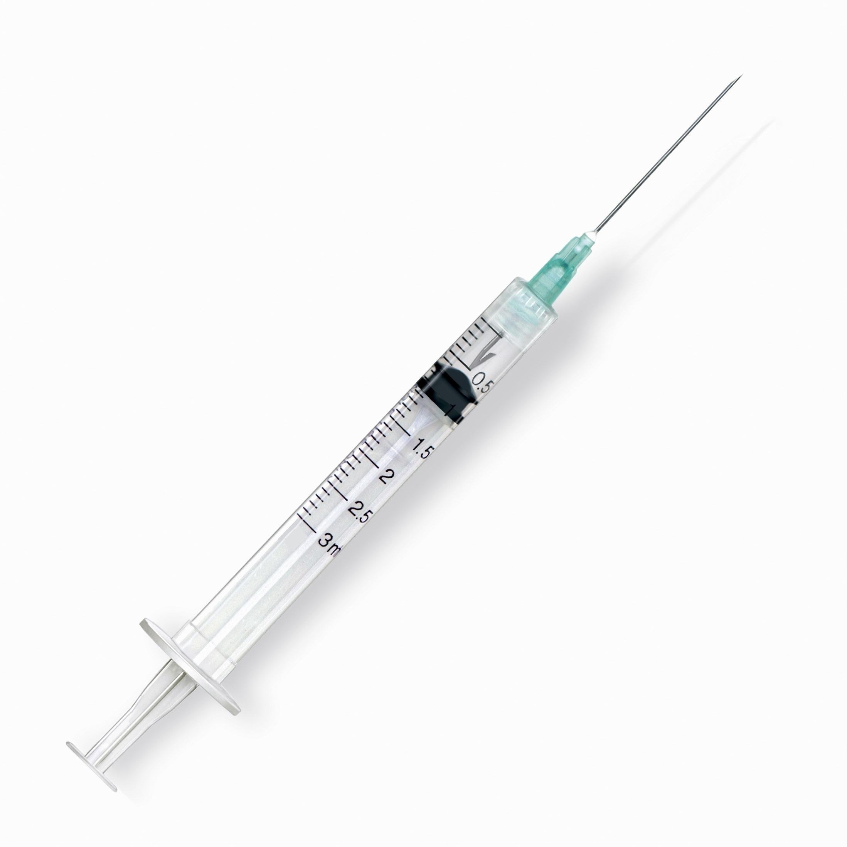
Name_________________________________________ Period___________ Date_____________
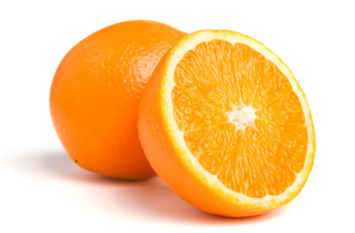
Injection Lab

Supplies:

- Syringe
- Injection needle
- Sterile water
- 1 orange per person or team

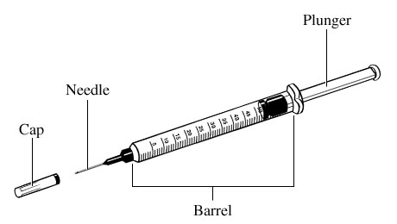

Directions:
- Gather lab supplies
- Using 2 colors of water, practice 2 methods of injections.
  - Inject 1 cc of water subcutaneously (under the skin of orange)
  - Inject 1 cc of water intramuscularly (in flesh of orange)
- Cut the orange in half to see if you were successful in placing the water in the correct place.
- With a teammate, practice drawing up different doses as specified by your teacher.
- Use a colored pencil to color in the correct dose on the syringes below.

1. 1 ¼ cc 2. 2.75 cc

3. ¾ cc 4. 1 ¾ cc

5. 2.25 cc 6. 1 cc

7. 6 ½ cc 8. 10 ¼ cc

9. 9 cc 10. 6.5 cc

11. 4 ¼ cc 12. 11 cc

