Name______________________________________ Period_________ Date___________

Specialty Animal Care Brochure

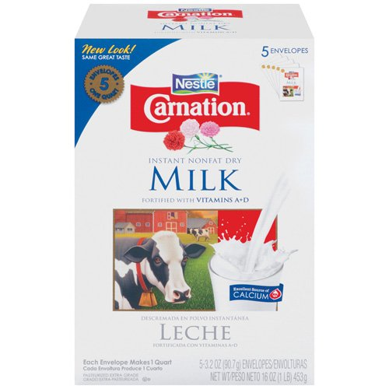
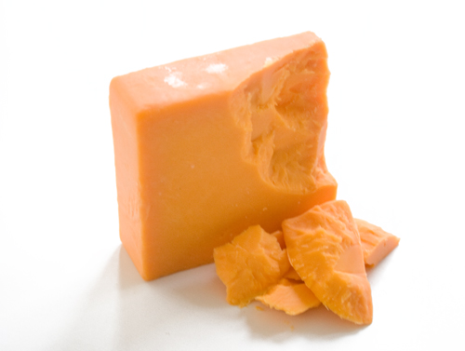
Directions: You will be making a tri-fold brochure about an exotic animal. The brochure should include all of the necessary information for a new specialty pet owner to get a good start with their new animal. Every city and state has specific laws about exotic/specialty pet ownership. For the purposes of this assignment we will be focusing on specialty pets and livestock that are legal in most areas and easily acquired at pet stores or through classified ads.
Fish & Aquatics:
- Soft Shell Turtle
- Salt Water Fish
- Fresh Water Fish

Livestock:
- Pot Bellied Pigs
- Llamas
- Alpacas
- Miniature Cattle
Small Mammals:
- Sugar Gliders
- Hedgehogs
- Ferrets
- Guinea Pigs
- Rats
- Hamsters
- Gerbils
- Chinchilla

Reptiles & Other:
- Red Eared Slider Turtle
- Red Belly Frogs
- Tarantula
- Boa Constrictor Snake
- Hermit Crabs
- Fire belly Toads
- Scorpion

Your brochure must include the following sections:

1- General Animal Information:
- Life span, where they originated, their benefits as pets, etc

2- Housing & Habitat Instructions
- Cage, toys, climate requirements (heating rock), Light requirements, expected cost to buy all start up equipment, etc

3- Food & Feeding Instructions
- What do they eat, how often, where can it be purchased, and how much should you expect to spend

4- Medical & Health Maintenance Required
- Should they be vaccinated, are they prone to any diseases, etc

5- How to Acquire the pet
- Where can an animal be purchased, how much will it likely cost

6- Pictures
- Include applicable pictures

Designed as Tri Fold Brochure | All required Sections included | Includes applicable pictures | Neat, Organized, and professional looking | Total
1 3 5 | 0 2 4 6 8 10 | 0 2 4 6 8 10 | 0 2 4 6 8 10 | / 35

