Name________________________________Period_________ Date________

Plant Propagation
Asexual Plant Reproduction- Cuttings Lab

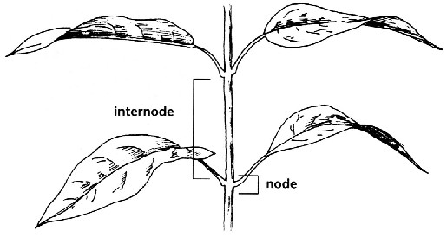

Node:

Internode:

Leaf:

Petiole:

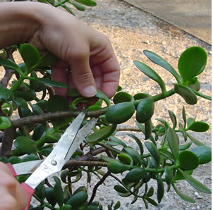
How to take Cuttings:

1-

2-
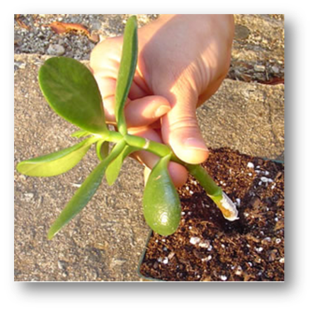

3-

4-
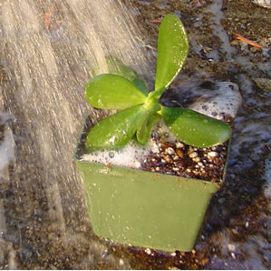

Types of Cuttings:

-Stem

-Leaf

-Leaf Section

-Root

-Heel

-Eye

Tips for Cuttings:

- Rooting Hormone isn’t always necessary, but may increase speed of root formation
- Remove ALL flowers
- Remove excessive leaves

Why is it a good idea to remove all flowers and excessive leaves after a cutting has been taken?

