BASIC PLANT PROCESSES
LABORATORY EXERCISE --MEASURING LOSS FROM TRANSPIRATION

Name________________________________________ Score__________________________

I. Materials needed

A. A growing plant in a pot, bucket or other container or a plant growing in a convenient location

B. Plastic bag or sheet of clear plastic that will cover the plant or a branch of the plant containing 10 to 12 leaves

C. String, rubber bands or other suitable tie materials

D. Stake to support the weight of the plastic

E. Plastic straw or other suitable tubing for a drain

F. Measuring cup or beaker

II. Procedure (Figure 1)

A. Be sure plant has been watered

B. Cover the entire vegetative portion of the plant or a section with plastic material

C. Locate tubing at bottom of plastic covering to serve as a water drain

D. Place plant in sunny location for an entire day; measure the water collected; empty container

E. Measure water collected during dark period of the day

F. Compare differences in the amount of water collected

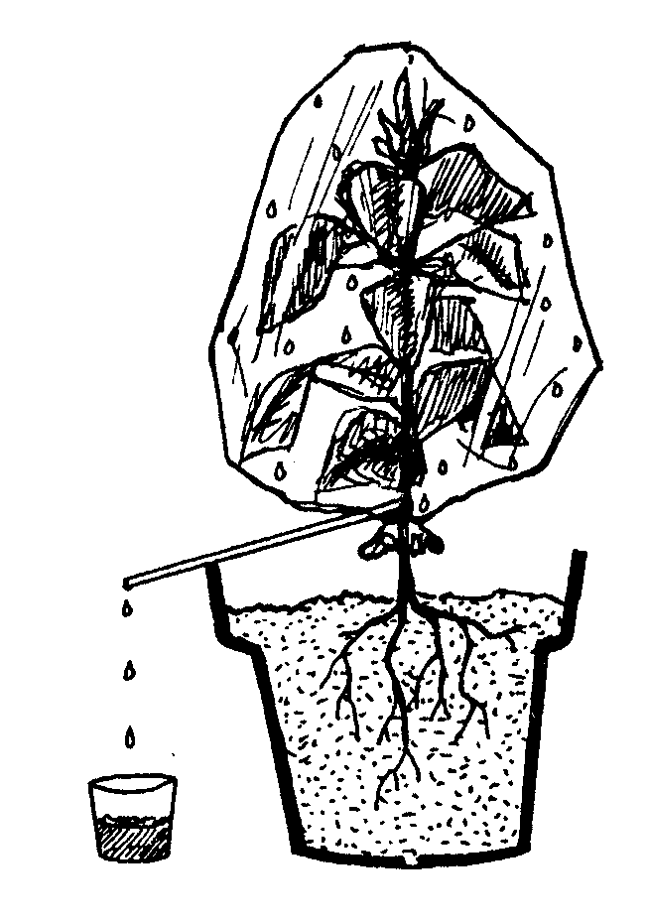

III. Questions

a. Which period produced the most water in the container? Why?
b. Does temperature have an effect on transpiration rates? Does light? Air humidity?

Lab #6 Answers to Exercise Transpiration

Part III:

a. Most water into container during the daylight period

Why? Stomata are open during the day, allowing water to escape

b. Temperature - as temperature increases, transpiration increases

Light - light increases temperature, which increases transpiration

Air humidity - as humidity increases, it lowers transpiration

