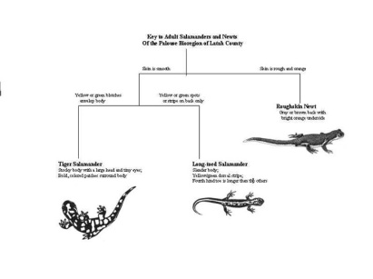
Name ______________________________________________________ Period __________
Dichotomous Keys and Cladograms
Dichotomous keys are used as a method to determine the identity of something (like the name of an insect, plant or rock). You use a dichotomous key by going through a series of choices that lead the user to the correct name of the item. Dichotomous means “divided in two parts”.
At each step of the process of using the key, the user is given two choices; each alternative leads to another question until the item is identified (like playing 20 questions).
You are going to practice using a dichotomous key AND make one yourself! Be afraid… be very afraid (just kidding, they are easy).
First, make a dichotomous key using the materials provided by your amazing, PERFECT teacher. Remember to first separate the items into two groups, follow ONE group to completion first. When you have finished your key, holler “dear teacher of mine”…. If I can correctly identify a piece of candy using your key – the candy is yours to eat. If not…...
My Dichotomous Key (if you need more room, grab another piece of paper from my desk):
1a.
1b.

2a.
2b.

Now that you are done, go into the lab area. There are pictures of birds on the lab tables. You need to use dichotomous keys to identify them. Put their names below:
1 ___________________________________ 2. ___________________________________
3. ___________________________________ 4. ___________________________________
5. ___________________________________ 6. ___________________________________
Next, try classifying a few basic organisms using the field guides placed in the room. DO NOT MOVE THE FIELD GUIDES!!! THEY NEED TO STAY IN THEIR CURRENT LOCATION.
1 ___________________________________ 2. ___________________________________
3. ___________________________________ 4. ___________________________________
Cladograms: If you have trouble answering these questions, look on page 527 of our book.
- What is a cladogram used for?

- What is a common ancestor?

- According the the cladogram below, which organisms have:
  - Mammary glands?
  - Claws or nails?
- What organisms have feathers?
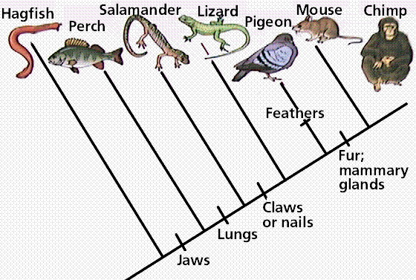
- Who should have the closest DNA, Chimp and Mouse OR Pigeon and Salamander?

- On page 528 of your book, describe how segmented worms and arthropods were classified and WHY they changed their classification.

