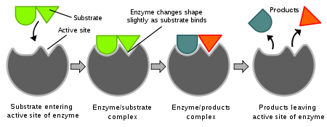**NAME_________________________________________ Period_______________**

**CHEMISTRY / MACROMOLECULES /**

**WATER / ENZYME REVIEW**

**CARBOHYDRATE REVIEW**

1. List 3 foods that contain mostly carbohydrates. __Bread; Fruit; Rice; Potatoes; Candy Canes; Pixi Sticks, Sugar Cubes and all things that make your tummy rumble._________

2. Carbohydrates are chains of what smaller organic molecule? __SUGARS_________________

3. Draw a simple picture of this smaller building block molecule.

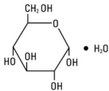 - you just need to be able to draw the basic shape.

4. List 3 ways that living creatures use carbohydrates.

a. _______Energy Storage_________________________________________________________

b. _______Energy Source____________________________________________________________

c. _________Structure___________________________________________________________

5. Give 2 examples of carbohydrates in living organisms.

________Glycogen______________________ ________Chitin or Cellulose

6. List the names of 3 sugars. ___Sucrose; Glucose; Pentose; Galactose; Fructose; Maltose____________________

7. Most sugars end in what 3 letters? ______-ose________________________________________

8. Another name for a sugar is… ______saccharide ____________________________________________

9. What is meant by a monosaccharide? ___one - sugar__________________________

**PROTEIN REVIEW**

1. List 3 foods that contain mostly proteins. ___juicy steak; nuts; beans; ground up hot-dogs (bring back memories?); cottage cheese, eggs…. Think of Walter the Farting Dog…. Poor thing ate too many beans ☺____

2. List 3 ways that living creatures use proteins. _____Muscles; Movement; Some Hormones; Enzymes;

3. Give 3 examples of proteins in living organisms. ___________________________________

_____Lactase (Enzyme); Fingernails; Hair; Growth Hormone; Hemoglobin; Muscles

__

4. Proteins are chains of what smaller organic molecule?___Amino Acids___________________________

5. Draw a simple picture of a protein showing this chain of smaller molecules.

**NUCLEIC ACIDS**

1. What are the functions of a nucleic acids in living organisms?

a. ____Store Information__________________________________________________

b. ____Transfer Information________________________________________________

2. What is the building block (monomer) for a nucleic acids? __nucleotide__________________________

3. What are the 3 parts of a nucleic acid monomer?

_____Phosphate____________ ____Pentose Sugar________________ ______Nitrogenous Base_____________________

4. Draw a simple diagram of the nucleic acid building block.

**sugar**

**N base**

**LIPIDS**

1. List 3 foods that contain mostly Lipids or Fats. ___Butter; Oil; Mayonnaise; Lard__________________________________

2. Lipids have 2 or 3 chains of what smaller organic molecule? __Glycerol & Fatty Acid

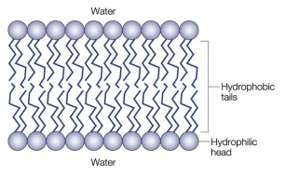

3. Draw a simple picture of this smaller building block molecule. 0

/\/\/\/\/\/\/\/\/\/\/\/\

Hopefully you can tell what we drew on the board over and over…. Having a hard time doing it on a computer.

4. List 3 ways that living creatures use lipids.

a. ______Cell Membranes (Bi-lipid Layer)________________________________

b. ________Energy Storage________________________________________________________________

c. _________Cushions Organs or Insulates Body_______________________________________________________________

5. Give 2 examples of it in living organisms.

_____Fat_______________________________ _____Cell Membrane_______________________________

**ENZYME REVIEW**

1. An enzyme and four different molecules are shown in the diagram below.



The enzyme would most likely affect reactions involving

(1) molecule *A*, only

(2) molecule *C*, only – like a puzzle piece – they fit

(3) molecules *B* and *D*

(4) molecules *A* and *C*

2. Base your answers to questions 2 through 4 on the diagram below that represents a human

enzyme and four types of molecules present in a solution in a flask.



Which molecule would most likely react with the enzyme? ___________________________

3. Explain your answer to question 2. What principle about how enzymes work does the question

illustrate?

_____________Shape is everything to an enzyme. The active site MUST have the same shape as the substrate in order to work properly… to fit.___

4. Match the enzymes with their substrates and functions.

_____ A. amylase 1. synthesizes DNA (come on… which one has DNA in it?)

_____ B. protease 2. digests sugar in beer (maltose)

_____ C. lactase 3. digests starch (amylose)

_____ D. DNA polymerase 4. synthesizes ATP

_____ E. maltase 5. digests milk sugar (lactose)

_____ F. ATP synthase 6. digests proteins

5. Base your answers to the following questions on the graph below and on your knowledge of biology.



6. What is the **optimal pH** for pepsin? __around 3____________________________________________

7. Is this pH **acid** or **basic**? ______Acidic________________________________________________

8. In what **organ of the digestive system** does pepsin work? ___Stomach… it says that in the graph_______________________

9. What is the **optimal pH** for trypsin? ______________________________________________

10. In what **organ of the digestive system** does trypsin work? __________________________

11. Is this pH **acid** or **basic**? ______________________________________________________

12. Neither enzyme works at a pHs of ______12, 13 or 14_________________________________________

13. What kind of organic molecule is an enzyme? __PROTEIN___________________________________

15. List 2 internal environmental factors that affect how well enzymes function.

_________temperature (think about freezing your hands) and concentration of enzymes (how many people breaking the toothpicks). There are others too!____

16. What happens to water when you heat it to 100°C?

_____Boils______________________________________________________________________

17. What happens to proteins dissolved in that water when you heat it to 100°C?

____________Denatures – doesn’t work anymore_________________________________________________________

18. What specific change happens to an enzyme that stops it from working when you heat it?

_______changes it’s shape.__________________________________________________________

19. Explain why changing the shape of an enzyme could affect the ability of the enzyme to function.

_______Think puzzle piece!_____________________________________________________

20. Draw a generalized graph of the action of an **enzyme from the human body** as the temperature changes from 0°C to 100°C. Mark the temperature of **optimal enzyme activity**.

21. What most likely happens to the rate of reaction of a human enzyme when the temperature

is increased gradually from 10°C to 30°C. Explain your answer.

_________________________________________________________________________________________________________________________________________________

________________________________________________________________________________________________________________________________________________

22. What most likely happens to the rate of reaction of a human enzyme when the temperature

is increased gradually from 40°C to 90°C. Explain your answer.

_________________________________________________________________________________________________________________________________________________________________________________________________________________________________________________________________________________________________

23. What is the optimal temperature for the functionality of a human enzyme? _______________

**Atoms and Water**

24. Draw and Label the parts of a nitrogen atom

25. Explain why an atom is an element, but an element doesn’t have to be just an atom. _____Carbon is an atom (has 6 carbons). It is also an element on the periodic table. HOWEVER, you can have a bunch of carbon atoms put together (like a diamond, or cole). At this point, it is not just one atom. ________________________________________________________________________________

26. In the book find the element Pb (Lead) and calculate how many neutrons an atom of Pb has in its nucleus __207 – 82 = ____

How many electrons does lead have in a neutral atom of lead?____________________

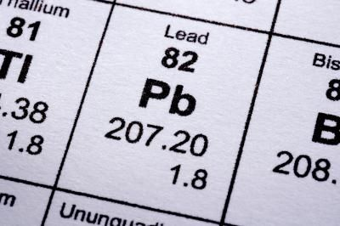

Atomic # - # of Protons. Also the # of electrons in a neutral atom.

27. Explain why you can change the number of electrons or neutrons in an atom of Pb, but you cannot change the number of protons in Pb. ________The number of protons defines what element it is. _______

28. List 4 properties of water below and tell why they are important to living organisms:

1. Cohesion – when plants Transpire, it makes water travel to the top.
2. Heat Capacity – holds your body’s temperature at a steady temperature (homeostasis)
3. Water as a Solvent – it can dissolve substances (like sugar) in your bloodstream so that they are small enough to pass through a cell membrane.
4. Water is a buffer (pH of 7)

29- What is pH and explain how H+ concentrations differ with acids and bases

pH just describes how many Hydrogen Ions or Hydroxide Ions there are. You have a lot more H+ ions in an acidic solution.

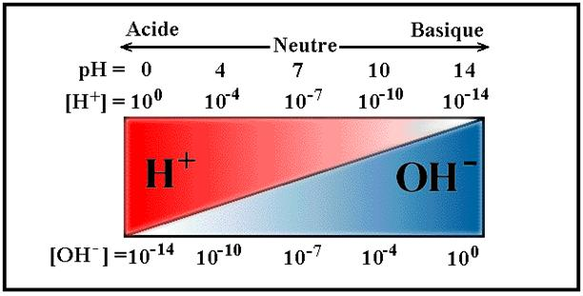

**EXTRA CREDIT: SUBMIT A TEST QUESTION…. IF IT IS CREATIVE, IT WILL BE USED ON THE TEST**