PLANT ANATOMY, GROWTH AND DEVELOPMENT

LABORATORY EXERCISE #7--OBSERVING THE STRUCTURE AND
FUNCTION OF FLOWERS

Name_______________________________________ Score______________________________

Slesnick, Irwin L., Biology Laboratory Manual, Scott, Foresman and Company, 1985. Reprinted by permission of Scott, Foresman and Company.

Introduction

In all flowering plants--or angiosperms--the flower is a highly refined organ that is specialized for sexual reproduction. The outer structures, the sepals and petals, are actually modified leaves that protect the reproductive structures. Each of the remaining parts plays a specific role in the actual seed formation. In this laboratory you will examine each of the flower structures and see how they are modified for their role in sexual reproduction.

Materials needed

Assorted fresh flowers Forceps
Stereoscopic microscope or hand lens Dissecting needle
Compound microscope 10% Sucrose solution
Coverslips Scalpel or single-edged razor blade
0.01% Methylene blue solution Lab or facial tissue
Clean sheet of unlined paper Tape

Part I: Macroscopic Study of the Flower

1. Obtain all the materials listed above and bring them to your work area.

2. Examine the outer structure of your flower. The sepals, which are modified leaves, form the outermost circle--or whorl. Collectively the sepals form the calyx. Find the place where the calyx attaches to the base of the flower. This is the receptacle. The petals are found just inside the sepals and the whorl of petals is called the corolla. Label the receptacle, sepal and petal on a.

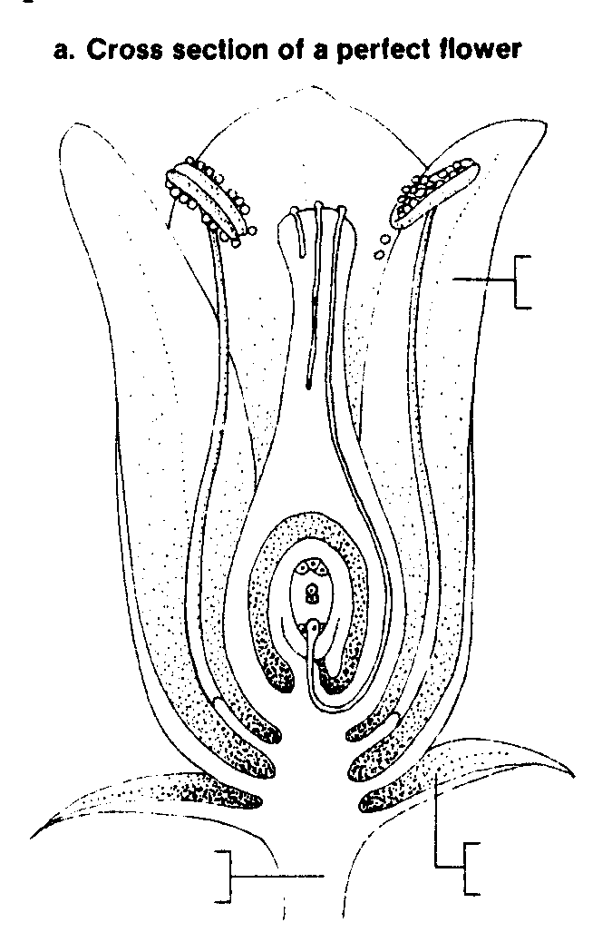
3 Monocots are flowers whose parts occur in threes or multiples of threes. Dicots are flowers whose parts occur in fours or fives or multiples thereof. Is the flower you are observing a monocot or a dicot?

(a)

4. Gently remove the sepals and the petals. Tape the sepals along the bottom of a clean sheet of paper. Then tape the petals in a row above the sepals. What do you notice about the number of sepals and petals?

(b)

Part II: The Male Reproductive Structures

1. Inside the corolla is a circle of stamens. These are the male reproductive organs, each consisting of an anther at the tip supported by a tubelike filament. Pollen grains found inside the anther are the male gametophytes. Label the anther, filament and pollen grain on b. Carefully remove the stamens and tape them in a row above the petals.

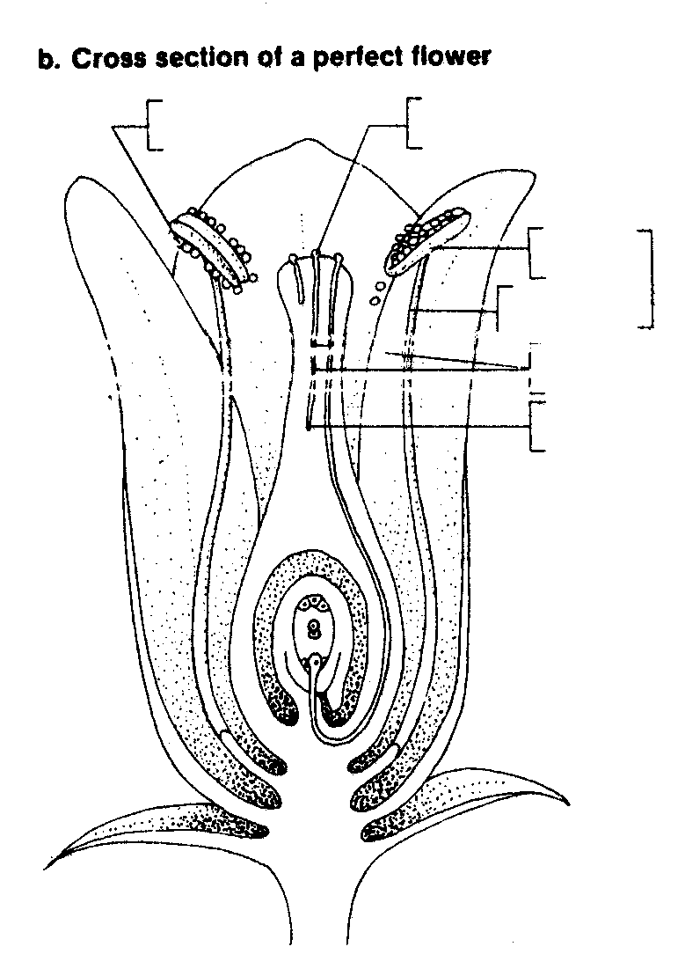

2. The anthers contain the pollen sacs. The pollen grains are formed from microspores in the pollen sacs. To examine the pollen grains more closely, add some pollen grains to a drop of water on a microscope slide. Add a coverslip and examine the pollen grains under high power of your microscope. The small dotlike structures you see are the pollen grains. Make a sketch of a few of the pollen grains in c.

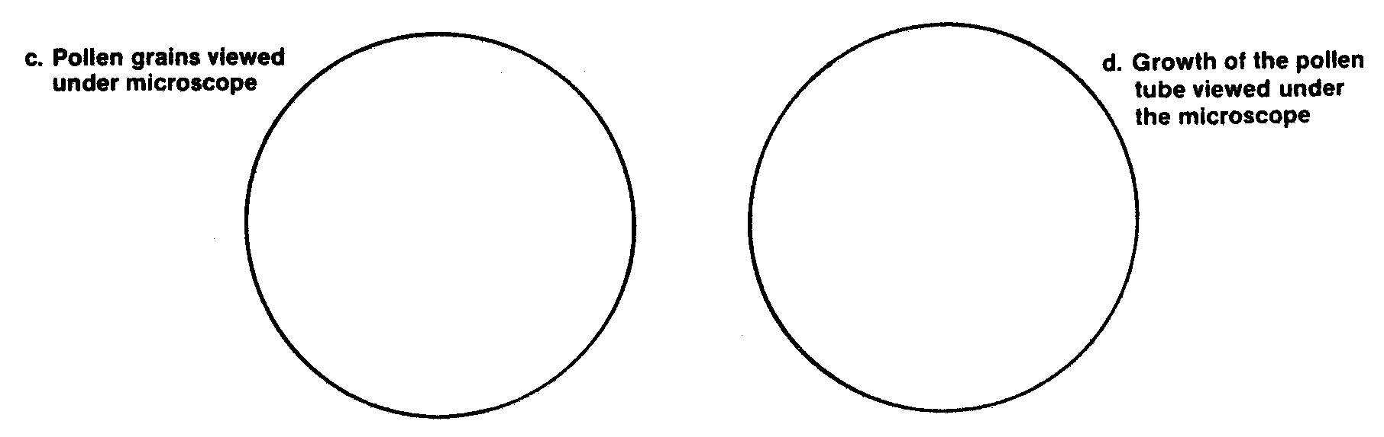
3. Sprinkle some pollen from your flower onto a drop of sucrose solution on a microscope slide. Add a coverslip and examine at high power at five-minute intervals for 30-60 minutes. The narrow thread-like structures you see growing are the pollen tubes. Locate and label the tube nucleus at the tip of the pollen tube in d on the previous page and the two sperm nuclei close behind. After 30 minutes make a sketch of the pollen tube growth. Describe the pollen grains and the growth of the pollen tubes.

(c)

Part III: The Female Reproductive Structures

1. The female reproductive organ--or carpel--is located in the center of the flower. The top portion of the carpel is the stigma. The stigma is usually sticky and is where the pollen grains collect. The style is the stalk-like structure that supports the stigma. The enlarged structure at the base of the carpel is the ovary. Ovules within the ovary produce the female gametophytes. Label the carpel, stigma, style and ovary on e.

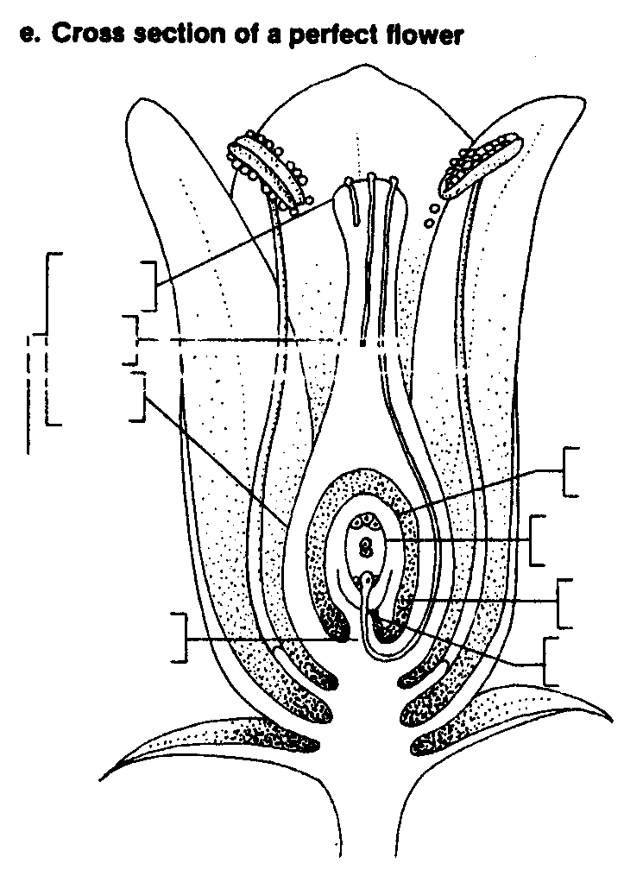

2. With a scalpel or razor blade, carefully remove the carpel by cutting just beneath the ovary. CAUTION: Use the sharp blade of your cutting instrument carefully to avoid injury. Always cut away from yourself. Then, make a cross section of the ovary as shown in f on the next page. Tape one half of the cross section on the paper above your drawing of the pollen grains. Secure one half of the cross section with your forceps. Then, using your scalpel, cut a thin slice from the section. Make a wet mount and examine under low power. Find the white spherical ovules that are attached to the ovary wall by a tiny stalk, the funiculus. The ovules develop into hollow compartments called locules. The outer layers of the ovule surround the embryo sac. The embryo sac is the female gametophyte and this is where the egg is located. Label the ovule, funiculus, locule and the embryo sac on e.

3. Using the cross section of the ovary, carefully separate a few ovules. Place the ovules in a drop of water on a clean microscope slide and add one drop of methylene blue stain. Place a coverslip on top. Fold a piece of tissue and place it on top of the coverslip. Gently press down to crush the ovules. Under low power examine the slide and locate the stained nuclei inside the embryo sacs. Make a sketch of the nuclei in g.

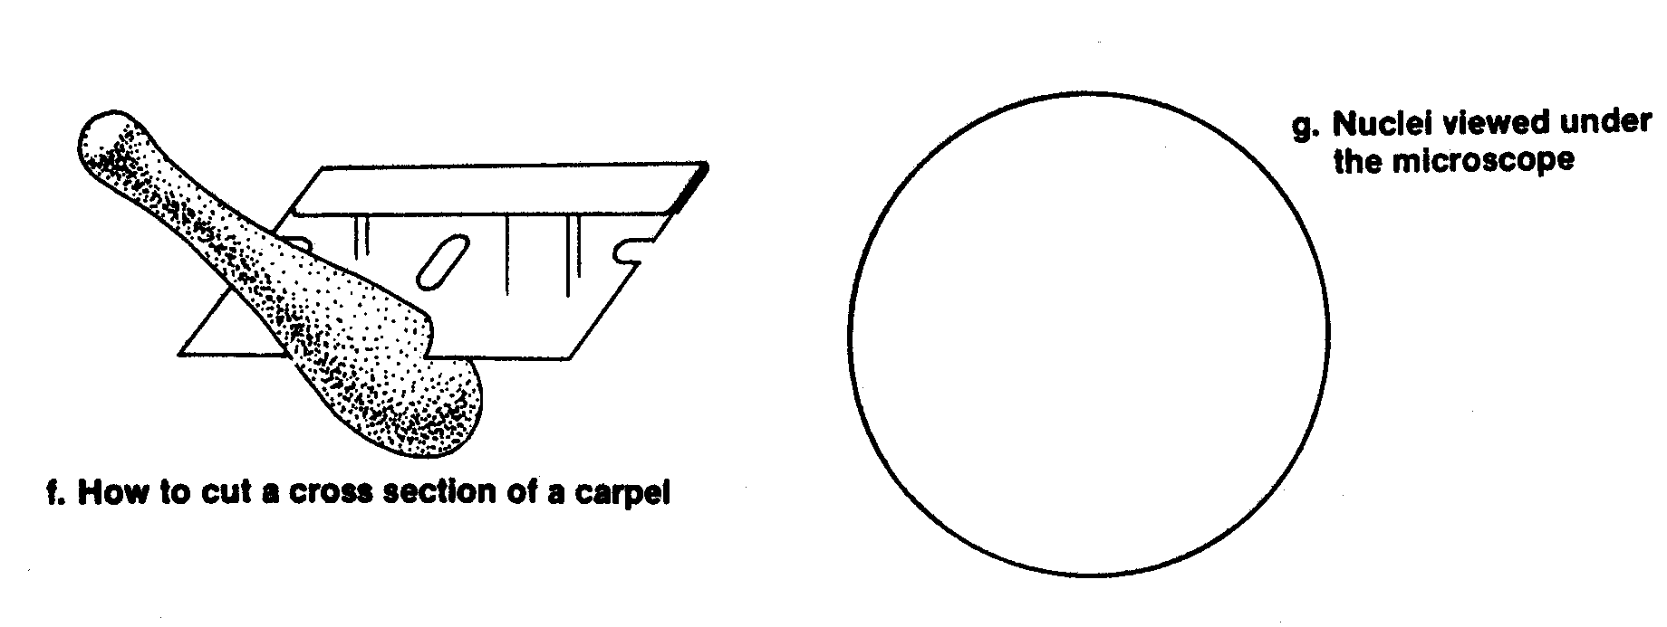

Part IV: Analysis

1. In what structure are the male gametophytes found?

2. In what structure are the female gametophytes found?

3. Where is the stigma located on the flower and how does this aid in pollination?

4. Describe the process of fertilization in angiosperms. Name each of the structures involved.

Part V: Going Further

Obtain a composite flower from your teacher. Notice that there appear to be two kinds of petals. These are actually flowers. The flowers of the outer row--the ray flowers--have showy petals. The flowers in the center are called the tube flowers. Carefully remove one of the ray flowers at its base. Using your scalpel or razor blade make a longitudinal cut down the center of the flower. Examine one half of the ray flower with your hand lens. List the flower parts present in the ray flower. Carefully remove one of the tube flowers beneath the base. Examine one half of the flower with your hand lens. List the flower parts present in the tube flower. What are the differences between the ray and tube flowers? Sunflowers are an example of a composite flower. The name comes from the arrangement of the flowers. Explain why sunflowers are composite flowers.
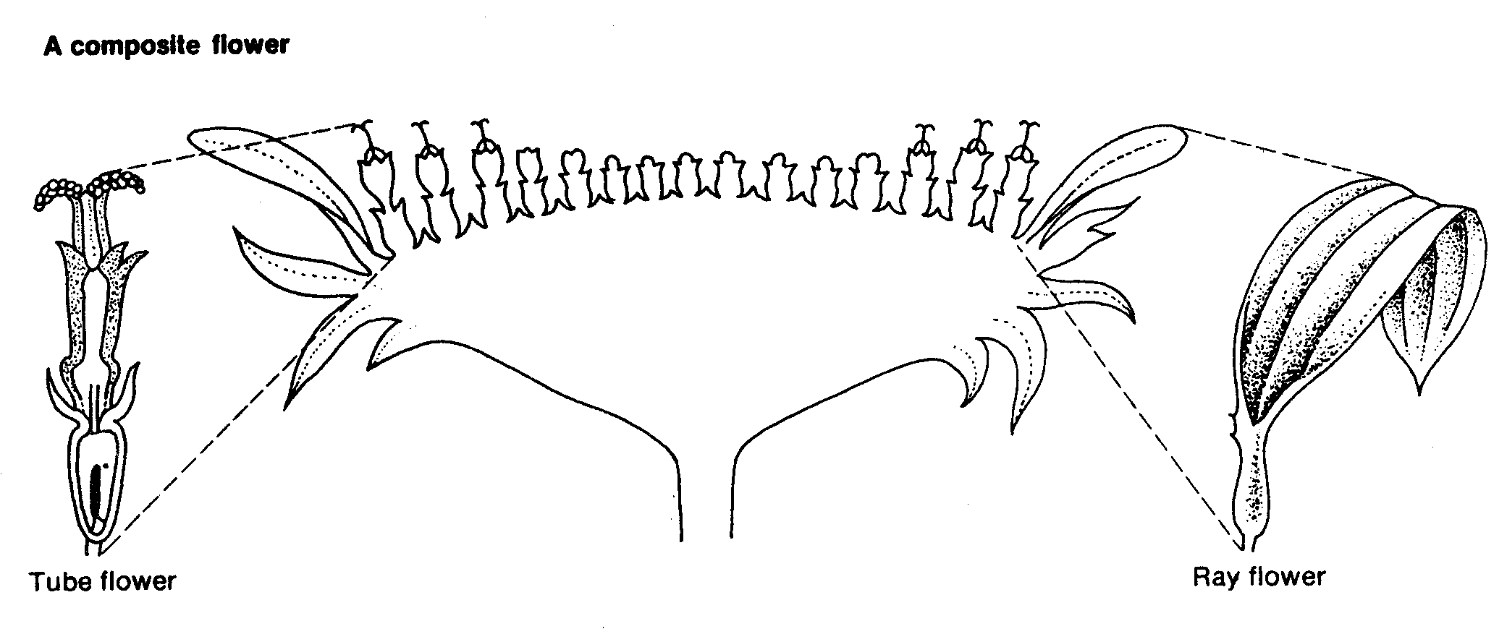
Answers to Lab #7

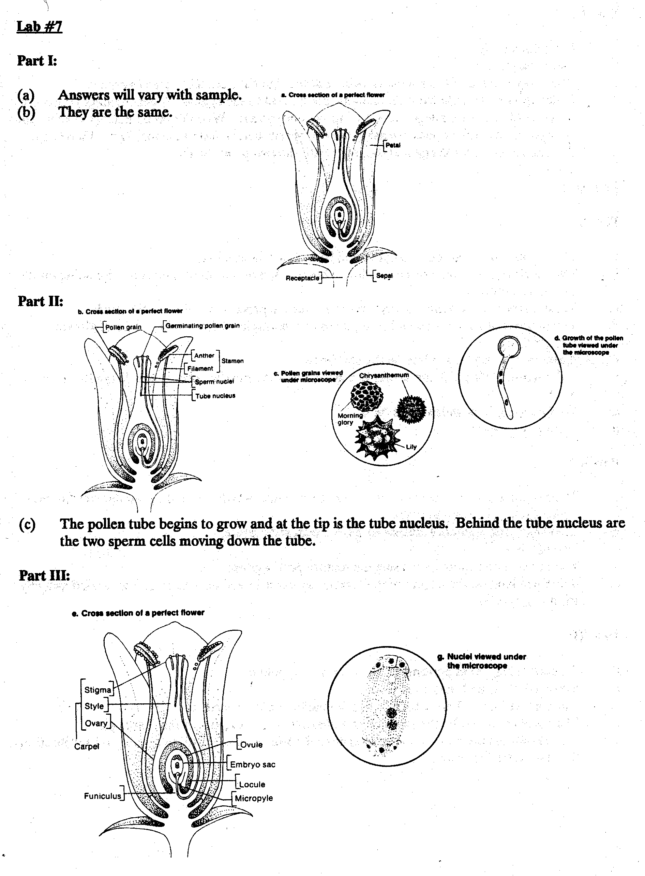
Part IV:

1. The pollen grains.
2. The embryo sac.
3. The sticky surface of the stigma is located at the tip of the carpel to collect pollen.
4. Pollen grains, released from the anthers, are carried to the stigma. A germinating pollen grain sends a pollen tube through the carpel to the embryo sac. When the tube nucleus reaches the embryo sac, the tube opens releasing the two sperm nuclei into the embryo sac. One sperm nucleus unites with the egg and the other with the two polar nuclei.

