Plant & Soil Science
Plant Cell Structure and Functions Study Guide

- What are the two types of cells?

Compare and Contrast Prokaryotic and Eukaryotic cells:
Write the prokaryotic characteristics in red and the Eukaryotic characteristics in blue:

Prokaryotic | Eukaryotic

- Draw an example of each cell type:

- What type of cell are plants made up of?

- Compare plant and animal cells?

 | Animal Cells | Plant Cells
Cell Wall
Plastids
(Chloroplasts)
Centrioles
Vacuoles
Lysosomes
Cilia and Flagella Absent in Plants

- Label the plant cell and its parts. Also explain the function of each part you label.

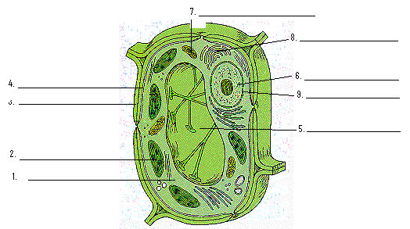

- What does it mean that plant cells are totipotent?

- Define cell cycle:

- Draw the cell cycle and label it:

- Name the Phases of Mitosis!

- What is cytokinesis?

- How many daughter cells do you get from mitosis?

- Compare and Contrast Mitosis and Meiosis:
Mitosis | Meiosis
Not every cell does this | Reduces Chromosome number by 1/2
Four Stages | Eight Stages
Results in: | Results in:

- What types of cells undergo meiosis?

- What is the purpose of meiosis?

