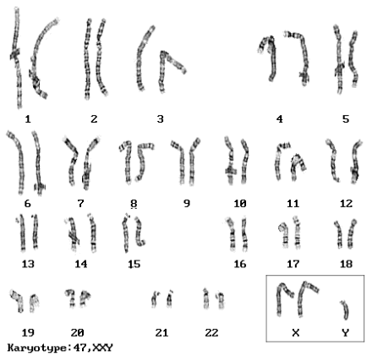
Name _____________________________________
Period _______________
Mitosis; DNA; Inheritance REVIEW
Part I: CELL CYCLE, MITOSIS & MEIOSIS
- Draw and Label the Steps of Mitosis.
Interphase | Prophase | Metaphase (Meet in the Middle) | Anaphase (Ana tears people apart) | Telophase (Looks like a telephone) | Back to Interphase OR YOU CAN SAY CYTOKINESIS

- a.What would happen to a cell if it lost it’s Nucleus? It wouldn’t be able to do ANYTHING, the nucleus tells the cell what to do.
b. What would happen to a cell if it lost it’s DNA? It couldn’t produce proteins (the workers of the cell and body), it couldn’t reproduce etc.
3. Where does Mitosis happen? IN SOMATIC CELLS – YOUR BODY CELLS (EVERYWHERE BUT THE GAMETES)
3. What is Meiosis and WHERE does it happen? MEIOSIS IS CELL DIVISION IN SEXUALLY REPRODUCING ORGANISMS. CELLS UNDERGO MITOSIS TWICE WHICH REDUCES THE CHROMOSOMES INTO HAPLOID CELLS (SO A FERTILIZED EGG WILL END UP WITH 23 SETS… OR 46 IN ALL… CHROMOSOMES)
4. When one cell undergoes meiosis, how many cells do you get in the end? 4
5. What kind of organisms undergo meiosis? SEXUALLY REPRODUCING ONES
6. What is asexual reproduction? A WAY FOR ORGANISMS TO REPRODUCE WITHOUT HAVING A PARTNER. ORGANISMS REPRODUCE THROUGH MITOSIS INSTEAD OF MEIOSIS… SO ALL OFFSPRING ARE EXACTLY THE SAME AS THE PARENT.
- Is there Genetic variability in asexual reproduction? Explain.
NO!!!! IF YOU REPRODUCE ASEXUALLY, YOUR OFFSPRING IS EXACTLY LIKE YOU! ALL YOUR GENES ARE THE SAME. ON THE FLIP SIDE, THINK ABOUT SEXUALLY REPRODUCTING ORGANISMS. YOU GET SOME CHROMOSOMES FROM YOUR FATHER AND SOME FROM MOTHER. YOU ALSO HAVE CROSSING OVER WHICH ALSO LEADS TO MORE VARIABLITY.
7. What is sexual reproduction? ORGANISMS THAT REPRODUCE THROUGH MEIOSIS.
a. Is there Genetic variability in sexual reproduction? Explain. YES!!!! SEE THE ANSWER UNDER 6A
Part II: DNA BASICS
8. Draw a sub-unit of DNA… one nucleic acid and label the parts.
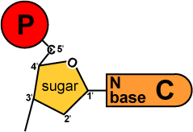
9. What is a chromosome?
Threadlike bodies that carry genetic information from one generation to the next
Males and Females have 23 pairs of chromosomes. 22 of those code for autosomal traits (or body traits). The 23rd pair are sex chromosomes. Label each as Male or Female:

10. XX ______FEMALE________________________ XY ____________MALE_______________________

XXY _Klinefelter Syndrome___(Males born with an extra X chromosome). They tend to have some physical traits that are unusual for males (sparse body hair, enlarged breasts, wide hips, voices not as deep etc.)

11. Why would someone with Klinefelter’s Syndrome be unable to father children?
IT IS HARD TO SPLIT 3 CHROMOSOMES EQUALLY INTO TWO PARTS (XXY)…. ANOTHER BIG PROBLEM. WHEN YOU HAVE TWO XX’S THAT ENCODE FOR FEMALE HORMONES, IT MESSES WITH THE REPRODUCTIVE CYCLE BIG TIME!

Just as a side note, there is also XXX syndrome (girls that are unusually tall, delayed motor skills, weak muscle tone). You can also have a girl with one X - Turner Syndrome (short, ovarian malfunction; brown spots; fold of skin on neck etc.)
PART III: PROTEIN SYNTHESIS
12. For this section, draw the process of protein synthesis. You should include the words or concepts below:
DNA
Base Pairs ATCG
DNA Polymerase (enzyme copies DNA)
Replication (copy DNA to DNA)
Nucleus
RNA Polymerase (enzyme copies DNA to RNA)
mRNA (Messenger RNA)
Base Pairs AUCG
Ribosome (site of protein synthesis)
t RNA (Transfers amino acids)
Amino Acids (building block of proteins)
Protein
Codon – know that base pairs are read in groups of 3. AGG – CTC – AAG etc.

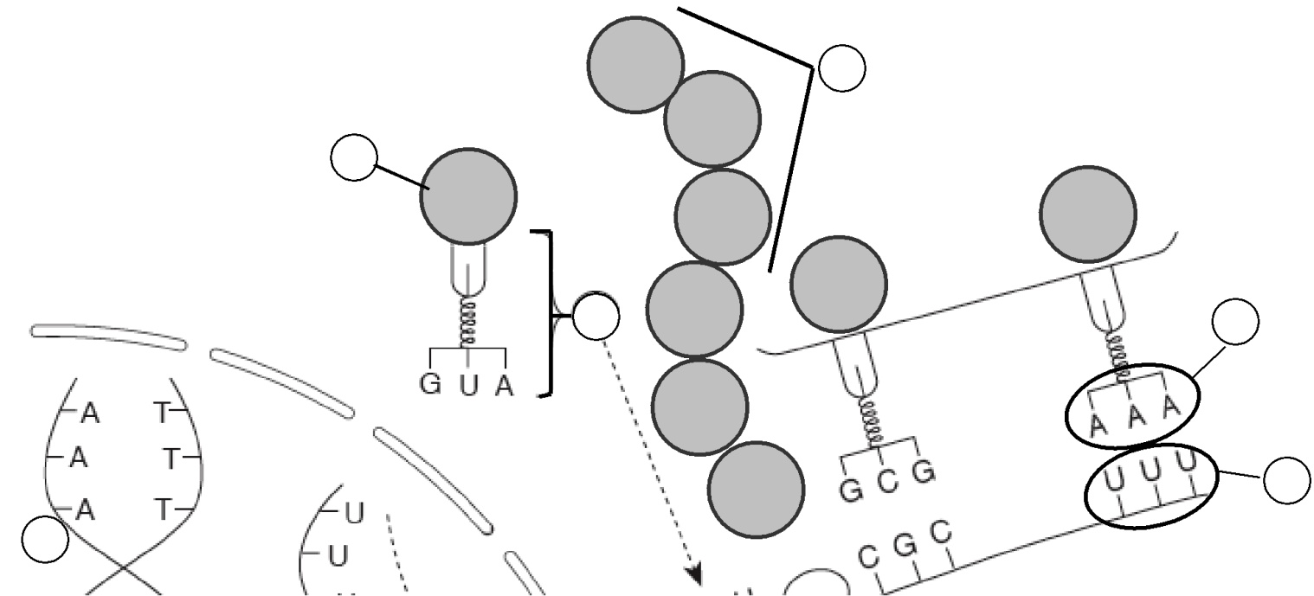

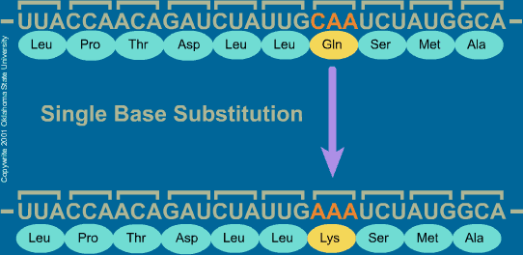
PART IV: MUTATIONS
13. What is a mutation? A CHANGE IN THE DNA
14. What is a point mutation? WHEN ONE NUCLEOTIDE (LETTER) IS SWITCHED OUT FOR ANOTHER.
a. Draw an example using base pairs (letters)
CCA ----- AAA (THE C WAS SWITCHED WITH THE “A”. LOOK AT THE IMAGE TO YOUR RIGHT.
15. What is a frameshift Mutation? WHEN ONE NUCLEOTIDE IS ADDED OR DELETED
- Draw an example (the “C” is deleted… so all anticodons are changed (groups of three letters)
THE CAT ATE THE RAT
THE ATA TET HER AT

16. Why are mutations usually such a problem? (Use the word protein)
It changes at least one amino acid (point mutation) or a series of amino acids which changes the entire protein. Your protein’s shape is EVERYTHING… WITHOUT IT’S SHAPE – NO FUNCTION!!!
17. Give an example of a mutation being a good thing (think about Black Plague):
PEOPLE HAD A MUTATION THAT CAUSED THEM TO BE IMMUNE TO THE BLACK PLAGUE… WE WILL LEARN MORE NEXT UNIT. BUT WE DID TALK ABOUT ALZHEIMERS AND A FEW OTHER ‘GOOD’ MUTATIONS AND THE PRODUCTION OF BETA AMYLOID.
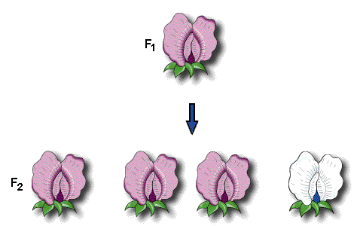
PART V: BASIC INHERITANCE
18. What is Gregor Mendel called? FATHER OF GENETICS
19. What plant did he work with? PEA PLANTS
20. Is the color the phenotype or Genotype?
PHENOTYPE… PHYSICAL APPEARANCE
Using the words: Homozygous; Heterozygous; Dominant or Recessive, classify the following genotypes:
21. HH ____HOMOZYGOUS DOMINANT_________________________________________________
22. Hh____HETEROZYGOUS (ONE CAPITAL, ONE LOWER CASE)___________________________________
23. hh____HOMOZYGOUS RECESSIVE______________________________________
23. One bunny carries heterozygous, long-haired traits (Rr), and its mate carries homozygous short-haired traits (rr). Use a Punnett square to determine the probability of one of their offspring having long hair. You will have 2 with Rr; 2 with rr. So half the children will have long hair
24. If the bunny has 2000 offspring (yes, busy parents), how many will have long hair according to your answer above? 1000 (half of 2000)
25. Now, put your answer into a phenotypic ratio (1:1; 1:2:1; 3:1).
1:1
26. Describe what it means to be type: A blood? It means you have “A” type antigens (name tags) on the surface of your blood cell.
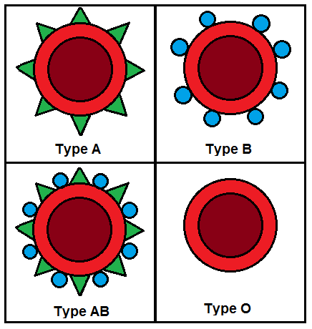
27. Fill in the following chart:
pheno-type | genotype | Antigen (THESE ARE NAME TAGS)  on RBC | antibodies  in blood | donation  status
A | A A ^{or} A i | type A___ antigens  on surface  of RBC | anti-B antibodies | __
B | BB ^{or} B i | __TYPE B antigens  on surface  of RBC | _ANTI- A_ antibodies | __
AB | AB | BOTH A&B_ antigens  on surface  of RBC | _NO____ antibodies | UNIVERSAL RECIPIENT
O | i i | __NO ANTIGENS__  on surface  of RBC | __ANTI A&B__ antibodies | UNIVERSAL DONOR

28. When we talk about pedigrees, we are often dealing with sex linked traits (meaning traits found on the X or Y chromosome). If a trait is found on the X chromosome, what would it take for a female to manifest the trait?
The female would have to have BOTH X’s (XX) affected. Both chromosomes would have to have the mutation.

29. What would it take for a female to be a carrier?
Only one X would be affected. She is a carrier, because she ‘carries’ the trait, but does NOT express it. She has one X affected, the other X has a working copy of the gene, so she is fine.

30. Can a male be a carrier of an X-linked trait?
NO! He only has one X (XY)…. so if that X is affected, he does not have a working copy.

31. What does it mean to have a “Dominant “ trait? Does it beat up your recessive trait? Explain and give an example.
Dominant trait just means that is the trait that is working; makes the proteins or is expressed. For instance, a white flower just doesn’t make pigment (recessive), if the flower also has a big P or a dominant trait that, the flower will be purple because purple masks the recessive (or white) allele.

