EVOLUTION and CLASSIFICATION STUDY GUIDE
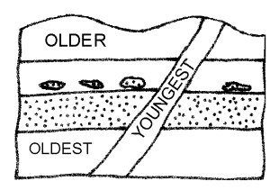
- The earth is 4.6 Billion Years Old
- Relative Dating: We know the order of events, but not actual dates.
- Absolute Dating: We know dates. We find the dates by measuring half life.
- Half Life: The time required for the amount of radioactive material to decrease by one-half. KNOW HOW TO CALCULATE!
- Uniformitarianism: The same laws that govern our world governed the past.
- There is a lot of diversity and variety on earth!
- Cladograms or Phylogenetic Trees show evolutionary relationships. Know how to find common ancestors.
- 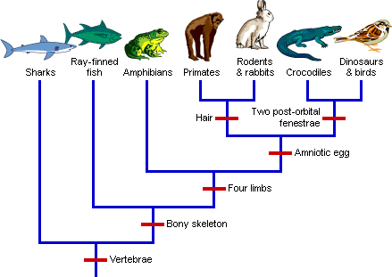
- Know how to read a dichotomous or taxonomic key
- CLASSIFICATION:
- There are 6 kingdoms:
  - Prokaryotes:
    - Bacteria – one celled organisms; microscopic; no organelles
    - Archaebacteria: Oldest form of life. Live in extreme environments
  - Eukaryotes (separate organelles in their cells)
    - Protists – any eukaryotic organism that isn’t a plant, animal or fungi.
    - Plants
    - Fungi
    - Animals
- You can further separate organisms into the 7 levels of classification:
  - Kingdom
  - Phylum
  - Class
  - Order
  - Family
  - Genus
  - Species
- Organisms belonging to the same Kingdom are most DISSIMILAR (Fruit Fly and Monkey).
- Species are most SIMILAR.
- The Classification system has changed over time based on increased technology that has allowed us view more organisms etc.
- Carolus Linnaeus proposed Binomial Nomenclature: Each species has a two part name:
  - Genus species (Homo sapiens).
- Darwin had two main ideas:
  - Tree Thinking: Organisms do not change in one straight path; it looks like a family tree. Organisms are organized by STRUCTURE and function.
  - Natural Selection
    - Variation must already exist in the population.
    - There is a change in Environment (new predator; different food source etc.)
    - Organisms must survive their new environment
    - Those organisms pass on their genes to the next generation.
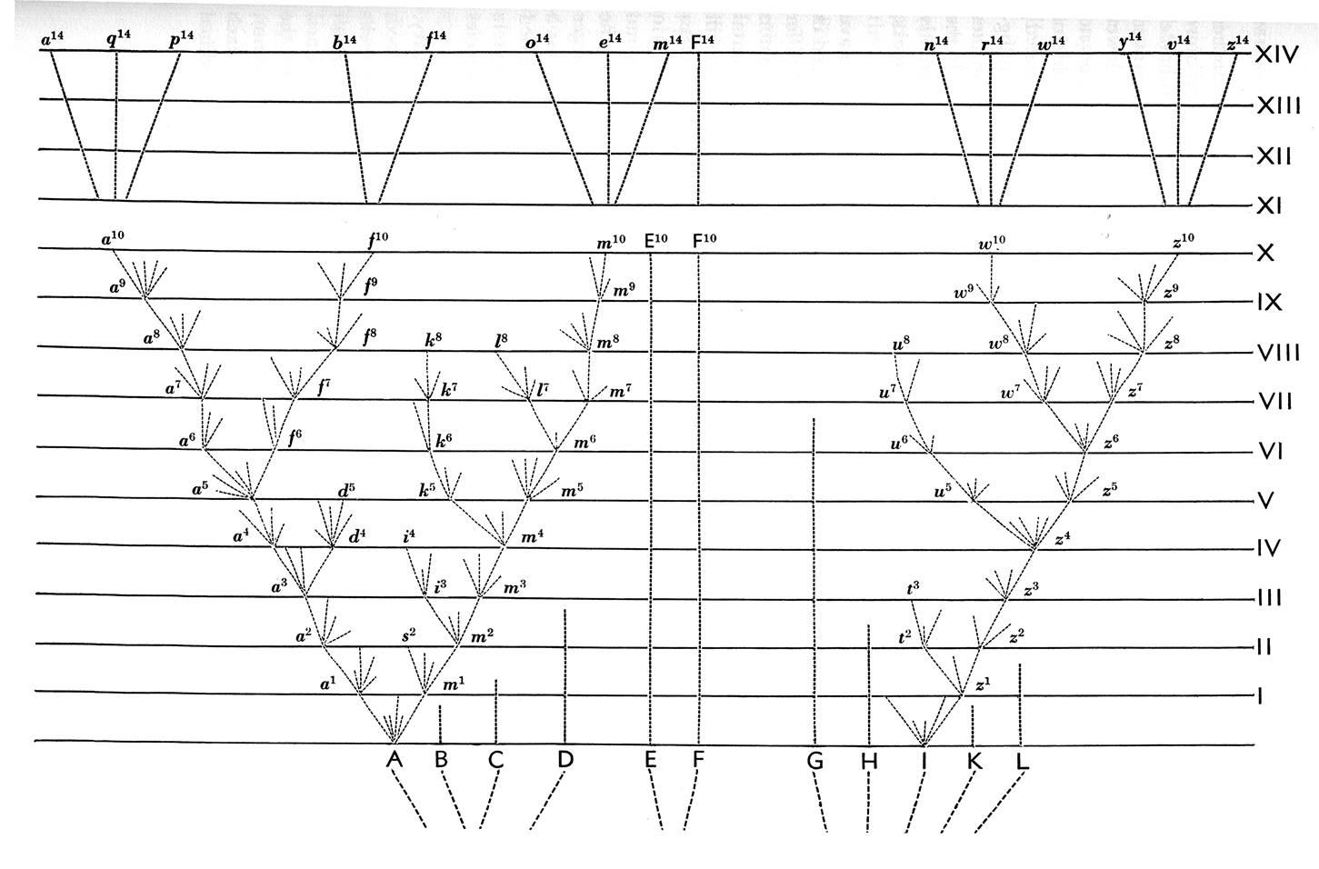

- KNOW THE EVIDENCES FOR EVOLUTION WORKSHEET VERY WELL!!!!!
- Know “Why The Theory of Evolution Matters”

