Name:_______________________________________________________________Date:___________Per:_________
Unit 4 Test Review – Test Sections 1 & 2
Cell Energy, Organelles and Functions
- Which cell organelle determines the amount of ATP (Cell Energy!) that is available to the cell? Mitochondria

- What is the process called that creates ATP and changes O2 and Glucose into CO2 and H2O? Cellular Respiration

- What organelles are used in creating proteins (protein synthesis)? Write them in order of the process.
Nucleus (DNA & RNA) Ribosomes Rough E.R. Golgi Apparatus

- If we were to increase the amount of Rough E.R. in a cell, what other organelle would we also need more of (HINT: Think protein synthesis!)? Golgi Apparatus

- Enzymes are what type of macromolecule? REMEMBER THIS. Proteins

Next to each description, write which organelle is described:
- Contains Genes and controls the cells function - Nucleus

- Enzyme made of Nucleic Acid helps assemble Amino Acids based on information from DNA (Use deductive reasoning for this one… which one would assemble amino acids?) Ribosomes

- Processes Lipids to make more Membrane for the cell – Smooth E.R.

- What organelle is the major producer of sugar and ATP and makes a cell AUTOTROPHIC? Chloroplasts

- Which organelle helps maintain pressure in a plant cell and stores nutrients? Vacuole

- What is the rigid layer that provides structure to plant cells called? Cell Wall

- Which organelle converts light energy into sugars? Chloroplasts

- Which organelle sorts and processes proteins? Golgi Apparatus

- Which organelle is the location where transcription & DNA replication occur? Nucleus

- Which organelle is a storage compartment for water and nutrients? Vacuole

- Which organelle holds genetic information (DNA)? Nucleus

- Which organelle assembles amino acid chains? (protein chains)? Ribosomes

- Which organelle processes and folds amino acid chains into finished proteins? Rough E.R.

- Which organelle sorts and ships completed proteins where they need to go in the body? Golgi Apparatus

- If you eat a lot of glucose, which organelle would your cells make more of to help process the glucose? Mitochondria

- What would happen if you ate a lot of glucose and removed the mitochondria from your cells? You would have an increase in glucose and a decrease in ATP (cellular energy)

- Which organelles are found in plant cells but NOT in animal cells? Cell Wall, Chloroplasts
- Which types of organisms perform photosynthesis? Plants

- Which types of organisms perform cellular respiration? Plants AND Animals

- Can ATP ONLY be made in the mitochondria? Where else could it be made? Chloroplasts

- What are the differences between a prokaryotic and eukaryotic cells? Prokaryotic cells do not have a nucleus. Eukaryotic cells have a nucleus (YOU are EUKARYOTIC!).

- If we increased the amount of light intensity available to a plant, what else would increase? The amount of glucose (sugar)

- What is the formula for photosynthesis (Write it using simple words AND using the chemical equation)?
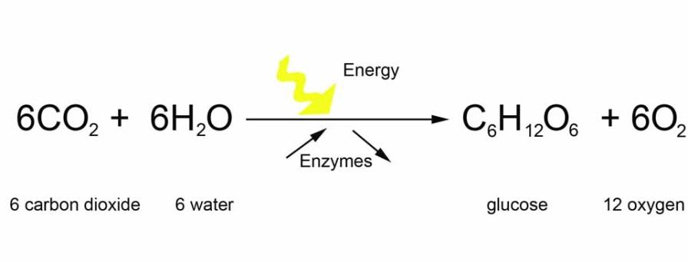

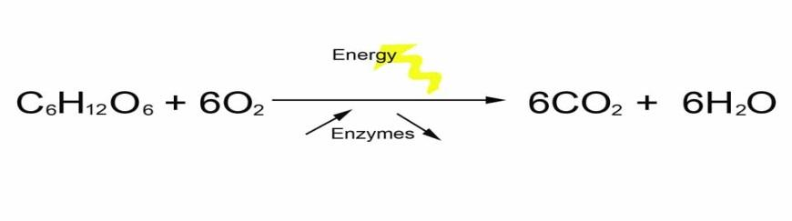
- What is the formula for chemical respiration (Write it using simple words AND using the chemical equation)?

- Label this animal cell using black pen or pencil. Using a red colored pencil (or other color), draw arrows showing the process of protein synthesis. Using a blue colored pencil, draw arrows showing the process of cellular respiration.

